UNITED STATES
SECURITIES AND EXCHANGE COMMISSION
Washington, D.C. 20549
FORM 8-K
CURRENT REPORT
Pursuant to Section 13 or 15(d)
of the Securities Exchange Act of 1934
Date of report (Date of earliest event reported): August 5, 2026
EVERCOMMERCE INC.
(Exact name of registrant as specified in its charter)
Delaware |  |  |  |  |  | 001-40575 |  |  |  |  |  | 81-4063248
(State or other jurisdiction  of incorporation or organization) |  |  |  |  |  | (Commission  File Number) |  |  |  |  |  | (I.R.S. Employer  Identification No.)
3601 Walnut Street, Suite 400
Denver, Colorado 80205
(Address of principal executive offices) (Zip Code)
(720) 647-4948
(Registrant’s telephone number, including area code)
N/A
(Former Name or Former Address, if Changed Since Last Report)
Check the appropriate box below if the Form 8-K filing is intended to simultaneously satisfy the filing obligation of the registrant under any of the following provisions:

☐ |  |  | Written communications pursuant to Rule 425 under the Securities Act (17 CFR 230.425)
☐ |  |  | Soliciting material pursuant to Rule 14a-12 under the Exchange Act (17 CFR 240.14a-12)
☐ |  |  | Pre-commencement communications pursuant to Rule 14d-2(b) under the Exchange Act (17 CFR 240.14d-2(b))
☐ |  |  | Pre-commencement communications pursuant to Rule 13e-4(c) under the Exchange Act (17 CFR 240.13e-4(c))
Securities registered pursuant to Section 12(b) of the Act:
Title of each class |  |  |  |  |  | Trading Symbols |  |  |  |  |  | Name of each exchange on which registered
Common Stock, $0.00001 par value per share |  |  |  |  |  | EVCM |  |  |  |  |  | The Nasdaq Stock Market LLC
Indicate by check mark whether the registrant is an emerging growth company as defined in Rule 405 of the Securities Act of 1933 (§230.405 of this chapter) or Rule 12b-2 of the Securities Exchange Act of 1934 (§240.12b-2 of this chapter).
Emerging growth company ☒
If an emerging growth company, indicate by check mark if the registrant has elected not to use the extended transition period for complying with any new or revised financial accounting standards provided pursuant to Section 13(a) of the Exchange Act. ☐

Item 2.02 Results of Operations and Financial Condition.
On August 5, 2026, EverCommerce Inc. (the “Company”) issued a press release announcing financial results for the three and six months ended June 30, 2026 and other matters described in the press release. A copy of the Company’s press release is furnished as Exhibit 99.1 to this Current Report on Form 8-K and incorporated herein by reference.
The information disclosed under this Item 2.02, including Exhibit 99.1 hereto, is being furnished and shall not be deemed “filed” for purposes of Section 18 of the Securities Exchange Act of 1934, as amended, nor shall it be incorporated by reference into any registration statement or other document pursuant to the Securities Act of 1933, as amended, except as expressly set forth in such filing.
Item 5.02 Departure of Directors or Certain Officers; Election of Directors; Appointment of Certain Officers; Compensatory Arrangements of Certain Officers.
On August 5, 2026, the Board of Directors (the “Board”) of the Company appointed Alex Goor as the Company’s Chief Executive Officer, effective August 6, 2026 (the “Effective Date”). Mr. Goor succeeds Eric Remer, who resigned as Chief Executive Officer and Chairman effective on the same date. Mr. Remer will remain a member of the Board. In addition, on August 5, 2026, the Board appointed Mr. Goor as a Class I director of the Company, effective on the Effective Date.
Mr. Goor, age 54, most recently served as Chief Information Officer of Interactive Data Corp. from October 2010 to February 2016. Mr. Goor has also served as a member of the Board of Directors of several private and public companies. Mr. Goor received his B.A. at Columbia College in Mathematics, where he graduated magna cum laude. The Company believes Mr. Goor is qualified to serve on the Board due to his extensive senior leadership experience in the technology, data and financial services industries, including his service in executive and governance roles at ACA Compliance Group, Interactive Data Corporation, Instinet Group and Datek Online, together with his experience serving on the boards of directors of other private and public companies.
In connection with Mr. Remer’s transition from the Chief Executive Officer role, the Company and Mr. Remer entered into a Transition and Release of Claims Agreement (the “Transition Agreement”). Pursuant to the Transition Agreement, subject to Mr. Remer’s execution and non-revocation of the release of claims set forth in the Transition Agreement and his continued compliance with the applicable restrictive covenants, Mr. Remer will be eligible to receive the severance payments and benefits pursuant to that certain Executive Employment Agreement by and between the Company and Mr. Remer, effective as of July 6, 2021 (the “Employment Agreement”) as if his employment was terminated by the Company without Cause (as defined in the Employment Agreement), in accordance with the terms of the Employment Agreement equal to (i) an amount equal to twelve months of his base salary, payable in the form of salary continuation in regular installments over the twelve (12)-month period following the Effective Date in accordance with the Company’s normal payroll practices, (ii) his annual target bonus for 2026, prorated on the number of days he was employed by the Company during 2026, payable in a lump sum within 60 days of the Effective Date, (iii) continued COBRA coverage for up to twelve months following his termination of employment based on the coverage levels in effect immediately prior to the Effective Date, and (iv) accelerated vesting of any outstanding time-based equity awards as of the Effective Date that would have vested during the 12 month period following the Effective Date if he had remained employed through such 12 month period. Following the Effective Date, Mr. Remer will continue to serve as a non-employee member of the Board and will be eligible to receive compensation pursuant to the EverCommerce Inc. Non-Employee Director Compensation Policy, as amended from time to time, in accordance with its terms.
In connection with Mr. Goor’s appointment as Chief Executive Officer, the Company entered into an Employment Agreement with Mr. Goor (the “Employment Agreement”). The Employment Agreement provides, among other things, that, in connection with his appointment as Chief Executive Officer, Mr. Goor will be entitled to an annual base salary of $530,000 and a target annual performance-based bonus equal to 90% of his base salary with the actual amount of such annual bonus earned based on the achievement of performance targets set by our board of directors or its delegate. The Employment Agreement also provides for Mr. Goor’s eligibility to participate in our long-term incentive plan under the 2021 Plan in the discretion of the Board.
Pursuant to the Employment Agreement, upon the termination of his employment by us without Cause or by Mr. Goor for Good Reason (each as defined in the Employment Agreement), Mr. Goor would be entitled to, in addition to any accrued amounts, subject to his execution and non-revocation of a release of claims and compliance with the applicable restrictive covenants, (i) continuation of his base salary for a period of 12 months, payable in equal installments in accordance with our normal payroll practices, (ii) an amount equal to the pro rata portion of his target annual performance based bonus for the year in which such termination occurs, payable in a lump sum within 60 days of termination (the “Pro Rata Bonus”), and (iii) continued COBRA coverage for up to 12 months following his termination of employment. Mr. Goor would also be entitled

to receive accelerated vesting of any outstanding time-based equity awards as of the date of his termination that would have vested during the 12 month period following the date of his termination if he had remained employed through such 12 month period, and any outstanding performance-based equity awards would remain outstanding and eligible to vest during such 12 month period (or until the end of the applicable performance period, if earlier) based on actual achievement.
If Mr. Goor is terminated by us without Cause or by Mr. Goor for Good Reason within three (3) months before or within 12 months after a change in control (as defined in the 2021 Plan), Mr. Goor is entitled to receive all of the severance benefits described above, provided, however, that any outstanding time-based equity awards granted prior to such change of control will fully accelerate and vest and to the extent any such award is subject to performance or other non-time-based vesting criteria and such termination occurs within the three (3) month period before a change in control, such award will remain outstanding and eligible to vest until the earlier of the last day of the applicable performance period or the change in control and be settled (as applicable) in accordance with its terms based on the actual achievement of such performance criteria.
Furthermore, if Mr. Goor is terminated by reason of his death or disability, he would be entitled to, in addition to any accrued amounts, subject to his or his estate's execution and non-revocation of a release of claims, the Pro Rata Bonus.
The Employment Agreement contains a perpetual confidentiality covenant as well as one-year post-termination non-competition and non-solicitation covenants.
In addition, in connection with his commencement of employment, effective as of the last day of the Measurement Period (as defined below), the Company will grant Mr. Goor equity awards consisting of (i) an award of restricted stock units with a target grant value of $3,000,000 (the “RSU Award”) and (ii) an award of performance-based restricted stock units with a target grant value of $3,750,000 (the “PSU Award”), in each case with the number of shares of Company common stock underlying such applicable award to be determined by dividing the target grant value by the average closing price of the Company’s common stock on the Nasdaq Stock Market over the 30 trading days starting on and immediately following the Effective Date (the "Measurement Period").
The RSU Award will vest as to 25% of the RSU Award on the first anniversary of the Effective Date, and the remainder shall vest in 12 equal quarterly installments on each quarterly anniversary thereafter such that 100% of the RSUs shall be vested on the fourth anniversary of the Effective Date. The PSU Award will be eligible to vest based the achievement of both (a) a service-based vesting schedule consistent with the vesting schedule of the RSU Award described in the preceding sentence and (b) specified stock price hurdles of $10.00 and $20.00 (with achievement between stock price hurdles determined by linear interpolation), measured as of the earlier of (i) the fourth anniversary of the Effective Date and (ii) a change in control (or in connection with certain qualifying terminations of employment, the date of such termination of employment if so determined by the Compensation Committee of the Board in its discretion).
The foregoing descriptions of the Transition Agreement and Employment Agreement do not purport to be complete and are qualified in their entirety by reference to the full text of the Transition Agreement and Employment Agreement, which are attached hereto as Exhibit 10.1 and 10.2, respectively, and incorporated herein by reference.
Item 9.01 Financial Statements and Exhibits.
(d) Exhibits.

Exhibit No. |  |  |  |  |  | Description
10.1 |  |  |  |  |  | Transition Agreement between the Company and Eric Remer, effective August 6, 2026.
10.2* |  |  |  |  |  | Employment Agreement between the Company and Alex Goor, effective August 6, 2026.
10.3* |  |  |  |  |  | Performance-Based Restricted Stock Unit Agreement between the Company and Alex Goor, effective August 6, 2026.
99.1 |  |  |  |  |  | Press release, dated August 5, 2026.
104 |  |  |  |  |  | Cover Page Interactive Data File - the cover page XBRL tags are embedded within the Inline XBRL document
* Portions of the exhibit, marked by brackets, have been omitted pursuant to Item 601(b)(10)(iv) of Regulation S-K because the omitted information (i) is not material and (ii) is treated as confidential by the Company.

SIGNATURES
Pursuant to the requirements of the Securities Exchange Act of 1934, the registrant has duly caused this report to be signed on its behalf by the undersigned hereunto duly authorized.

 |  |  |  |  |  | EVERCOMMERCE INC.
Date: August 5, 2026 |  |  |  |  |  | By: |  |  |  |  |  | /s/ Lisa Storey
 |  |  |  |  |  |  |  |  |  |  |  | Lisa Storey
 |  |  |  |  |  |  |  |  |  |  |  | Chief Legal Officer
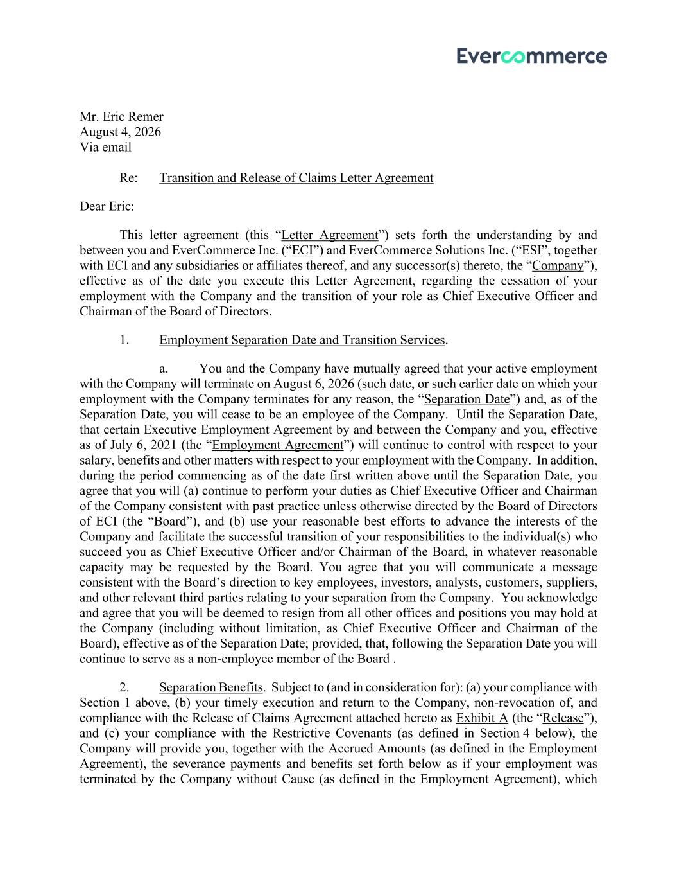

Mr. Eric Remer August 4, 2026 Via email Re: Transition and Release of Claims Letter Agreement Dear Eric: This letter agreement (this “Letter Agreement”) sets forth the understanding by and between you and EverCommerce Inc. (“ECI”) and EverCommerce Solutions Inc. (“ESI”, together with ECI and any subsidiaries or affiliates thereof, and any successor(s) thereto, the “Company”), effective as of the date you execute this Letter Agreement, regarding the cessation of your employment with the Company and the transition of your role as Chief Executive Officer and Chairman of the Board of Directors. 1. Employment Separation Date and Transition Services. a. You and the Company have mutually agreed that your active employment with the Company will terminate on August 6, 2026 (such date, or such earlier date on which your employment with the Company terminates for any reason, the “Separation Date”) and, as of the Separation Date, you will cease to be an employee of the Company. Until the Separation Date, that certain Executive Employment Agreement by and between the Company and you, effective as of July 6, 2021 (the “Employment Agreement”) will continue to control with respect to your salary, benefits and other matters with respect to your employment with the Company. In addition, during the period commencing as of the date first written above until the Separation Date, you agree that you will (a) continue to perform your duties as Chief Executive Officer and Chairman of the Company consistent with past practice unless otherwise directed by the Board of Directors of ECI (the “Board”), and (b) use your reasonable best efforts to advance the interests of the Company and facilitate the successful transition of your responsibilities to the individual(s) who succeed you as Chief Executive Officer and/or Chairman of the Board, in whatever reasonable capacity may be requested by the Board. You agree that you will communicate a message consistent with the Board’s direction to key employees, investors, analysts, customers, suppliers, and other relevant third parties relating to your separation from the Company. You acknowledge and agree that you will be deemed to resign from all other offices and positions you may hold at the Company (including without limitation, as Chief Executive Officer and Chairman of the Board), effective as of the Separation Date; provided, that, following the Separation Date you will continue to serve as a non-employee member of the Board . 2. Separation Benefits. Subject to (and in consideration for): (a) your compliance with Section 1 above, (b) your timely execution and return to the Company, non-revocation of, and compliance with the Release of Claims Agreement attached hereto as Exhibit A (the “Release”), and (c) your compliance with the Restrictive Covenants (as defined in Section 4 below), the Company will provide you, together with the Accrued Amounts (as defined in the Employment Agreement), the severance payments and benefits set forth below as if your employment was terminated by the Company without Cause (as defined in the Employment Agreement), which

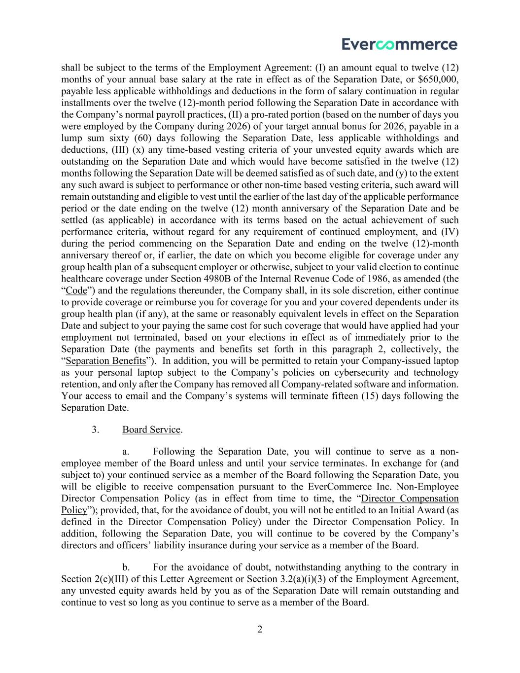
2 shall be subject to the terms of the Employment Agreement: (I) an amount equal to twelve (12) months of your annual base salary at the rate in effect as of the Separation Date, or $650,000, payable less applicable withholdings and deductions in the form of salary continuation in regular installments over the twelve (12)-month period following the Separation Date in accordance with the Company’s normal payroll practices, (II) a pro-rated portion (based on the number of days you were employed by the Company during 2026) of your target annual bonus for 2026, payable in a lump sum sixty (60) days following the Separation Date, less applicable withholdings and deductions, (III) (x) any time-based vesting criteria of your unvested equity awards which are outstanding on the Separation Date and which would have become satisfied in the twelve (12) months following the Separation Date will be deemed satisfied as of such date, and (y) to the extent any such award is subject to performance or other non-time based vesting criteria, such award will remain outstanding and eligible to vest until the earlier of the last day of the applicable performance period or the date ending on the twelve (12) month anniversary of the Separation Date and be settled (as applicable) in accordance with its terms based on the actual achievement of such performance criteria, without regard for any requirement of continued employment, and (IV) during the period commencing on the Separation Date and ending on the twelve (12)-month anniversary thereof or, if earlier, the date on which you become eligible for coverage under any group health plan of a subsequent employer or otherwise, subject to your valid election to continue healthcare coverage under Section 4980B of the Internal Revenue Code of 1986, as amended (the “Code”) and the regulations thereunder, the Company shall, in its sole discretion, either continue to provide coverage or reimburse you for coverage for you and your covered dependents under its group health plan (if any), at the same or reasonably equivalent levels in effect on the Separation Date and subject to your paying the same cost for such coverage that would have applied had your employment not terminated, based on your elections in effect as of immediately prior to the Separation Date (the payments and benefits set forth in this paragraph 2, collectively, the “Separation Benefits”). In addition, you will be permitted to retain your Company-issued laptop as your personal laptop subject to the Company’s policies on cybersecurity and technology retention, and only after the Company has removed all Company-related software and information. Your access to email and the Company’s systems will terminate fifteen (15) days following the Separation Date. 3. Board Service. a. Following the Separation Date, you will continue to serve as a non- employee member of the Board unless and until your service terminates. In exchange for (and subject to) your continued service as a member of the Board following the Separation Date, you will be eligible to receive compensation pursuant to the EverCommerce Inc. Non-Employee Director Compensation Policy (as in effect from time to time, the “Director Compensation Policy”); provided, that, for the avoidance of doubt, you will not be entitled to an Initial Award (as defined in the Director Compensation Policy) under the Director Compensation Policy. In addition, following the Separation Date, you will continue to be covered by the Company’s directors and officers’ liability insurance during your service as a member of the Board. b. For the avoidance of doubt, notwithstanding anything to the contrary in Section 2(c)(III) of this Letter Agreement or Section 3.2(a)(i)(3) of the Employment Agreement, any unvested equity awards held by you as of the Separation Date will remain outstanding and continue to vest so long as you continue to serve as a member of the Board.

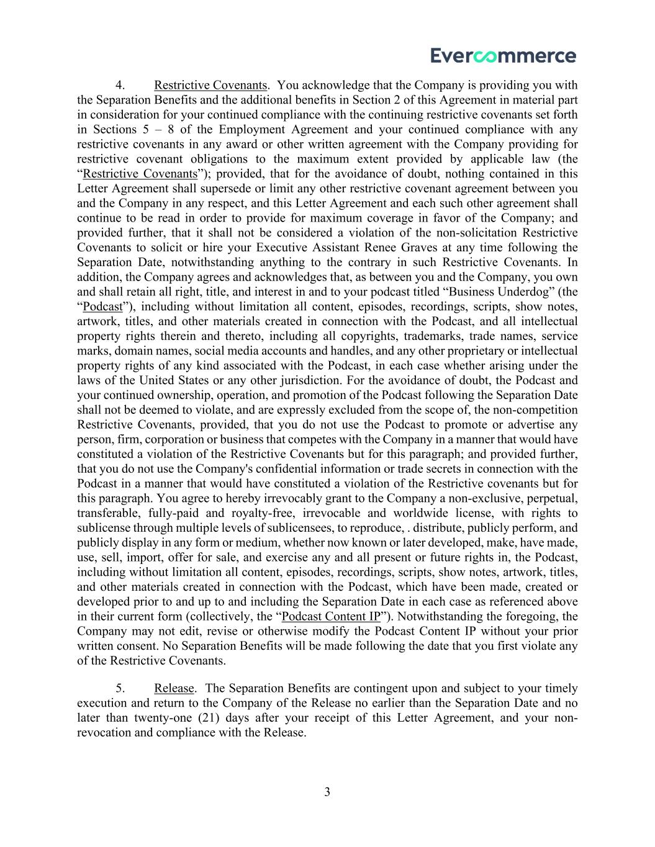
3 4. Restrictive Covenants. You acknowledge that the Company is providing you with the Separation Benefits and the additional benefits in Section 2 of this Agreement in material part in consideration for your continued compliance with the continuing restrictive covenants set forth in Sections 5 – 8 of the Employment Agreement and your continued compliance with any restrictive covenants in any award or other written agreement with the Company providing for restrictive covenant obligations to the maximum extent provided by applicable law (the “Restrictive Covenants”); provided, that for the avoidance of doubt, nothing contained in this Letter Agreement shall supersede or limit any other restrictive covenant agreement between you and the Company in any respect, and this Letter Agreement and each such other agreement shall continue to be read in order to provide for maximum coverage in favor of the Company; and provided further, that it shall not be considered a violation of the non-solicitation Restrictive Covenants to solicit or hire your Executive Assistant Renee Graves at any time following the Separation Date, notwithstanding anything to the contrary in such Restrictive Covenants. In addition, the Company agrees and acknowledges that, as between you and the Company, you own and shall retain all right, title, and interest in and to your podcast titled “Business Underdog” (the “Podcast”), including without limitation all content, episodes, recordings, scripts, show notes, artwork, titles, and other materials created in connection with the Podcast, and all intellectual property rights therein and thereto, including all copyrights, trademarks, trade names, service marks, domain names, social media accounts and handles, and any other proprietary or intellectual property rights of any kind associated with the Podcast, in each case whether arising under the laws of the United States or any other jurisdiction. For the avoidance of doubt, the Podcast and your continued ownership, operation, and promotion of the Podcast following the Separation Date shall not be deemed to violate, and are expressly excluded from the scope of, the non-competition Restrictive Covenants, provided, that you do not use the Podcast to promote or advertise any person, firm, corporation or business that competes with the Company in a manner that would have constituted a violation of the Restrictive Covenants but for this paragraph; and provided further, that you do not use the Company's confidential information or trade secrets in connection with the Podcast in a manner that would have constituted a violation of the Restrictive covenants but for this paragraph. You agree to hereby irrevocably grant to the Company a non-exclusive, perpetual, transferable, fully-paid and royalty-free, irrevocable and worldwide license, with rights to sublicense through multiple levels of sublicensees, to reproduce, . distribute, publicly perform, and publicly display in any form or medium, whether now known or later developed, make, have made, use, sell, import, offer for sale, and exercise any and all present or future rights in, the Podcast, including without limitation all content, episodes, recordings, scripts, show notes, artwork, titles, and other materials created in connection with the Podcast, which have been made, created or developed prior to and up to and including the Separation Date in each case as referenced above in their current form (collectively, the “Podcast Content IP”). Notwithstanding the foregoing, the Company may not edit, revise or otherwise modify the Podcast Content IP without your prior written consent. No Separation Benefits will be made following the date that you first violate any of the Restrictive Covenants. 5. Release. The Separation Benefits are contingent upon and subject to your timely execution and return to the Company of the Release no earlier than the Separation Date and no later than twenty-one (21) days after your receipt of this Letter Agreement, and your non- revocation and compliance with the Release.

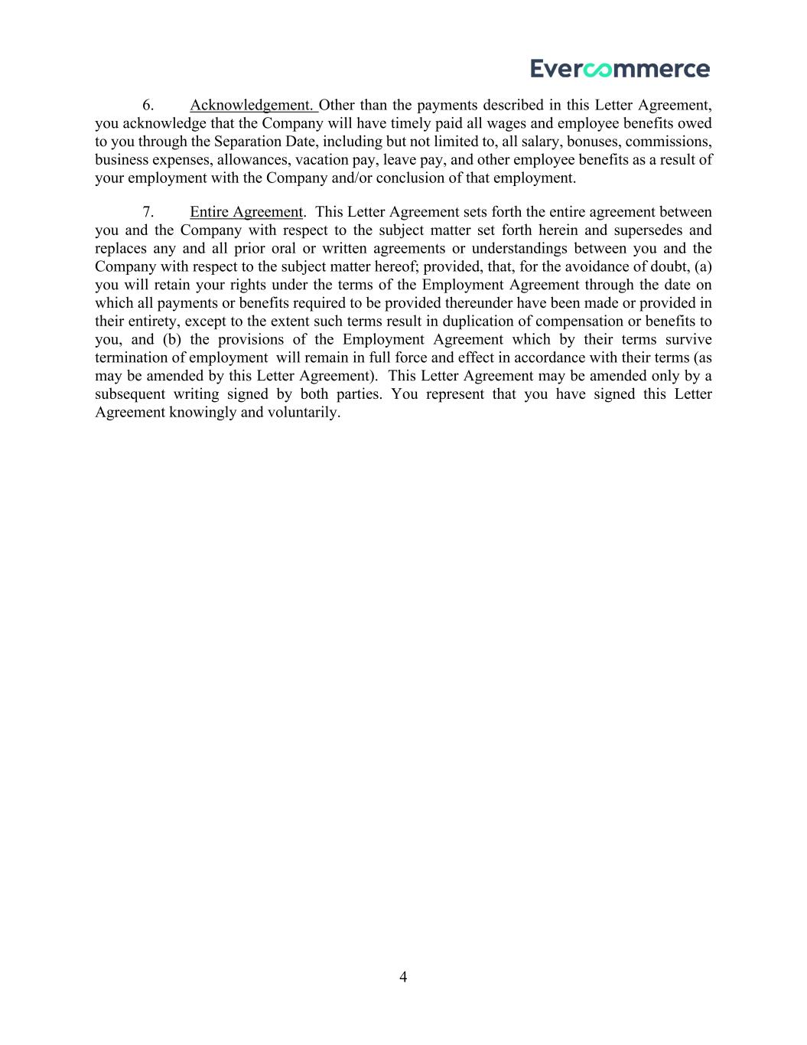
4 6. Acknowledgement. Other than the payments described in this Letter Agreement, you acknowledge that the Company will have timely paid all wages and employee benefits owed to you through the Separation Date, including but not limited to, all salary, bonuses, commissions, business expenses, allowances, vacation pay, leave pay, and other employee benefits as a result of your employment with the Company and/or conclusion of that employment. 7. Entire Agreement. This Letter Agreement sets forth the entire agreement between you and the Company with respect to the subject matter set forth herein and supersedes and replaces any and all prior oral or written agreements or understandings between you and the Company with respect to the subject matter hereof; provided, that, for the avoidance of doubt, (a) you will retain your rights under the terms of the Employment Agreement through the date on which all payments or benefits required to be provided thereunder have been made or provided in their entirety, except to the extent such terms result in duplication of compensation or benefits to you, and (b) the provisions of the Employment Agreement which by their terms survive termination of employment will remain in full force and effect in accordance with their terms (as may be amended by this Letter Agreement). This Letter Agreement may be amended only by a subsequent writing signed by both parties. You represent that you have signed this Letter Agreement knowingly and voluntarily.

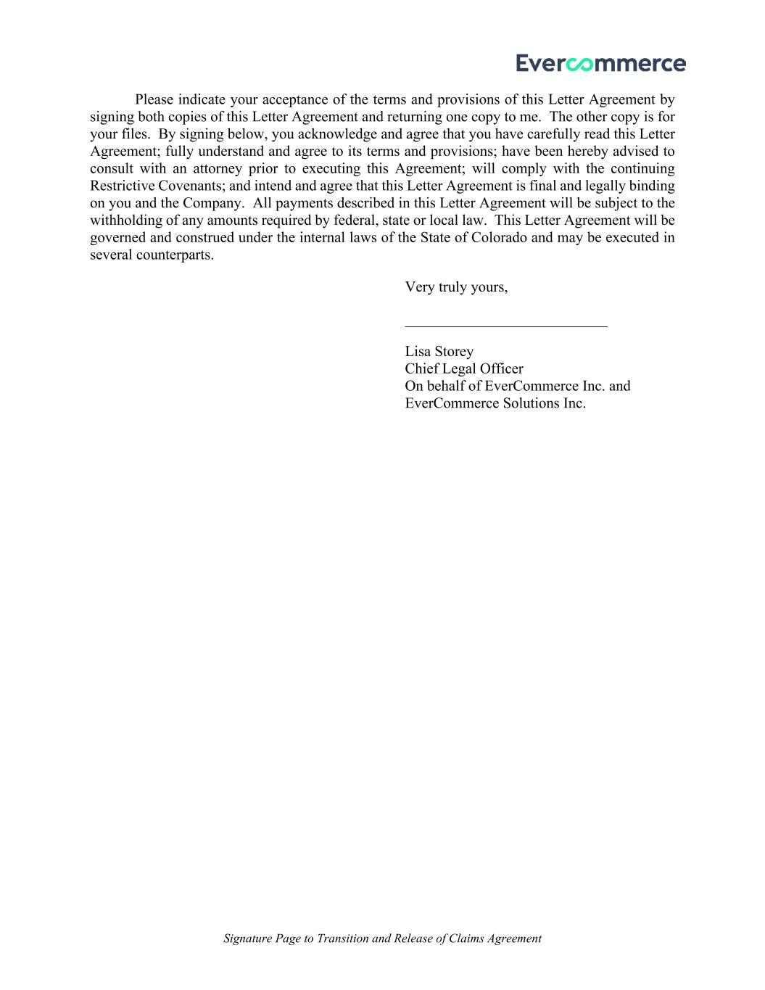
Signature Page to Transition and Release of Claims Agreement Please indicate your acceptance of the terms and provisions of this Letter Agreement by signing both copies of this Letter Agreement and returning one copy to me. The other copy is for your files. By signing below, you acknowledge and agree that you have carefully read this Letter Agreement; fully understand and agree to its terms and provisions; have been hereby advised to consult with an attorney prior to executing this Agreement; will comply with the continuing Restrictive Covenants; and intend and agree that this Letter Agreement is final and legally binding on you and the Company. All payments described in this Letter Agreement will be subject to the withholding of any amounts required by federal, state or local law. This Letter Agreement will be governed and construed under the internal laws of the State of Colorado and may be executed in several counterparts. Very truly yours, ___________________________ Lisa Storey Chief Legal Officer On behalf of EverCommerce Inc. and EverCommerce Solutions Inc.


Signature Page to Transition and Release of Claims Agreement I hereby agree to, acknowledge and accept the terms of the Letter Agreement: ______________________________ Eric Remer ______________________________ Date

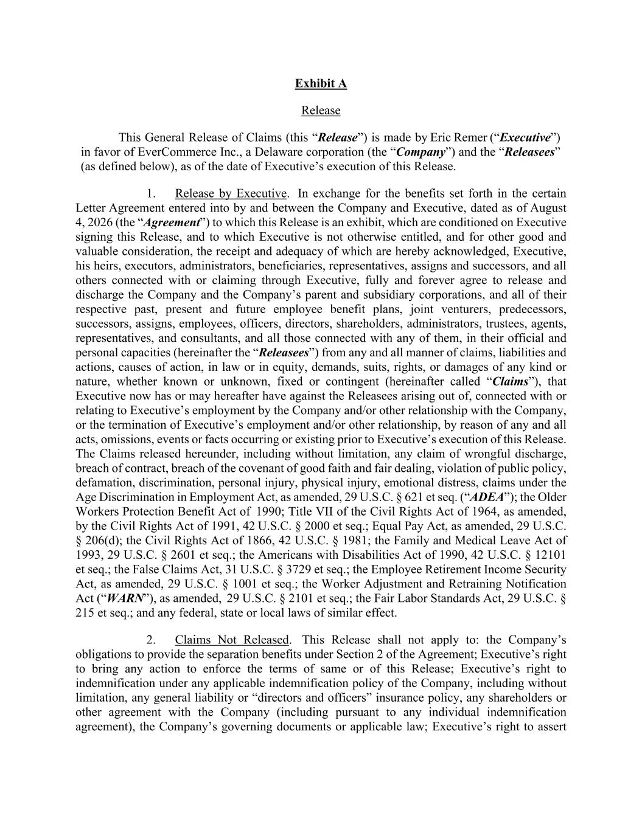
Exhibit A Release This General Release of Claims (this “Release”) is made by Eric Remer (“Executive”) in favor of EverCommerce Inc., a Delaware corporation (the “Company”) and the “Releasees” (as defined below), as of the date of Executive’s execution of this Release. 1. Release by Executive. In exchange for the benefits set forth in the certain Letter Agreement entered into by and between the Company and Executive, dated as of August 4, 2026 (the “Agreement”) to which this Release is an exhibit, which are conditioned on Executive signing this Release, and to which Executive is not otherwise entitled, and for other good and valuable consideration, the receipt and adequacy of which are hereby acknowledged, Executive, his heirs, executors, administrators, beneficiaries, representatives, assigns and successors, and all others connected with or claiming through Executive, fully and forever agree to release and discharge the Company and the Company’s parent and subsidiary corporations, and all of their respective past, present and future employee benefit plans, joint venturers, predecessors, successors, assigns, employees, officers, directors, shareholders, administrators, trustees, agents, representatives, and consultants, and all those connected with any of them, in their official and personal capacities (hereinafter the “Releasees”) from any and all manner of claims, liabilities and actions, causes of action, in law or in equity, demands, suits, rights, or damages of any kind or nature, whether known or unknown, fixed or contingent (hereinafter called “Claims”), that Executive now has or may hereafter have against the Releasees arising out of, connected with or relating to Executive’s employment by the Company and/or other relationship with the Company, or the termination of Executive’s employment and/or other relationship, by reason of any and all acts, omissions, events or facts occurring or existing prior to Executive’s execution of this Release. The Claims released hereunder, including without limitation, any claim of wrongful discharge, breach of contract, breach of the covenant of good faith and fair dealing, violation of public policy, defamation, discrimination, personal injury, physical injury, emotional distress, claims under the Age Discrimination in Employment Act, as amended, 29 U.S.C. § 621 et seq. (“ADEA”); the Older Workers Protection Benefit Act of 1990; Title VII of the Civil Rights Act of 1964, as amended, by the Civil Rights Act of 1991, 42 U.S.C. § 2000 et seq.; Equal Pay Act, as amended, 29 U.S.C. § 206(d); the Civil Rights Act of 1866, 42 U.S.C. § 1981; the Family and Medical Leave Act of 1993, 29 U.S.C. § 2601 et seq.; the Americans with Disabilities Act of 1990, 42 U.S.C. § 12101 et seq.; the False Claims Act, 31 U.S.C. § 3729 et seq.; the Employee Retirement Income Security Act, as amended, 29 U.S.C. § 1001 et seq.; the Worker Adjustment and Retraining Notification Act (“WARN”), as amended, 29 U.S.C. § 2101 et seq.; the Fair Labor Standards Act, 29 U.S.C. § 215 et seq.; and any federal, state or local laws of similar effect. 2. Claims Not Released. This Release shall not apply to: the Company’s obligations to provide the separation benefits under Section 2 of the Agreement; Executive’s right to bring any action to enforce the terms of same or of this Release; Executive’s right to indemnification under any applicable indemnification policy of the Company, including without limitation, any general liability or “directors and officers” insurance policy, any shareholders or other agreement with the Company (including pursuant to any individual indemnification agreement), the Company’s governing documents or applicable law; Executive’s right to assert

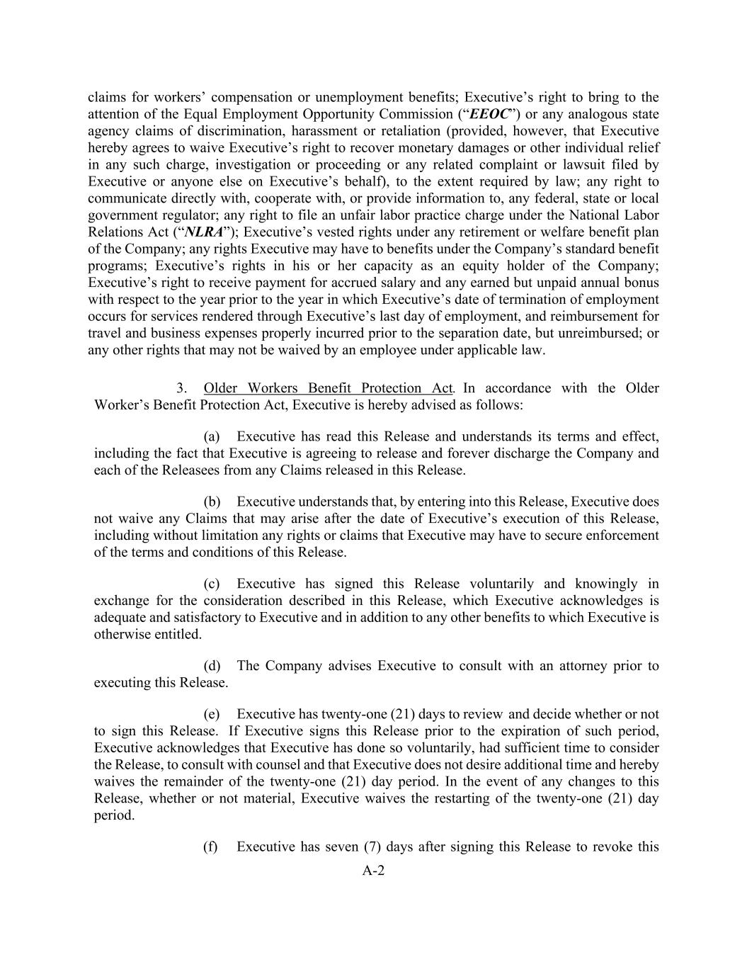
A-2 claims for workers’ compensation or unemployment benefits; Executive’s right to bring to the attention of the Equal Employment Opportunity Commission (“EEOC”) or any analogous state agency claims of discrimination, harassment or retaliation (provided, however, that Executive hereby agrees to waive Executive’s right to recover monetary damages or other individual relief in any such charge, investigation or proceeding or any related complaint or lawsuit filed by Executive or anyone else on Executive’s behalf), to the extent required by law; any right to communicate directly with, cooperate with, or provide information to, any federal, state or local government regulator; any right to file an unfair labor practice charge under the National Labor Relations Act (“NLRA”); Executive’s vested rights under any retirement or welfare benefit plan of the Company; any rights Executive may have to benefits under the Company’s standard benefit programs; Executive’s rights in his or her capacity as an equity holder of the Company; Executive’s right to receive payment for accrued salary and any earned but unpaid annual bonus with respect to the year prior to the year in which Executive’s date of termination of employment occurs for services rendered through Executive’s last day of employment, and reimbursement for travel and business expenses properly incurred prior to the separation date, but unreimbursed; or any other rights that may not be waived by an employee under applicable law. 3. Older Workers Benefit Protection Act. In accordance with the Older Worker’s Benefit Protection Act, Executive is hereby advised as follows: (a) Executive has read this Release and understands its terms and effect, including the fact that Executive is agreeing to release and forever discharge the Company and each of the Releasees from any Claims released in this Release. (b) Executive understands that, by entering into this Release, Executive does not waive any Claims that may arise after the date of Executive’s execution of this Release, including without limitation any rights or claims that Executive may have to secure enforcement of the terms and conditions of this Release. (c) Executive has signed this Release voluntarily and knowingly in exchange for the consideration described in this Release, which Executive acknowledges is adequate and satisfactory to Executive and in addition to any other benefits to which Executive is otherwise entitled. (d) The Company advises Executive to consult with an attorney prior to executing this Release. (e) Executive has twenty-one (21) days to review and decide whether or not to sign this Release. If Executive signs this Release prior to the expiration of such period, Executive acknowledges that Executive has done so voluntarily, had sufficient time to consider the Release, to consult with counsel and that Executive does not desire additional time and hereby waives the remainder of the twenty-one (21) day period. In the event of any changes to this Release, whether or not material, Executive waives the restarting of the twenty-one (21) day period. (f) Executive has seven (7) days after signing this Release to revoke this

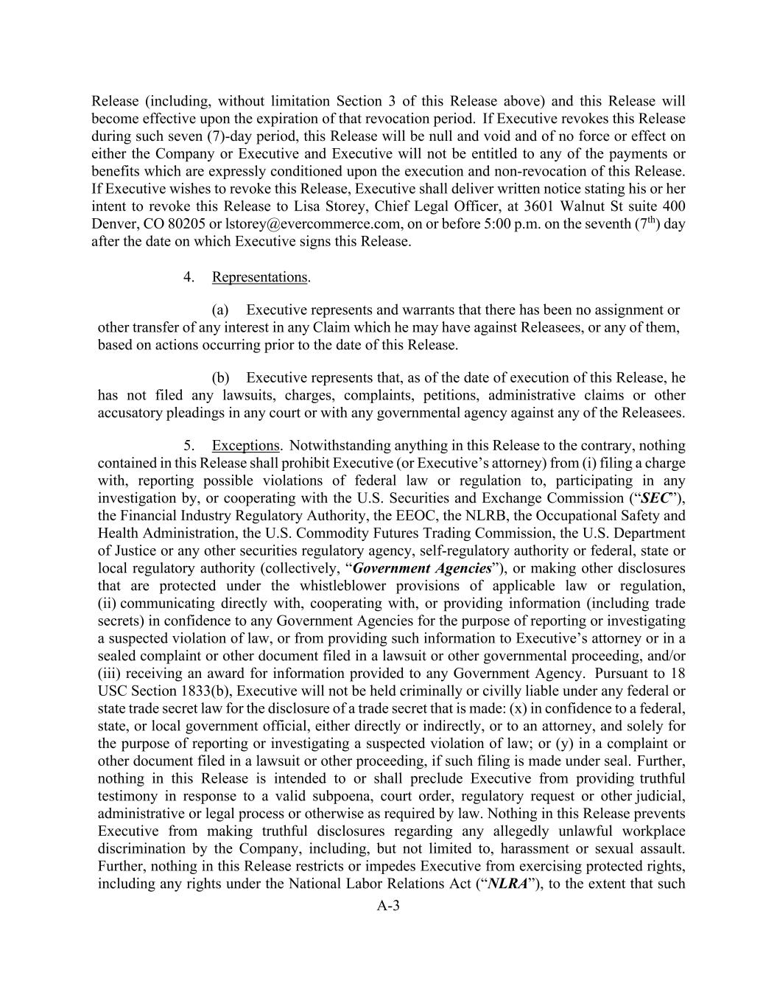
A-3 Release (including, without limitation Section 3 of this Release above) and this Release will become effective upon the expiration of that revocation period. If Executive revokes this Release during such seven (7)-day period, this Release will be null and void and of no force or effect on either the Company or Executive and Executive will not be entitled to any of the payments or benefits which are expressly conditioned upon the execution and non-revocation of this Release. If Executive wishes to revoke this Release, Executive shall deliver written notice stating his or her intent to revoke this Release to Lisa Storey, Chief Legal Officer, at 3601 Walnut St suite 400 Denver, CO 80205 or lstorey@evercommerce.com, on or before 5:00 p.m. on the seventh (7th) day after the date on which Executive signs this Release. 4. Representations. (a) Executive represents and warrants that there has been no assignment or other transfer of any interest in any Claim which he may have against Releasees, or any of them, based on actions occurring prior to the date of this Release. (b) Executive represents that, as of the date of execution of this Release, he has not filed any lawsuits, charges, complaints, petitions, administrative claims or other accusatory pleadings in any court or with any governmental agency against any of the Releasees. 5. Exceptions. Notwithstanding anything in this Release to the contrary, nothing contained in this Release shall prohibit Executive (or Executive’s attorney) from (i) filing a charge with, reporting possible violations of federal law or regulation to, participating in any investigation by, or cooperating with the U.S. Securities and Exchange Commission (“SEC”), the Financial Industry Regulatory Authority, the EEOC, the NLRB, the Occupational Safety and Health Administration, the U.S. Commodity Futures Trading Commission, the U.S. Department of Justice or any other securities regulatory agency, self-regulatory authority or federal, state or local regulatory authority (collectively, “Government Agencies”), or making other disclosures that are protected under the whistleblower provisions of applicable law or regulation, (ii) communicating directly with, cooperating with, or providing information (including trade secrets) in confidence to any Government Agencies for the purpose of reporting or investigating a suspected violation of law, or from providing such information to Executive’s attorney or in a sealed complaint or other document filed in a lawsuit or other governmental proceeding, and/or (iii) receiving an award for information provided to any Government Agency. Pursuant to 18 USC Section 1833(b), Executive will not be held criminally or civilly liable under any federal or state trade secret law for the disclosure of a trade secret that is made: (x) in confidence to a federal, state, or local government official, either directly or indirectly, or to an attorney, and solely for the purpose of reporting or investigating a suspected violation of law; or (y) in a complaint or other document filed in a lawsuit or other proceeding, if such filing is made under seal. Further, nothing in this Release is intended to or shall preclude Executive from providing truthful testimony in response to a valid subpoena, court order, regulatory request or other judicial, administrative or legal process or otherwise as required by law. Nothing in this Release prevents Executive from making truthful disclosures regarding any allegedly unlawful workplace discrimination by the Company, including, but not limited to, harassment or sexual assault. Further, nothing in this Release restricts or impedes Executive from exercising protected rights, including any rights under the National Labor Relations Act (“NLRA”), to the extent that such

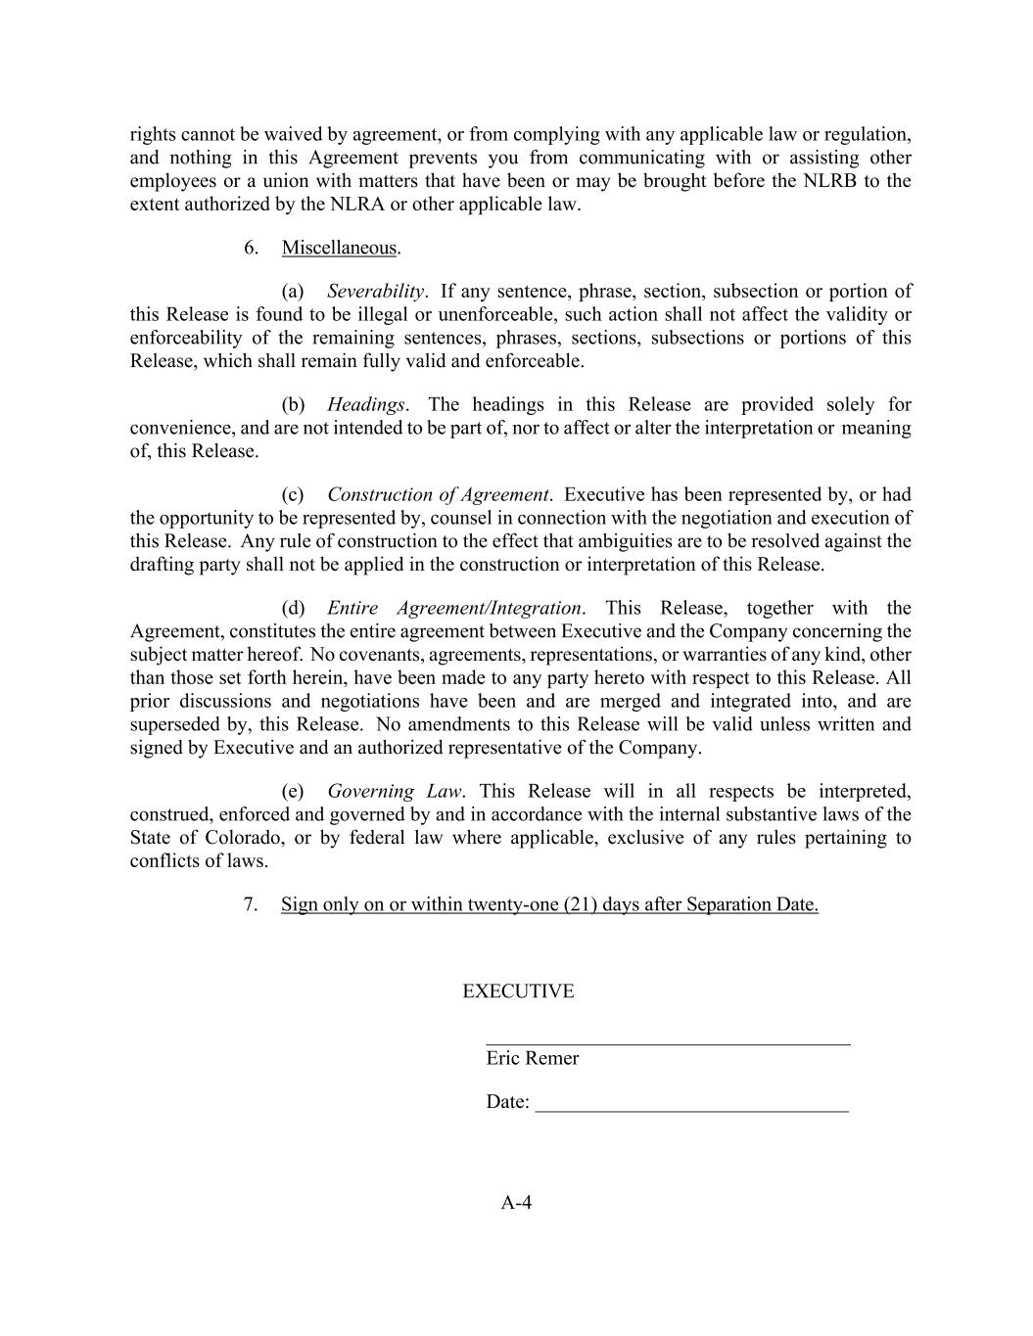
A-4 rights cannot be waived by agreement, or from complying with any applicable law or regulation, and nothing in this Agreement prevents you from communicating with or assisting other employees or a union with matters that have been or may be brought before the NLRB to the extent authorized by the NLRA or other applicable law. 6. Miscellaneous. (a) Severability. If any sentence, phrase, section, subsection or portion of this Release is found to be illegal or unenforceable, such action shall not affect the validity or enforceability of the remaining sentences, phrases, sections, subsections or portions of this Release, which shall remain fully valid and enforceable. (b) Headings. The headings in this Release are provided solely for convenience, and are not intended to be part of, nor to affect or alter the interpretation or meaning of, this Release. (c) Construction of Agreement. Executive has been represented by, or had the opportunity to be represented by, counsel in connection with the negotiation and execution of this Release. Any rule of construction to the effect that ambiguities are to be resolved against the drafting party shall not be applied in the construction or interpretation of this Release. (d) Entire Agreement/Integration. This Release, together with the Agreement, constitutes the entire agreement between Executive and the Company concerning the subject matter hereof. No covenants, agreements, representations, or warranties of any kind, other than those set forth herein, have been made to any party hereto with respect to this Release. All prior discussions and negotiations have been and are merged and integrated into, and are superseded by, this Release. No amendments to this Release will be valid unless written and signed by Executive and an authorized representative of the Company. (e) Governing Law. This Release will in all respects be interpreted, construed, enforced and governed by and in accordance with the internal substantive laws of the State of Colorado, or by federal law where applicable, exclusive of any rules pertaining to conflicts of laws. 7. Sign only on or within twenty-one (21) days after Separation Date. EXECUTIVE ____________________________________ Eric Remer Date: _______________________________

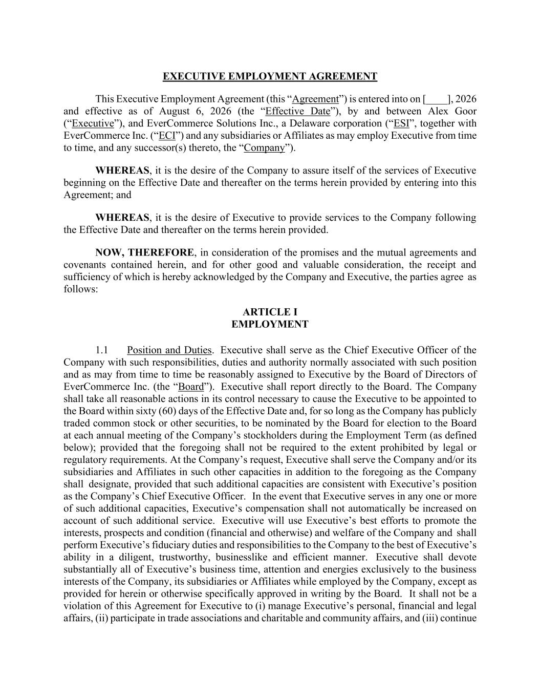
EXECUTIVE EMPLOYMENT AGREEMENT This Executive Employment Agreement (this “Agreement”) is entered into on [____], 2026 and effective as of August 6, 2026 (the “Effective Date”), by and between Alex Goor (“Executive”), and EverCommerce Solutions Inc., a Delaware corporation (“ESI”, together with EverCommerce Inc. (“ECI”) and any subsidiaries or Affiliates as may employ Executive from time to time, and any successor(s) thereto, the “Company”). WHEREAS, it is the desire of the Company to assure itself of the services of Executive beginning on the Effective Date and thereafter on the terms herein provided by entering into this Agreement; and WHEREAS, it is the desire of Executive to provide services to the Company following the Effective Date and thereafter on the terms herein provided. NOW, THEREFORE, in consideration of the promises and the mutual agreements and covenants contained herein, and for other good and valuable consideration, the receipt and sufficiency of which is hereby acknowledged by the Company and Executive, the parties agree as follows: ARTICLE I EMPLOYMENT 1.1 Position and Duties. Executive shall serve as the Chief Executive Officer of the Company with such responsibilities, duties and authority normally associated with such position and as may from time to time be reasonably assigned to Executive by the Board of Directors of EverCommerce Inc. (the “Board”). Executive shall report directly to the Board. The Company shall take all reasonable actions in its control necessary to cause the Executive to be appointed to the Board within sixty (60) days of the Effective Date and, for so long as the Company has publicly traded common stock or other securities, to be nominated by the Board for election to the Board at each annual meeting of the Company’s stockholders during the Employment Term (as defined below); provided that the foregoing shall not be required to the extent prohibited by legal or regulatory requirements. At the Company’s request, Executive shall serve the Company and/or its subsidiaries and Affiliates in such other capacities in addition to the foregoing as the Company shall designate, provided that such additional capacities are consistent with Executive’s position as the Company’s Chief Executive Officer. In the event that Executive serves in any one or more of such additional capacities, Executive’s compensation shall not automatically be increased on account of such additional service. Executive will use Executive’s best efforts to promote the interests, prospects and condition (financial and otherwise) and welfare of the Company and shall perform Executive’s fiduciary duties and responsibilities to the Company to the best of Executive’s ability in a diligent, trustworthy, businesslike and efficient manner. Executive shall devote substantially all of Executive’s business time, attention and energies exclusively to the business interests of the Company, its subsidiaries or Affiliates while employed by the Company, except as provided for herein or otherwise specifically approved in writing by the Board. It shall not be a violation of this Agreement for Executive to (i) manage Executive’s personal, financial and legal affairs, (ii) participate in trade associations and charitable and community affairs, and (iii) continue

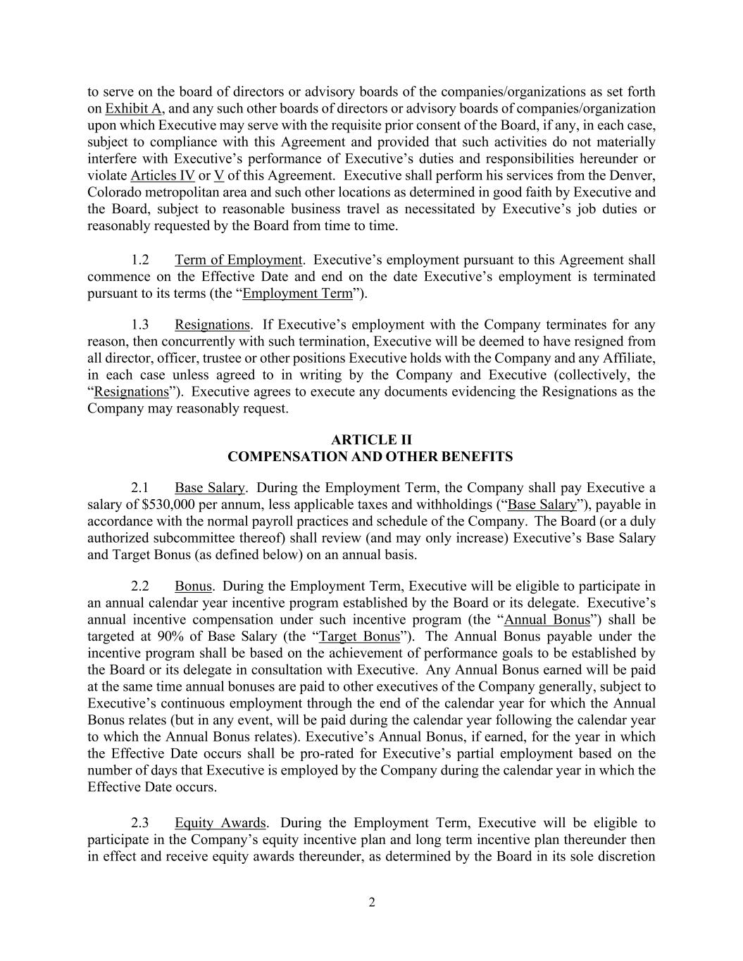
2 to serve on the board of directors or advisory boards of the companies/organizations as set forth on Exhibit A, and any such other boards of directors or advisory boards of companies/organization upon which Executive may serve with the requisite prior consent of the Board, if any, in each case, subject to compliance with this Agreement and provided that such activities do not materially interfere with Executive’s performance of Executive’s duties and responsibilities hereunder or violate Articles IV or V of this Agreement. Executive shall perform his services from the Denver, Colorado metropolitan area and such other locations as determined in good faith by Executive and the Board, subject to reasonable business travel as necessitated by Executive’s job duties or reasonably requested by the Board from time to time. 1.2 Term of Employment. Executive’s employment pursuant to this Agreement shall commence on the Effective Date and end on the date Executive’s employment is terminated pursuant to its terms (the “Employment Term”). 1.3 Resignations. If Executive’s employment with the Company terminates for any reason, then concurrently with such termination, Executive will be deemed to have resigned from all director, officer, trustee or other positions Executive holds with the Company and any Affiliate, in each case unless agreed to in writing by the Company and Executive (collectively, the “Resignations”). Executive agrees to execute any documents evidencing the Resignations as the Company may reasonably request. ARTICLE II COMPENSATION AND OTHER BENEFITS 2.1 Base Salary. During the Employment Term, the Company shall pay Executive a salary of $530,000 per annum, less applicable taxes and withholdings (“Base Salary”), payable in accordance with the normal payroll practices and schedule of the Company. The Board (or a duly authorized subcommittee thereof) shall review (and may only increase) Executive’s Base Salary and Target Bonus (as defined below) on an annual basis. 2.2 Bonus. During the Employment Term, Executive will be eligible to participate in an annual calendar year incentive program established by the Board or its delegate. Executive’s annual incentive compensation under such incentive program (the “Annual Bonus”) shall be targeted at 90% of Base Salary (the “Target Bonus”). The Annual Bonus payable under the incentive program shall be based on the achievement of performance goals to be established by the Board or its delegate in consultation with Executive. Any Annual Bonus earned will be paid at the same time annual bonuses are paid to other executives of the Company generally, subject to Executive’s continuous employment through the end of the calendar year for which the Annual Bonus relates (but in any event, will be paid during the calendar year following the calendar year to which the Annual Bonus relates). Executive’s Annual Bonus, if earned, for the year in which the Effective Date occurs shall be pro-rated for Executive’s partial employment based on the number of days that Executive is employed by the Company during the calendar year in which the Effective Date occurs. 2.3 Equity Awards. During the Employment Term, Executive will be eligible to participate in the Company’s equity incentive plan and long term incentive plan thereunder then in effect and receive equity awards thereunder, as determined by the Board in its sole discretion

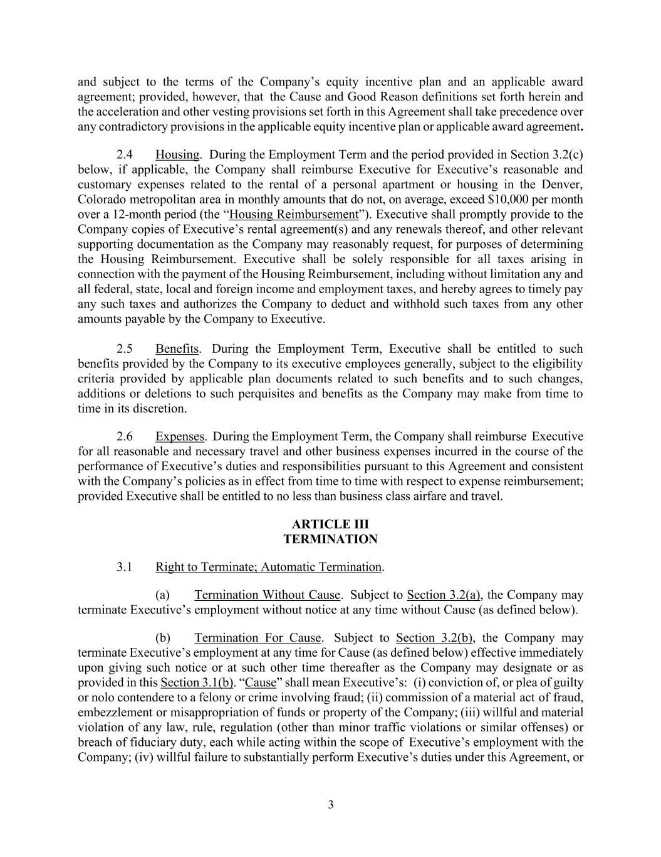
3 and subject to the terms of the Company’s equity incentive plan and an applicable award agreement; provided, however, that the Cause and Good Reason definitions set forth herein and the acceleration and other vesting provisions set forth in this Agreement shall take precedence over any contradictory provisions in the applicable equity incentive plan or applicable award agreement. 2.4 Housing. During the Employment Term and the period provided in Section 3.2(c) below, if applicable, the Company shall reimburse Executive for Executive’s reasonable and customary expenses related to the rental of a personal apartment or housing in the Denver, Colorado metropolitan area in monthly amounts that do not, on average, exceed $10,000 per month over a 12-month period (the “Housing Reimbursement”). Executive shall promptly provide to the Company copies of Executive’s rental agreement(s) and any renewals thereof, and other relevant supporting documentation as the Company may reasonably request, for purposes of determining the Housing Reimbursement. Executive shall be solely responsible for all taxes arising in connection with the payment of the Housing Reimbursement, including without limitation any and all federal, state, local and foreign income and employment taxes, and hereby agrees to timely pay any such taxes and authorizes the Company to deduct and withhold such taxes from any other amounts payable by the Company to Executive. 2.5 Benefits. During the Employment Term, Executive shall be entitled to such benefits provided by the Company to its executive employees generally, subject to the eligibility criteria provided by applicable plan documents related to such benefits and to such changes, additions or deletions to such perquisites and benefits as the Company may make from time to time in its discretion. 2.6 Expenses. During the Employment Term, the Company shall reimburse Executive for all reasonable and necessary travel and other business expenses incurred in the course of the performance of Executive’s duties and responsibilities pursuant to this Agreement and consistent with the Company’s policies as in effect from time to time with respect to expense reimbursement; provided Executive shall be entitled to no less than business class airfare and travel. ARTICLE III TERMINATION 3.1 Right to Terminate; Automatic Termination. (a) Termination Without Cause. Subject to Section 3.2(a), the Company may terminate Executive’s employment without notice at any time without Cause (as defined below). (b) Termination For Cause. Subject to Section 3.2(b), the Company may terminate Executive’s employment at any time for Cause (as defined below) effective immediately upon giving such notice or at such other time thereafter as the Company may designate or as provided in this Section 3.1(b). “Cause” shall mean Executive’s: (i) conviction of, or plea of guilty or nolo contendere to a felony or crime involving fraud; (ii) commission of a material act of fraud, embezzlement or misappropriation of funds or property of the Company; (iii) willful and material violation of any law, rule, regulation (other than minor traffic violations or similar offenses) or breach of fiduciary duty, each while acting within the scope of Executive’s employment with the Company; (iv) willful failure to substantially perform Executive’s duties under this Agreement, or

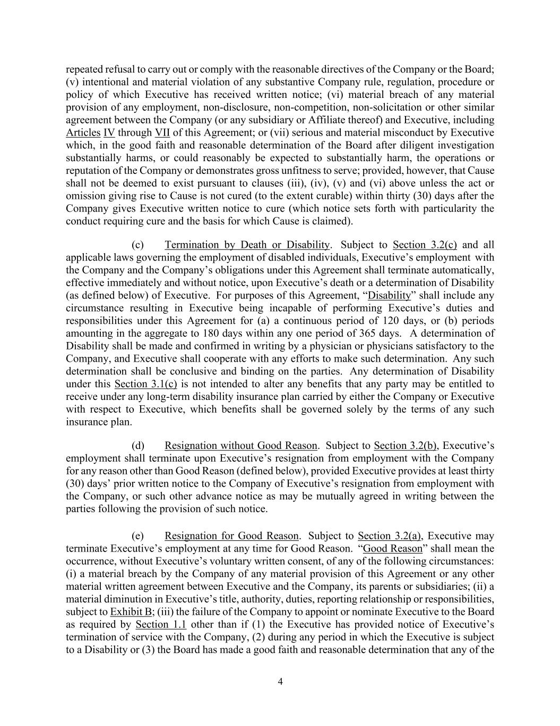
4 repeated refusal to carry out or comply with the reasonable directives of the Company or the Board; (v) intentional and material violation of any substantive Company rule, regulation, procedure or policy of which Executive has received written notice; (vi) material breach of any material provision of any employment, non-disclosure, non-competition, non-solicitation or other similar agreement between the Company (or any subsidiary or Affiliate thereof) and Executive, including Articles IV through VII of this Agreement; or (vii) serious and material misconduct by Executive which, in the good faith and reasonable determination of the Board after diligent investigation substantially harms, or could reasonably be expected to substantially harm, the operations or reputation of the Company or demonstrates gross unfitness to serve; provided, however, that Cause shall not be deemed to exist pursuant to clauses (iii), (iv), (v) and (vi) above unless the act or omission giving rise to Cause is not cured (to the extent curable) within thirty (30) days after the Company gives Executive written notice to cure (which notice sets forth with particularity the conduct requiring cure and the basis for which Cause is claimed). (c) Termination by Death or Disability. Subject to Section 3.2(c) and all applicable laws governing the employment of disabled individuals, Executive’s employment with the Company and the Company’s obligations under this Agreement shall terminate automatically, effective immediately and without notice, upon Executive’s death or a determination of Disability (as defined below) of Executive. For purposes of this Agreement, “Disability” shall include any circumstance resulting in Executive being incapable of performing Executive’s duties and responsibilities under this Agreement for (a) a continuous period of 120 days, or (b) periods amounting in the aggregate to 180 days within any one period of 365 days. A determination of Disability shall be made and confirmed in writing by a physician or physicians satisfactory to the Company, and Executive shall cooperate with any efforts to make such determination. Any such determination shall be conclusive and binding on the parties. Any determination of Disability under this Section 3.1(c) is not intended to alter any benefits that any party may be entitled to receive under any long-term disability insurance plan carried by either the Company or Executive with respect to Executive, which benefits shall be governed solely by the terms of any such insurance plan. (d) Resignation without Good Reason. Subject to Section 3.2(b), Executive’s employment shall terminate upon Executive’s resignation from employment with the Company for any reason other than Good Reason (defined below), provided Executive provides at least thirty (30) days’ prior written notice to the Company of Executive’s resignation from employment with the Company, or such other advance notice as may be mutually agreed in writing between the parties following the provision of such notice. (e) Resignation for Good Reason. Subject to Section 3.2(a), Executive may terminate Executive’s employment at any time for Good Reason. “Good Reason” shall mean the occurrence, without Executive’s voluntary written consent, of any of the following circumstances: (i) a material breach by the Company of any material provision of this Agreement or any other material written agreement between Executive and the Company, its parents or subsidiaries; (ii) a material diminution in Executive’s title, authority, duties, reporting relationship or responsibilities, subject to Exhibit B; (iii) the failure of the Company to appoint or nominate Executive to the Board as required by Section 1.1 other than if (1) the Executive has provided notice of Executive’s termination of service with the Company, (2) during any period in which the Executive is subject to a Disability or (3) the Board has made a good faith and reasonable determination that any of the

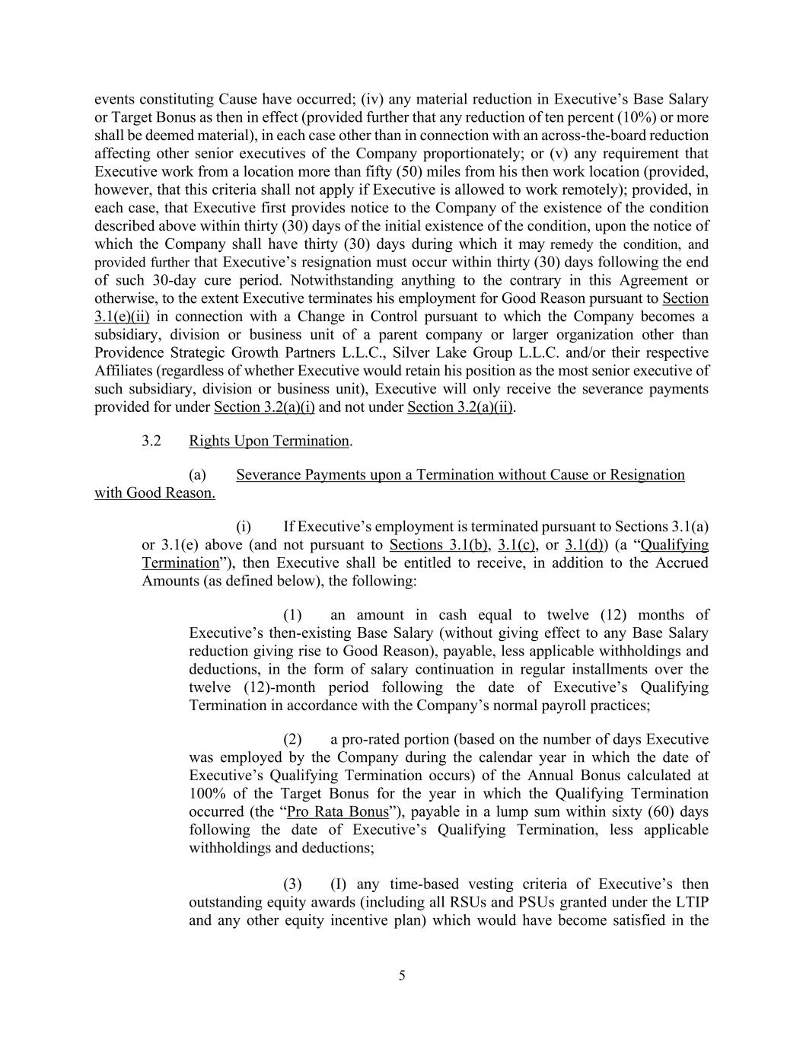
5 events constituting Cause have occurred; (iv) any material reduction in Executive’s Base Salary or Target Bonus as then in effect (provided further that any reduction of ten percent (10%) or more shall be deemed material), in each case other than in connection with an across-the-board reduction affecting other senior executives of the Company proportionately; or (v) any requirement that Executive work from a location more than fifty (50) miles from his then work location (provided, however, that this criteria shall not apply if Executive is allowed to work remotely); provided, in each case, that Executive first provides notice to the Company of the existence of the condition described above within thirty (30) days of the initial existence of the condition, upon the notice of which the Company shall have thirty (30) days during which it may remedy the condition, and provided further that Executive’s resignation must occur within thirty (30) days following the end of such 30-day cure period. Notwithstanding anything to the contrary in this Agreement or otherwise, to the extent Executive terminates his employment for Good Reason pursuant to Section 3.1(e)(ii) in connection with a Change in Control pursuant to which the Company becomes a subsidiary, division or business unit of a parent company or larger organization other than Providence Strategic Growth Partners L.L.C., Silver Lake Group L.L.C. and/or their respective Affiliates (regardless of whether Executive would retain his position as the most senior executive of such subsidiary, division or business unit), Executive will only receive the severance payments provided for under Section 3.2(a)(i) and not under Section 3.2(a)(ii). 3.2 Rights Upon Termination. (a) Severance Payments upon a Termination without Cause or Resignation with Good Reason. (i) If Executive’s employment is terminated pursuant to Sections 3.1(a) or 3.1(e) above (and not pursuant to Sections 3.1(b), 3.1(c), or 3.1(d)) (a “Qualifying Termination”), then Executive shall be entitled to receive, in addition to the Accrued Amounts (as defined below), the following: (1) an amount in cash equal to twelve (12) months of Executive’s then-existing Base Salary (without giving effect to any Base Salary reduction giving rise to Good Reason), payable, less applicable withholdings and deductions, in the form of salary continuation in regular installments over the twelve (12)-month period following the date of Executive’s Qualifying Termination in accordance with the Company’s normal payroll practices; (2) a pro-rated portion (based on the number of days Executive was employed by the Company during the calendar year in which the date of Executive’s Qualifying Termination occurs) of the Annual Bonus calculated at 100% of the Target Bonus for the year in which the Qualifying Termination occurred (the “Pro Rata Bonus”), payable in a lump sum within sixty (60) days following the date of Executive’s Qualifying Termination, less applicable withholdings and deductions; (3) (I) any time-based vesting criteria of Executive’s then outstanding equity awards (including all RSUs and PSUs granted under the LTIP and any other equity incentive plan) which would have become satisfied in the

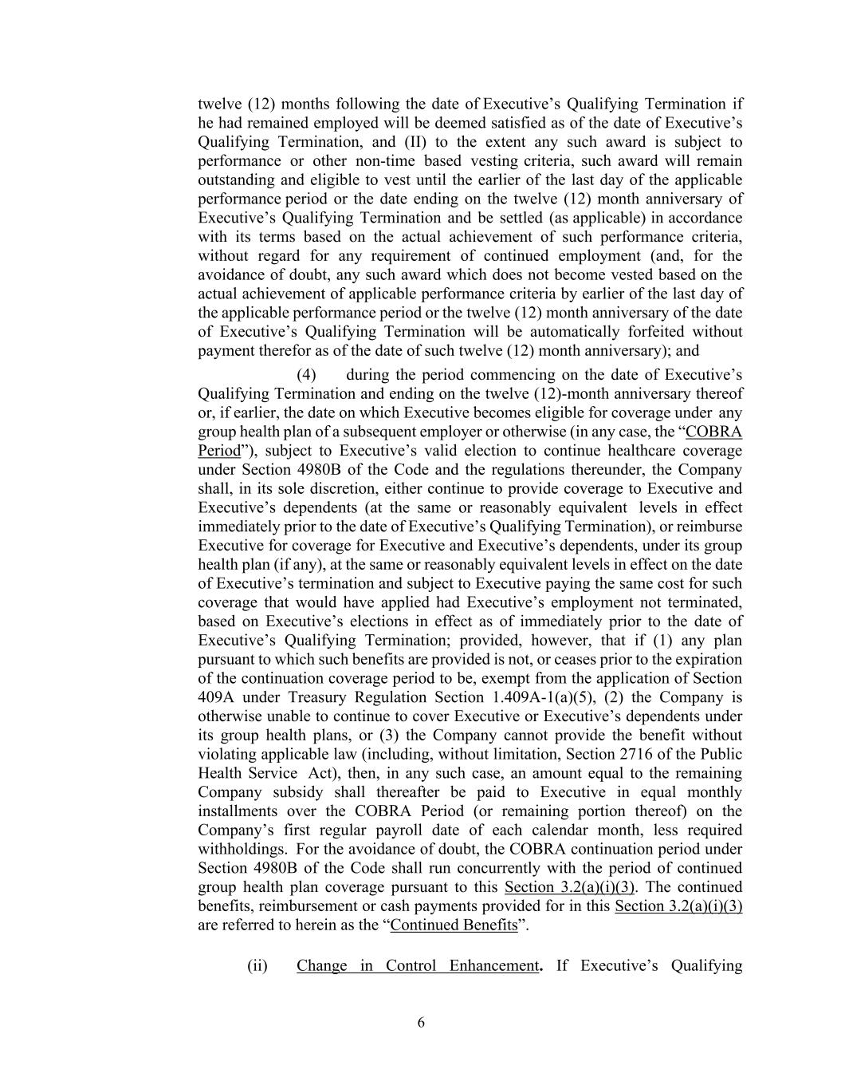
6 twelve (12) months following the date of Executive’s Qualifying Termination if he had remained employed will be deemed satisfied as of the date of Executive’s Qualifying Termination, and (II) to the extent any such award is subject to performance or other non-time based vesting criteria, such award will remain outstanding and eligible to vest until the earlier of the last day of the applicable performance period or the date ending on the twelve (12) month anniversary of Executive’s Qualifying Termination and be settled (as applicable) in accordance with its terms based on the actual achievement of such performance criteria, without regard for any requirement of continued employment (and, for the avoidance of doubt, any such award which does not become vested based on the actual achievement of applicable performance criteria by earlier of the last day of the applicable performance period or the twelve (12) month anniversary of the date of Executive’s Qualifying Termination will be automatically forfeited without payment therefor as of the date of such twelve (12) month anniversary); and (4) during the period commencing on the date of Executive’s Qualifying Termination and ending on the twelve (12)-month anniversary thereof or, if earlier, the date on which Executive becomes eligible for coverage under any group health plan of a subsequent employer or otherwise (in any case, the “COBRA Period”), subject to Executive’s valid election to continue healthcare coverage under Section 4980B of the Code and the regulations thereunder, the Company shall, in its sole discretion, either continue to provide coverage to Executive and Executive’s dependents (at the same or reasonably equivalent levels in effect immediately prior to the date of Executive’s Qualifying Termination), or reimburse Executive for coverage for Executive and Executive’s dependents, under its group health plan (if any), at the same or reasonably equivalent levels in effect on the date of Executive’s termination and subject to Executive paying the same cost for such coverage that would have applied had Executive’s employment not terminated, based on Executive’s elections in effect as of immediately prior to the date of Executive’s Qualifying Termination; provided, however, that if (1) any plan pursuant to which such benefits are provided is not, or ceases prior to the expiration of the continuation coverage period to be, exempt from the application of Section 409A under Treasury Regulation Section 1.409A-1(a)(5), (2) the Company is otherwise unable to continue to cover Executive or Executive’s dependents under its group health plans, or (3) the Company cannot provide the benefit without violating applicable law (including, without limitation, Section 2716 of the Public Health Service Act), then, in any such case, an amount equal to the remaining Company subsidy shall thereafter be paid to Executive in equal monthly installments over the COBRA Period (or remaining portion thereof) on the Company’s first regular payroll date of each calendar month, less required withholdings. For the avoidance of doubt, the COBRA continuation period under Section 4980B of the Code shall run concurrently with the period of continued group health plan coverage pursuant to this Section 3.2(a)(i)(3). The continued benefits, reimbursement or cash payments provided for in this Section 3.2(a)(i)(3) are referred to herein as the “Continued Benefits”. (ii) Change in Control Enhancement. If Executive’s Qualifying

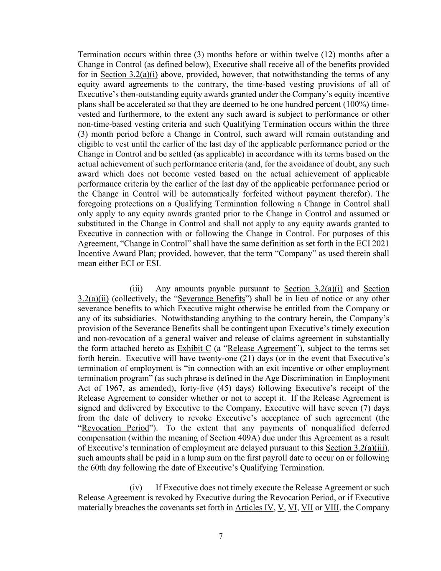
7 Termination occurs within three (3) months before or within twelve (12) months after a Change in Control (as defined below), Executive shall receive all of the benefits provided for in Section 3.2(a)(i) above, provided, however, that notwithstanding the terms of any equity award agreements to the contrary, the time-based vesting provisions of all of Executive’s then-outstanding equity awards granted under the Company’s equity incentive plans shall be accelerated so that they are deemed to be one hundred percent (100%) time- vested and furthermore, to the extent any such award is subject to performance or other non-time-based vesting criteria and such Qualifying Termination occurs within the three (3) month period before a Change in Control, such award will remain outstanding and eligible to vest until the earlier of the last day of the applicable performance period or the Change in Control and be settled (as applicable) in accordance with its terms based on the actual achievement of such performance criteria (and, for the avoidance of doubt, any such award which does not become vested based on the actual achievement of applicable performance criteria by the earlier of the last day of the applicable performance period or the Change in Control will be automatically forfeited without payment therefor). The foregoing protections on a Qualifying Termination following a Change in Control shall only apply to any equity awards granted prior to the Change in Control and assumed or substituted in the Change in Control and shall not apply to any equity awards granted to Executive in connection with or following the Change in Control. For purposes of this Agreement, “Change in Control” shall have the same definition as set forth in the ECI 2021 Incentive Award Plan; provided, however, that the term “Company” as used therein shall mean either ECI or ESI. (iii) Any amounts payable pursuant to Section 3.2(a)(i) and Section 3.2(a)(ii) (collectively, the “Severance Benefits”) shall be in lieu of notice or any other severance benefits to which Executive might otherwise be entitled from the Company or any of its subsidiaries. Notwithstanding anything to the contrary herein, the Company’s provision of the Severance Benefits shall be contingent upon Executive’s timely execution and non-revocation of a general waiver and release of claims agreement in substantially the form attached hereto as Exhibit C (a “Release Agreement”), subject to the terms set forth herein. Executive will have twenty-one (21) days (or in the event that Executive’s termination of employment is “in connection with an exit incentive or other employment termination program” (as such phrase is defined in the Age Discrimination in Employment Act of 1967, as amended), forty-five (45) days) following Executive’s receipt of the Release Agreement to consider whether or not to accept it. If the Release Agreement is signed and delivered by Executive to the Company, Executive will have seven (7) days from the date of delivery to revoke Executive’s acceptance of such agreement (the “Revocation Period”). To the extent that any payments of nonqualified deferred compensation (within the meaning of Section 409A) due under this Agreement as a result of Executive’s termination of employment are delayed pursuant to this Section 3.2(a)(iii), such amounts shall be paid in a lump sum on the first payroll date to occur on or following the 60th day following the date of Executive’s Qualifying Termination. (iv) If Executive does not timely execute the Release Agreement or such Release Agreement is revoked by Executive during the Revocation Period, or if Executive materially breaches the covenants set forth in Articles IV, V, VI, VII or VIII, the Company

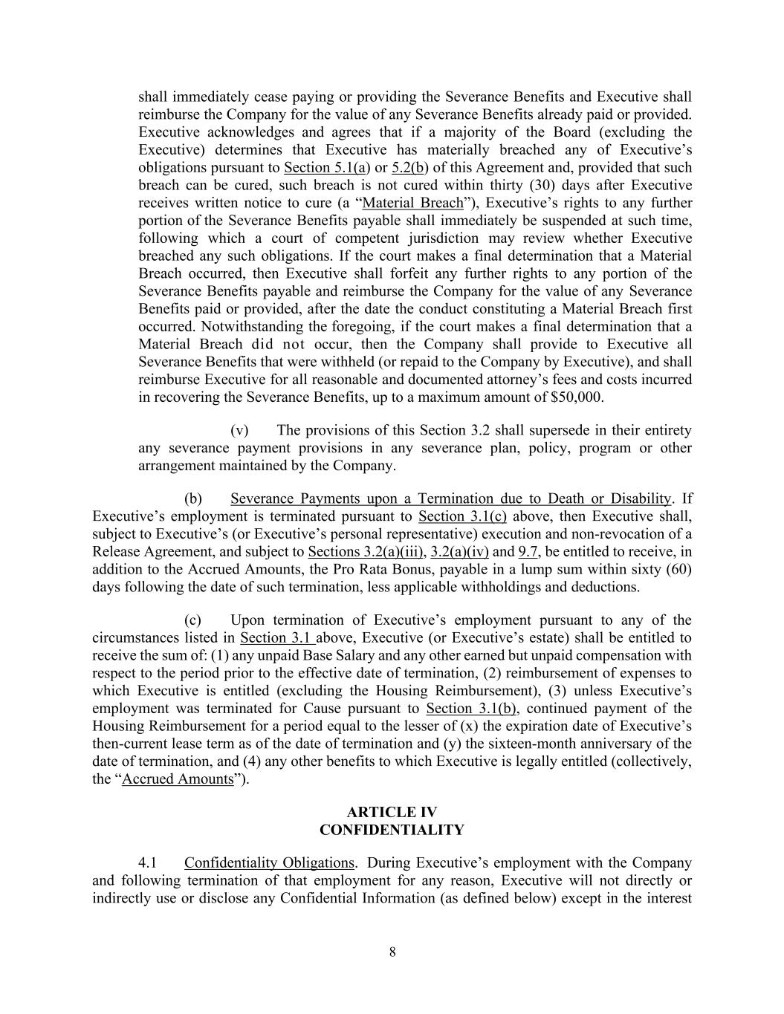
8 shall immediately cease paying or providing the Severance Benefits and Executive shall reimburse the Company for the value of any Severance Benefits already paid or provided. Executive acknowledges and agrees that if a majority of the Board (excluding the Executive) determines that Executive has materially breached any of Executive’s obligations pursuant to Section 5.1(a) or 5.2(b) of this Agreement and, provided that such breach can be cured, such breach is not cured within thirty (30) days after Executive receives written notice to cure (a “Material Breach”), Executive’s rights to any further portion of the Severance Benefits payable shall immediately be suspended at such time, following which a court of competent jurisdiction may review whether Executive breached any such obligations. If the court makes a final determination that a Material Breach occurred, then Executive shall forfeit any further rights to any portion of the Severance Benefits payable and reimburse the Company for the value of any Severance Benefits paid or provided, after the date the conduct constituting a Material Breach first occurred. Notwithstanding the foregoing, if the court makes a final determination that a Material Breach did not occur, then the Company shall provide to Executive all Severance Benefits that were withheld (or repaid to the Company by Executive), and shall reimburse Executive for all reasonable and documented attorney’s fees and costs incurred in recovering the Severance Benefits, up to a maximum amount of $50,000. (v) The provisions of this Section 3.2 shall supersede in their entirety any severance payment provisions in any severance plan, policy, program or other arrangement maintained by the Company. (b) Severance Payments upon a Termination due to Death or Disability. If Executive’s employment is terminated pursuant to Section 3.1(c) above, then Executive shall, subject to Executive’s (or Executive’s personal representative) execution and non-revocation of a Release Agreement, and subject to Sections 3.2(a)(iii), 3.2(a)(iv) and 9.7, be entitled to receive, in addition to the Accrued Amounts, the Pro Rata Bonus, payable in a lump sum within sixty (60) days following the date of such termination, less applicable withholdings and deductions. (c) Upon termination of Executive’s employment pursuant to any of the circumstances listed in Section 3.1 above, Executive (or Executive’s estate) shall be entitled to receive the sum of: (1) any unpaid Base Salary and any other earned but unpaid compensation with respect to the period prior to the effective date of termination, (2) reimbursement of expenses to which Executive is entitled (excluding the Housing Reimbursement), (3) unless Executive’s employment was terminated for Cause pursuant to Section 3.1(b), continued payment of the Housing Reimbursement for a period equal to the lesser of (x) the expiration date of Executive’s then-current lease term as of the date of termination and (y) the sixteen-month anniversary of the date of termination, and (4) any other benefits to which Executive is legally entitled (collectively, the “Accrued Amounts”). ARTICLE IV CONFIDENTIALITY 4.1 Confidentiality Obligations. During Executive’s employment with the Company and following termination of that employment for any reason, Executive will not directly or indirectly use or disclose any Confidential Information (as defined below) except in the interest

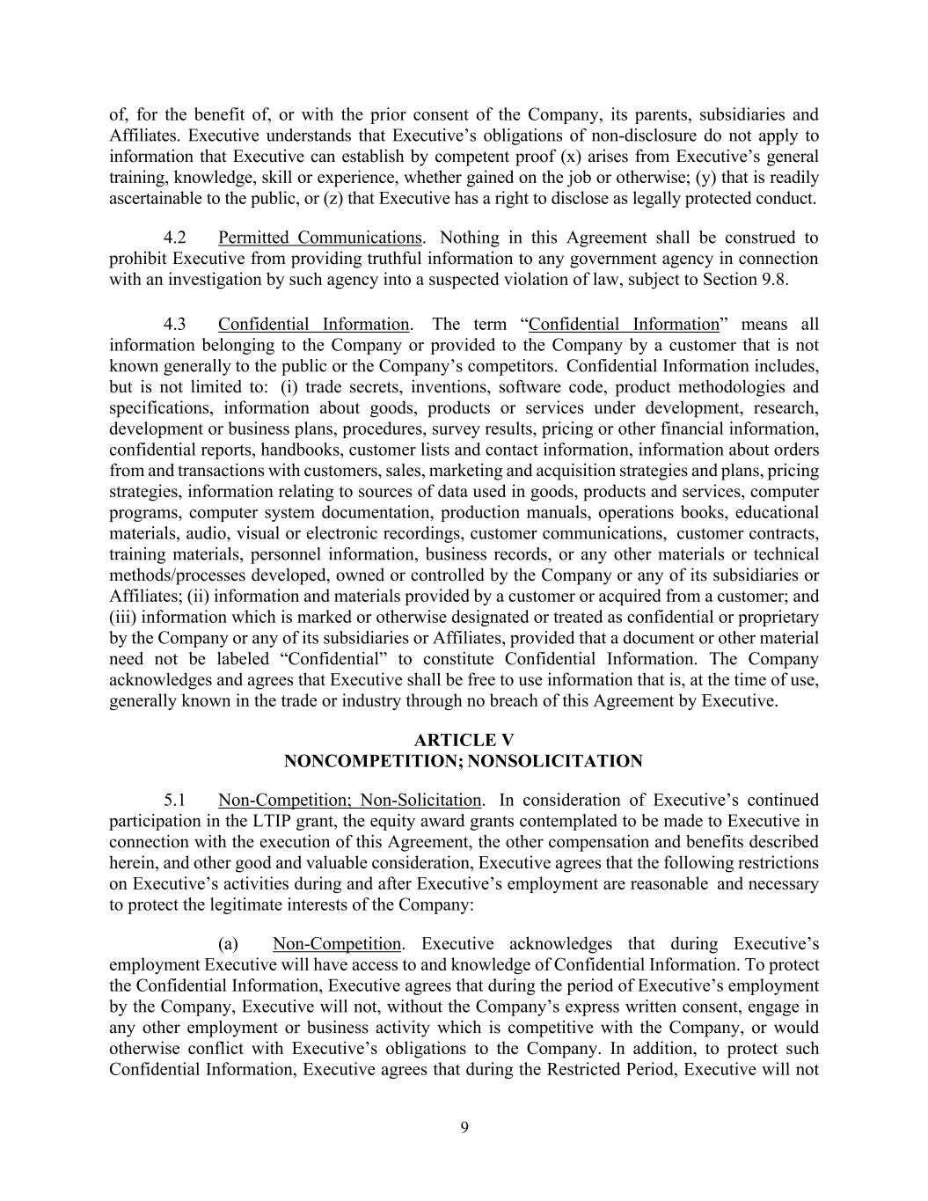
9 of, for the benefit of, or with the prior consent of the Company, its parents, subsidiaries and Affiliates. Executive understands that Executive’s obligations of non-disclosure do not apply to information that Executive can establish by competent proof (x) arises from Executive’s general training, knowledge, skill or experience, whether gained on the job or otherwise; (y) that is readily ascertainable to the public, or (z) that Executive has a right to disclose as legally protected conduct. 4.2 Permitted Communications. Nothing in this Agreement shall be construed to prohibit Executive from providing truthful information to any government agency in connection with an investigation by such agency into a suspected violation of law, subject to Section 9.8. 4.3 Confidential Information. The term “Confidential Information” means all information belonging to the Company or provided to the Company by a customer that is not known generally to the public or the Company’s competitors. Confidential Information includes, but is not limited to: (i) trade secrets, inventions, software code, product methodologies and specifications, information about goods, products or services under development, research, development or business plans, procedures, survey results, pricing or other financial information, confidential reports, handbooks, customer lists and contact information, information about orders from and transactions with customers, sales, marketing and acquisition strategies and plans, pricing strategies, information relating to sources of data used in goods, products and services, computer programs, computer system documentation, production manuals, operations books, educational materials, audio, visual or electronic recordings, customer communications, customer contracts, training materials, personnel information, business records, or any other materials or technical methods/processes developed, owned or controlled by the Company or any of its subsidiaries or Affiliates; (ii) information and materials provided by a customer or acquired from a customer; and (iii) information which is marked or otherwise designated or treated as confidential or proprietary by the Company or any of its subsidiaries or Affiliates, provided that a document or other material need not be labeled “Confidential” to constitute Confidential Information. The Company acknowledges and agrees that Executive shall be free to use information that is, at the time of use, generally known in the trade or industry through no breach of this Agreement by Executive. ARTICLE V NONCOMPETITION; NONSOLICITATION 5.1 Non-Competition; Non-Solicitation. In consideration of Executive’s continued participation in the LTIP grant, the equity award grants contemplated to be made to Executive in connection with the execution of this Agreement, the other compensation and benefits described herein, and other good and valuable consideration, Executive agrees that the following restrictions on Executive’s activities during and after Executive’s employment are reasonable and necessary to protect the legitimate interests of the Company: (a) Non-Competition. Executive acknowledges that during Executive’s employment Executive will have access to and knowledge of Confidential Information. To protect the Confidential Information, Executive agrees that during the period of Executive’s employment by the Company, Executive will not, without the Company’s express written consent, engage in any other employment or business activity which is competitive with the Company, or would otherwise conflict with Executive’s obligations to the Company. In addition, to protect such Confidential Information, Executive agrees that during the Restricted Period, Executive will not

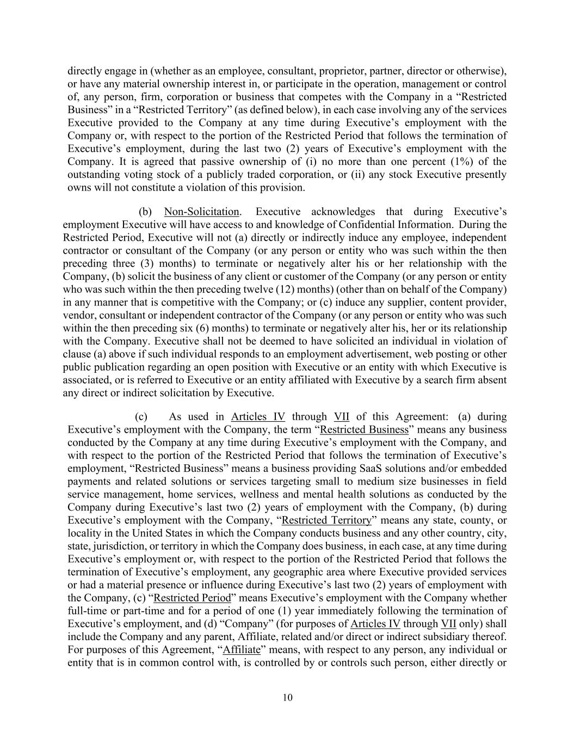
10 directly engage in (whether as an employee, consultant, proprietor, partner, director or otherwise), or have any material ownership interest in, or participate in the operation, management or control of, any person, firm, corporation or business that competes with the Company in a “Restricted Business” in a “Restricted Territory” (as defined below), in each case involving any of the services Executive provided to the Company at any time during Executive’s employment with the Company or, with respect to the portion of the Restricted Period that follows the termination of Executive’s employment, during the last two (2) years of Executive’s employment with the Company. It is agreed that passive ownership of (i) no more than one percent (1%) of the outstanding voting stock of a publicly traded corporation, or (ii) any stock Executive presently owns will not constitute a violation of this provision. (b) Non-Solicitation. Executive acknowledges that during Executive’s employment Executive will have access to and knowledge of Confidential Information. During the Restricted Period, Executive will not (a) directly or indirectly induce any employee, independent contractor or consultant of the Company (or any person or entity who was such within the then preceding three (3) months) to terminate or negatively alter his or her relationship with the Company, (b) solicit the business of any client or customer of the Company (or any person or entity who was such within the then preceding twelve (12) months) (other than on behalf of the Company) in any manner that is competitive with the Company; or (c) induce any supplier, content provider, vendor, consultant or independent contractor of the Company (or any person or entity who was such within the then preceding six (6) months) to terminate or negatively alter his, her or its relationship with the Company. Executive shall not be deemed to have solicited an individual in violation of clause (a) above if such individual responds to an employment advertisement, web posting or other public publication regarding an open position with Executive or an entity with which Executive is associated, or is referred to Executive or an entity affiliated with Executive by a search firm absent any direct or indirect solicitation by Executive. (c) As used in Articles IV through VII of this Agreement: (a) during Executive’s employment with the Company, the term “Restricted Business” means any business conducted by the Company at any time during Executive’s employment with the Company, and with respect to the portion of the Restricted Period that follows the termination of Executive’s employment, “Restricted Business” means a business providing SaaS solutions and/or embedded payments and related solutions or services targeting small to medium size businesses in field service management, home services, wellness and mental health solutions as conducted by the Company during Executive’s last two (2) years of employment with the Company, (b) during Executive’s employment with the Company, “Restricted Territory” means any state, county, or locality in the United States in which the Company conducts business and any other country, city, state, jurisdiction, or territory in which the Company does business, in each case, at any time during Executive’s employment or, with respect to the portion of the Restricted Period that follows the termination of Executive’s employment, any geographic area where Executive provided services or had a material presence or influence during Executive’s last two (2) years of employment with the Company, (c) “Restricted Period” means Executive’s employment with the Company whether full-time or part-time and for a period of one (1) year immediately following the termination of Executive’s employment, and (d) “Company” (for purposes of Articles IV through VII only) shall include the Company and any parent, Affiliate, related and/or direct or indirect subsidiary thereof. For purposes of this Agreement, “Affiliate” means, with respect to any person, any individual or entity that is in common control with, is controlled by or controls such person, either directly or

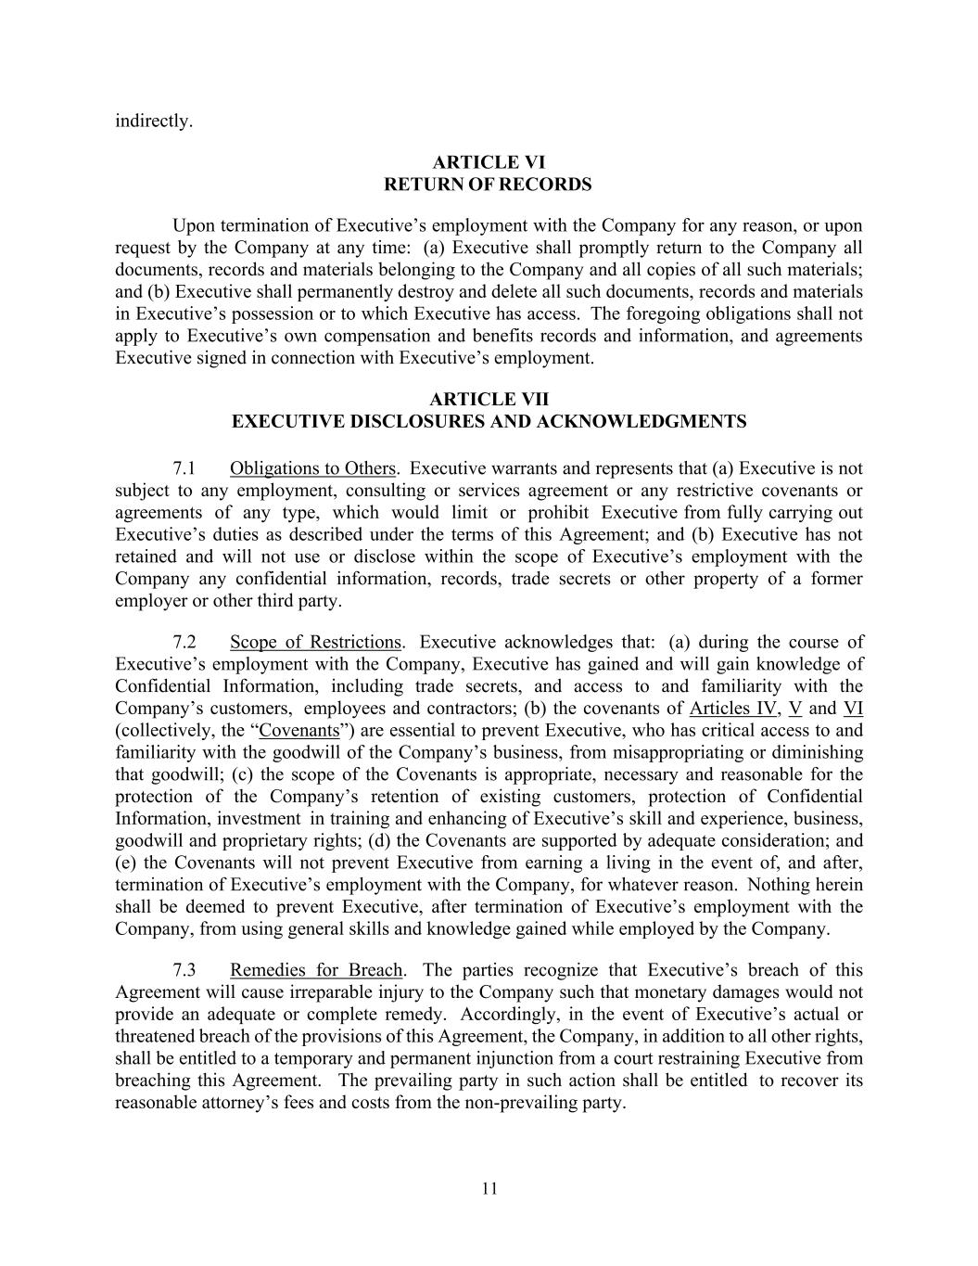
11 indirectly. ARTICLE VI RETURN OF RECORDS Upon termination of Executive’s employment with the Company for any reason, or upon request by the Company at any time: (a) Executive shall promptly return to the Company all documents, records and materials belonging to the Company and all copies of all such materials; and (b) Executive shall permanently destroy and delete all such documents, records and materials in Executive’s possession or to which Executive has access. The foregoing obligations shall not apply to Executive’s own compensation and benefits records and information, and agreements Executive signed in connection with Executive’s employment. ARTICLE VII EXECUTIVE DISCLOSURES AND ACKNOWLEDGMENTS 7.1 Obligations to Others. Executive warrants and represents that (a) Executive is not subject to any employment, consulting or services agreement or any restrictive covenants or agreements of any type, which would limit or prohibit Executive from fully carrying out Executive’s duties as described under the terms of this Agreement; and (b) Executive has not retained and will not use or disclose within the scope of Executive’s employment with the Company any confidential information, records, trade secrets or other property of a former employer or other third party. 7.2 Scope of Restrictions. Executive acknowledges that: (a) during the course of Executive’s employment with the Company, Executive has gained and will gain knowledge of Confidential Information, including trade secrets, and access to and familiarity with the Company’s customers, employees and contractors; (b) the covenants of Articles IV, V and VI (collectively, the “Covenants”) are essential to prevent Executive, who has critical access to and familiarity with the goodwill of the Company’s business, from misappropriating or diminishing that goodwill; (c) the scope of the Covenants is appropriate, necessary and reasonable for the protection of the Company’s retention of existing customers, protection of Confidential Information, investment in training and enhancing of Executive’s skill and experience, business, goodwill and proprietary rights; (d) the Covenants are supported by adequate consideration; and (e) the Covenants will not prevent Executive from earning a living in the event of, and after, termination of Executive’s employment with the Company, for whatever reason. Nothing herein shall be deemed to prevent Executive, after termination of Executive’s employment with the Company, from using general skills and knowledge gained while employed by the Company. 7.3 Remedies for Breach. The parties recognize that Executive’s breach of this Agreement will cause irreparable injury to the Company such that monetary damages would not provide an adequate or complete remedy. Accordingly, in the event of Executive’s actual or threatened breach of the provisions of this Agreement, the Company, in addition to all other rights, shall be entitled to a temporary and permanent injunction from a court restraining Executive from breaching this Agreement. The prevailing party in such action shall be entitled to recover its reasonable attorney’s fees and costs from the non-prevailing party.

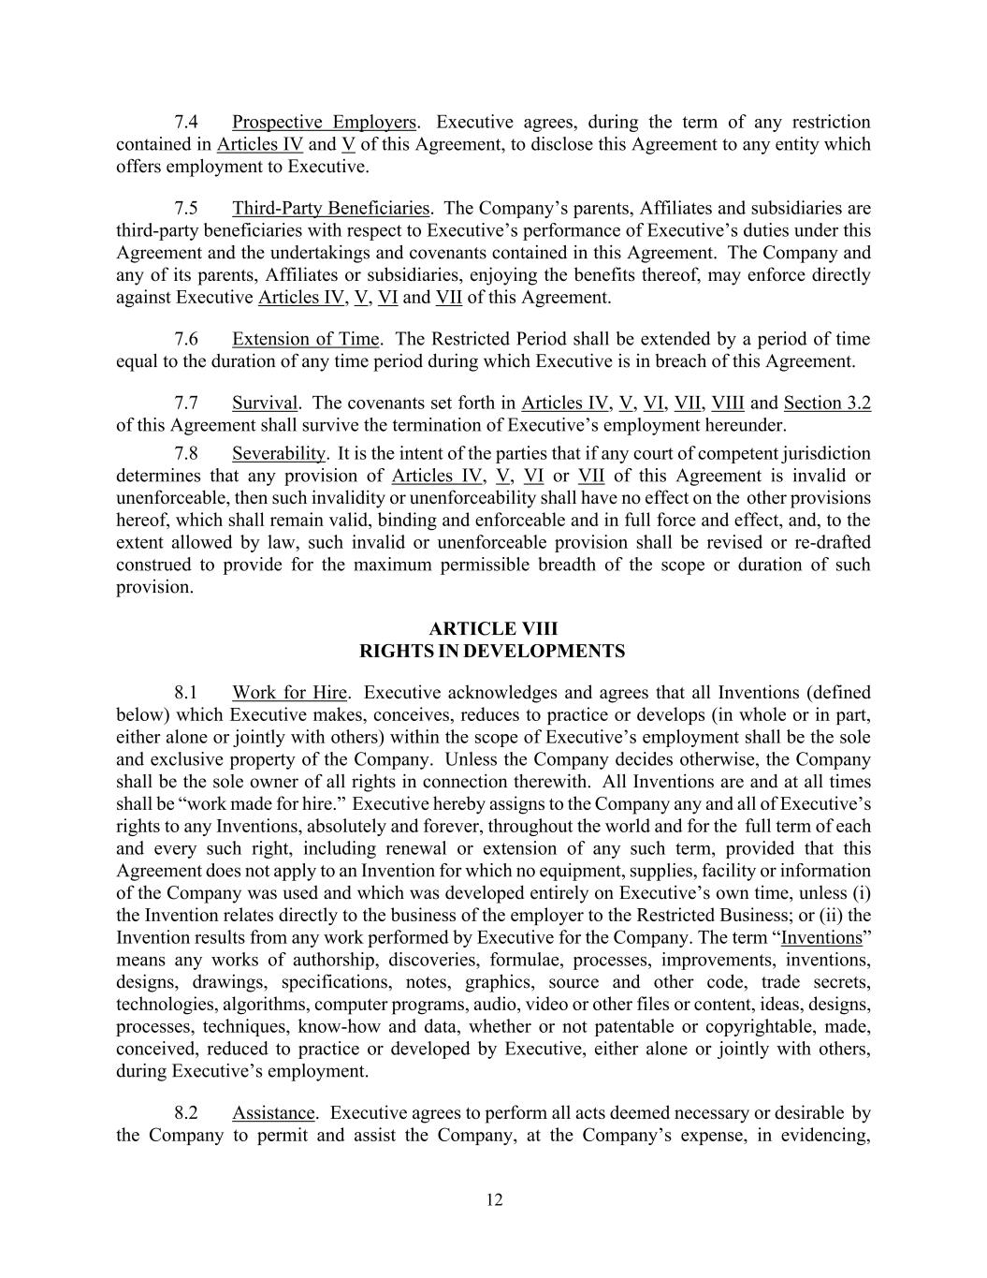
12 7.4 Prospective Employers. Executive agrees, during the term of any restriction contained in Articles IV and V of this Agreement, to disclose this Agreement to any entity which offers employment to Executive. 7.5 Third-Party Beneficiaries. The Company’s parents, Affiliates and subsidiaries are third-party beneficiaries with respect to Executive’s performance of Executive’s duties under this Agreement and the undertakings and covenants contained in this Agreement. The Company and any of its parents, Affiliates or subsidiaries, enjoying the benefits thereof, may enforce directly against Executive Articles IV, V, VI and VII of this Agreement. 7.6 Extension of Time. The Restricted Period shall be extended by a period of time equal to the duration of any time period during which Executive is in breach of this Agreement. 7.7 Survival. The covenants set forth in Articles IV, V, VI, VII, VIII and Section 3.2 of this Agreement shall survive the termination of Executive’s employment hereunder. 7.8 Severability. It is the intent of the parties that if any court of competent jurisdiction determines that any provision of Articles IV, V, VI or VII of this Agreement is invalid or unenforceable, then such invalidity or unenforceability shall have no effect on the other provisions hereof, which shall remain valid, binding and enforceable and in full force and effect, and, to the extent allowed by law, such invalid or unenforceable provision shall be revised or re-drafted construed to provide for the maximum permissible breadth of the scope or duration of such provision. ARTICLE VIII RIGHTS IN DEVELOPMENTS 8.1 Work for Hire. Executive acknowledges and agrees that all Inventions (defined below) which Executive makes, conceives, reduces to practice or develops (in whole or in part, either alone or jointly with others) within the scope of Executive’s employment shall be the sole and exclusive property of the Company. Unless the Company decides otherwise, the Company shall be the sole owner of all rights in connection therewith. All Inventions are and at all times shall be “work made for hire.” Executive hereby assigns to the Company any and all of Executive’s rights to any Inventions, absolutely and forever, throughout the world and for the full term of each and every such right, including renewal or extension of any such term, provided that this Agreement does not apply to an Invention for which no equipment, supplies, facility or information of the Company was used and which was developed entirely on Executive’s own time, unless (i) the Invention relates directly to the business of the employer to the Restricted Business; or (ii) the Invention results from any work performed by Executive for the Company. The term “Inventions” means any works of authorship, discoveries, formulae, processes, improvements, inventions, designs, drawings, specifications, notes, graphics, source and other code, trade secrets, technologies, algorithms, computer programs, audio, video or other files or content, ideas, designs, processes, techniques, know-how and data, whether or not patentable or copyrightable, made, conceived, reduced to practice or developed by Executive, either alone or jointly with others, during Executive’s employment. 8.2 Assistance. Executive agrees to perform all acts deemed necessary or desirable by the Company to permit and assist the Company, at the Company’s expense, in evidencing,

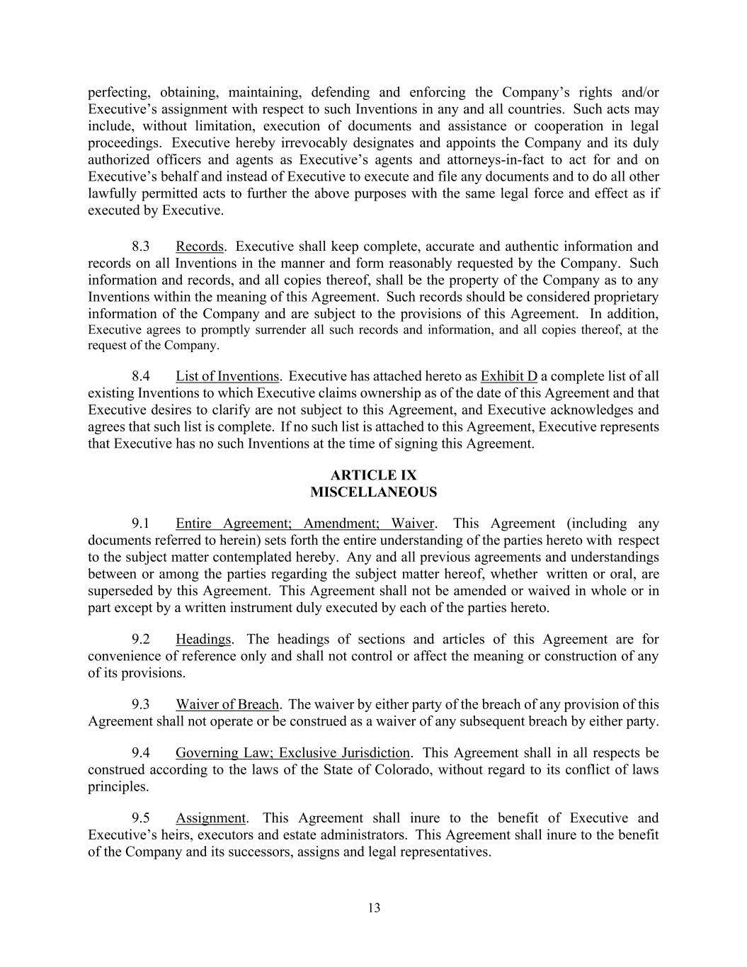
13 perfecting, obtaining, maintaining, defending and enforcing the Company’s rights and/or Executive’s assignment with respect to such Inventions in any and all countries. Such acts may include, without limitation, execution of documents and assistance or cooperation in legal proceedings. Executive hereby irrevocably designates and appoints the Company and its duly authorized officers and agents as Executive’s agents and attorneys-in-fact to act for and on Executive’s behalf and instead of Executive to execute and file any documents and to do all other lawfully permitted acts to further the above purposes with the same legal force and effect as if executed by Executive. 8.3 Records. Executive shall keep complete, accurate and authentic information and records on all Inventions in the manner and form reasonably requested by the Company. Such information and records, and all copies thereof, shall be the property of the Company as to any Inventions within the meaning of this Agreement. Such records should be considered proprietary information of the Company and are subject to the provisions of this Agreement. In addition, Executive agrees to promptly surrender all such records and information, and all copies thereof, at the request of the Company. 8.4 List of Inventions. Executive has attached hereto as Exhibit D a complete list of all existing Inventions to which Executive claims ownership as of the date of this Agreement and that Executive desires to clarify are not subject to this Agreement, and Executive acknowledges and agrees that such list is complete. If no such list is attached to this Agreement, Executive represents that Executive has no such Inventions at the time of signing this Agreement. ARTICLE IX MISCELLANEOUS 9.1 Entire Agreement; Amendment; Waiver. This Agreement (including any documents referred to herein) sets forth the entire understanding of the parties hereto with respect to the subject matter contemplated hereby. Any and all previous agreements and understandings between or among the parties regarding the subject matter hereof, whether written or oral, are superseded by this Agreement. This Agreement shall not be amended or waived in whole or in part except by a written instrument duly executed by each of the parties hereto. 9.2 Headings. The headings of sections and articles of this Agreement are for convenience of reference only and shall not control or affect the meaning or construction of any of its provisions. 9.3 Waiver of Breach. The waiver by either party of the breach of any provision of this Agreement shall not operate or be construed as a waiver of any subsequent breach by either party. 9.4 Governing Law; Exclusive Jurisdiction. This Agreement shall in all respects be construed according to the laws of the State of Colorado, without regard to its conflict of laws principles. 9.5 Assignment. This Agreement shall inure to the benefit of Executive and Executive’s heirs, executors and estate administrators. This Agreement shall inure to the benefit of the Company and its successors, assigns and legal representatives.

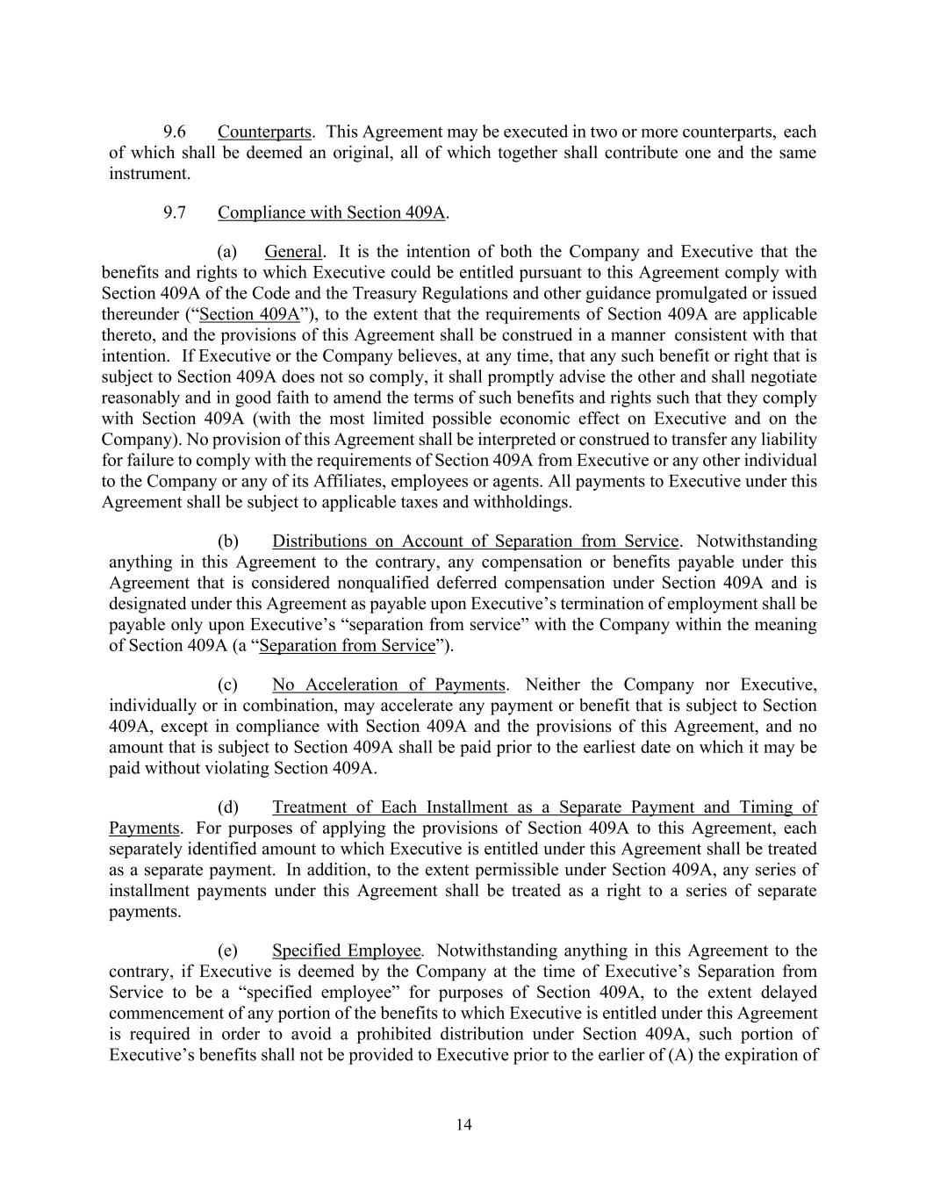
14 9.6 Counterparts. This Agreement may be executed in two or more counterparts, each of which shall be deemed an original, all of which together shall contribute one and the same instrument. 9.7 Compliance with Section 409A. (a) General. It is the intention of both the Company and Executive that the benefits and rights to which Executive could be entitled pursuant to this Agreement comply with Section 409A of the Code and the Treasury Regulations and other guidance promulgated or issued thereunder (“Section 409A”), to the extent that the requirements of Section 409A are applicable thereto, and the provisions of this Agreement shall be construed in a manner consistent with that intention. If Executive or the Company believes, at any time, that any such benefit or right that is subject to Section 409A does not so comply, it shall promptly advise the other and shall negotiate reasonably and in good faith to amend the terms of such benefits and rights such that they comply with Section 409A (with the most limited possible economic effect on Executive and on the Company). No provision of this Agreement shall be interpreted or construed to transfer any liability for failure to comply with the requirements of Section 409A from Executive or any other individual to the Company or any of its Affiliates, employees or agents. All payments to Executive under this Agreement shall be subject to applicable taxes and withholdings. (b) Distributions on Account of Separation from Service. Notwithstanding anything in this Agreement to the contrary, any compensation or benefits payable under this Agreement that is considered nonqualified deferred compensation under Section 409A and is designated under this Agreement as payable upon Executive’s termination of employment shall be payable only upon Executive’s “separation from service” with the Company within the meaning of Section 409A (a “Separation from Service”). (c) No Acceleration of Payments. Neither the Company nor Executive, individually or in combination, may accelerate any payment or benefit that is subject to Section 409A, except in compliance with Section 409A and the provisions of this Agreement, and no amount that is subject to Section 409A shall be paid prior to the earliest date on which it may be paid without violating Section 409A. (d) Treatment of Each Installment as a Separate Payment and Timing of Payments. For purposes of applying the provisions of Section 409A to this Agreement, each separately identified amount to which Executive is entitled under this Agreement shall be treated as a separate payment. In addition, to the extent permissible under Section 409A, any series of installment payments under this Agreement shall be treated as a right to a series of separate payments. (e) Specified Employee. Notwithstanding anything in this Agreement to the contrary, if Executive is deemed by the Company at the time of Executive’s Separation from Service to be a “specified employee” for purposes of Section 409A, to the extent delayed commencement of any portion of the benefits to which Executive is entitled under this Agreement is required in order to avoid a prohibited distribution under Section 409A, such portion of Executive’s benefits shall not be provided to Executive prior to the earlier of (A) the expiration of

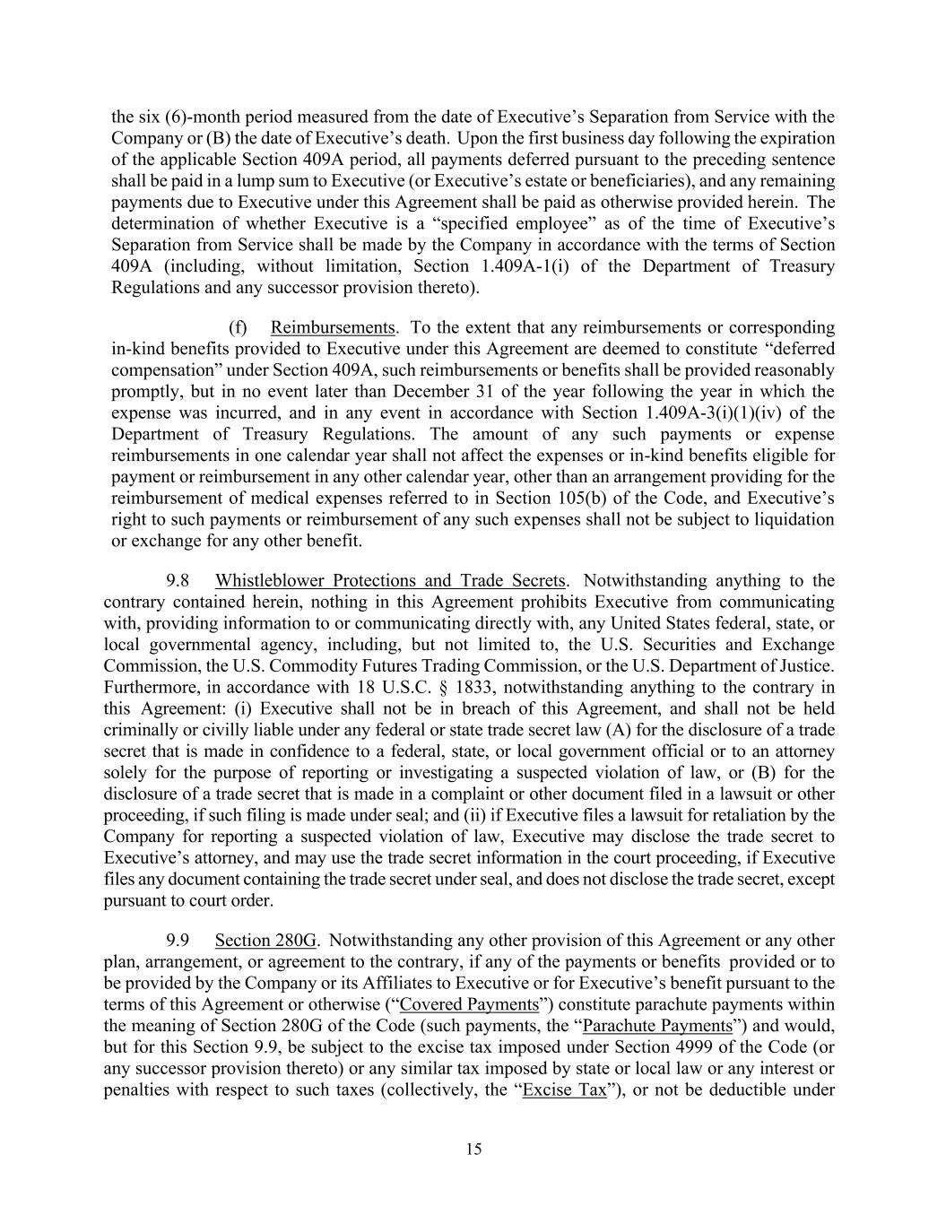
15 the six (6)-month period measured from the date of Executive’s Separation from Service with the Company or (B) the date of Executive’s death. Upon the first business day following the expiration of the applicable Section 409A period, all payments deferred pursuant to the preceding sentence shall be paid in a lump sum to Executive (or Executive’s estate or beneficiaries), and any remaining payments due to Executive under this Agreement shall be paid as otherwise provided herein. The determination of whether Executive is a “specified employee” as of the time of Executive’s Separation from Service shall be made by the Company in accordance with the terms of Section 409A (including, without limitation, Section 1.409A-1(i) of the Department of Treasury Regulations and any successor provision thereto). (f) Reimbursements. To the extent that any reimbursements or corresponding in-kind benefits provided to Executive under this Agreement are deemed to constitute “deferred compensation” under Section 409A, such reimbursements or benefits shall be provided reasonably promptly, but in no event later than December 31 of the year following the year in which the expense was incurred, and in any event in accordance with Section 1.409A-3(i)(1)(iv) of the Department of Treasury Regulations. The amount of any such payments or expense reimbursements in one calendar year shall not affect the expenses or in-kind benefits eligible for payment or reimbursement in any other calendar year, other than an arrangement providing for the reimbursement of medical expenses referred to in Section 105(b) of the Code, and Executive’s right to such payments or reimbursement of any such expenses shall not be subject to liquidation or exchange for any other benefit. 9.8 Whistleblower Protections and Trade Secrets. Notwithstanding anything to the contrary contained herein, nothing in this Agreement prohibits Executive from communicating with, providing information to or communicating directly with, any United States federal, state, or local governmental agency, including, but not limited to, the U.S. Securities and Exchange Commission, the U.S. Commodity Futures Trading Commission, or the U.S. Department of Justice. Furthermore, in accordance with 18 U.S.C. § 1833, notwithstanding anything to the contrary in this Agreement: (i) Executive shall not be in breach of this Agreement, and shall not be held criminally or civilly liable under any federal or state trade secret law (A) for the disclosure of a trade secret that is made in confidence to a federal, state, or local government official or to an attorney solely for the purpose of reporting or investigating a suspected violation of law, or (B) for the disclosure of a trade secret that is made in a complaint or other document filed in a lawsuit or other proceeding, if such filing is made under seal; and (ii) if Executive files a lawsuit for retaliation by the Company for reporting a suspected violation of law, Executive may disclose the trade secret to Executive’s attorney, and may use the trade secret information in the court proceeding, if Executive files any document containing the trade secret under seal, and does not disclose the trade secret, except pursuant to court order. 9.9 Section 280G. Notwithstanding any other provision of this Agreement or any other plan, arrangement, or agreement to the contrary, if any of the payments or benefits provided or to be provided by the Company or its Affiliates to Executive or for Executive’s benefit pursuant to the terms of this Agreement or otherwise (“Covered Payments”) constitute parachute payments within the meaning of Section 280G of the Code (such payments, the “Parachute Payments”) and would, but for this Section 9.9, be subject to the excise tax imposed under Section 4999 of the Code (or any successor provision thereto) or any similar tax imposed by state or local law or any interest or penalties with respect to such taxes (collectively, the “Excise Tax”), or not be deductible under

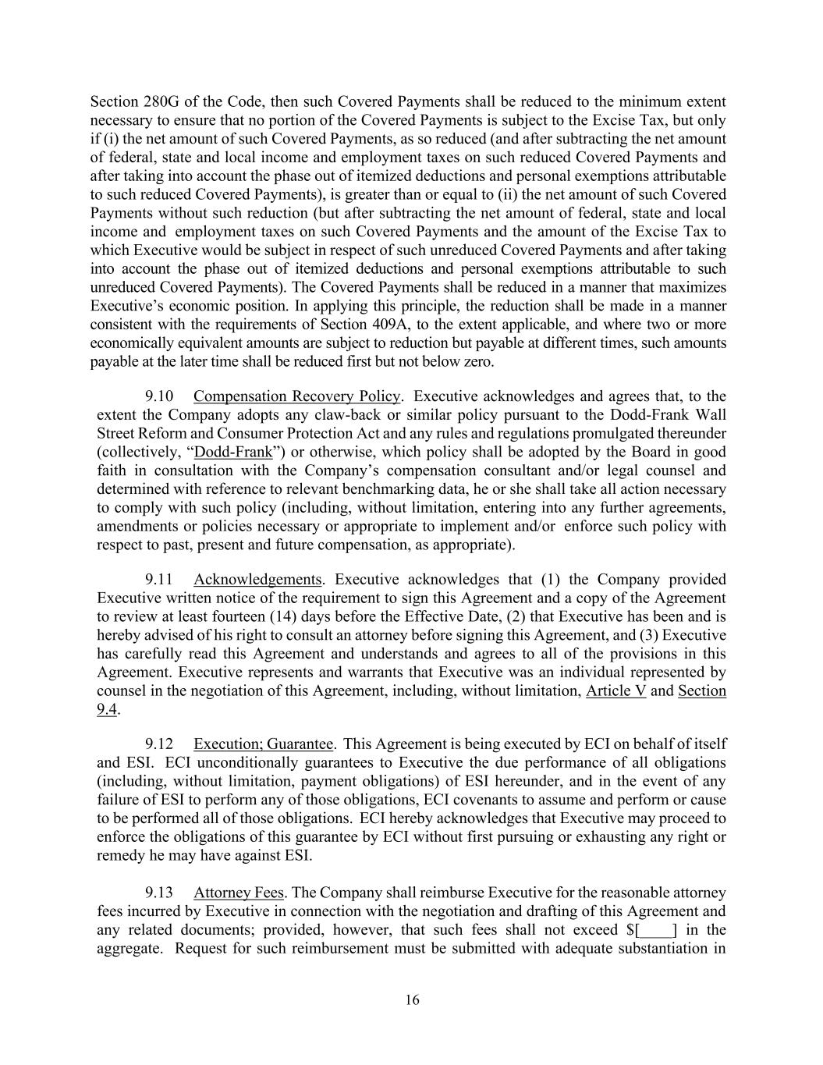
16 Section 280G of the Code, then such Covered Payments shall be reduced to the minimum extent necessary to ensure that no portion of the Covered Payments is subject to the Excise Tax, but only if (i) the net amount of such Covered Payments, as so reduced (and after subtracting the net amount of federal, state and local income and employment taxes on such reduced Covered Payments and after taking into account the phase out of itemized deductions and personal exemptions attributable to such reduced Covered Payments), is greater than or equal to (ii) the net amount of such Covered Payments without such reduction (but after subtracting the net amount of federal, state and local income and employment taxes on such Covered Payments and the amount of the Excise Tax to which Executive would be subject in respect of such unreduced Covered Payments and after taking into account the phase out of itemized deductions and personal exemptions attributable to such unreduced Covered Payments). The Covered Payments shall be reduced in a manner that maximizes Executive’s economic position. In applying this principle, the reduction shall be made in a manner consistent with the requirements of Section 409A, to the extent applicable, and where two or more economically equivalent amounts are subject to reduction but payable at different times, such amounts payable at the later time shall be reduced first but not below zero. 9.10 Compensation Recovery Policy. Executive acknowledges and agrees that, to the extent the Company adopts any claw-back or similar policy pursuant to the Dodd-Frank Wall Street Reform and Consumer Protection Act and any rules and regulations promulgated thereunder (collectively, “Dodd-Frank”) or otherwise, which policy shall be adopted by the Board in good faith in consultation with the Company’s compensation consultant and/or legal counsel and determined with reference to relevant benchmarking data, he or she shall take all action necessary to comply with such policy (including, without limitation, entering into any further agreements, amendments or policies necessary or appropriate to implement and/or enforce such policy with respect to past, present and future compensation, as appropriate). 9.11 Acknowledgements. Executive acknowledges that (1) the Company provided Executive written notice of the requirement to sign this Agreement and a copy of the Agreement to review at least fourteen (14) days before the Effective Date, (2) that Executive has been and is hereby advised of his right to consult an attorney before signing this Agreement, and (3) Executive has carefully read this Agreement and understands and agrees to all of the provisions in this Agreement. Executive represents and warrants that Executive was an individual represented by counsel in the negotiation of this Agreement, including, without limitation, Article V and Section 9.4. 9.12 Execution; Guarantee. This Agreement is being executed by ECI on behalf of itself and ESI. ECI unconditionally guarantees to Executive the due performance of all obligations (including, without limitation, payment obligations) of ESI hereunder, and in the event of any failure of ESI to perform any of those obligations, ECI covenants to assume and perform or cause to be performed all of those obligations. ECI hereby acknowledges that Executive may proceed to enforce the obligations of this guarantee by ECI without first pursuing or exhausting any right or remedy he may have against ESI. 9.13 Attorney Fees. The Company shall reimburse Executive for the reasonable attorney fees incurred by Executive in connection with the negotiation and drafting of this Agreement and any related documents; provided, however, that such fees shall not exceed $[____] in the aggregate. Request for such reimbursement must be submitted with adequate substantiation in


17 accordance with the Company’s reimbursement policy. [Remainder of Page Intentionally Blank; Signature Page to Follow]

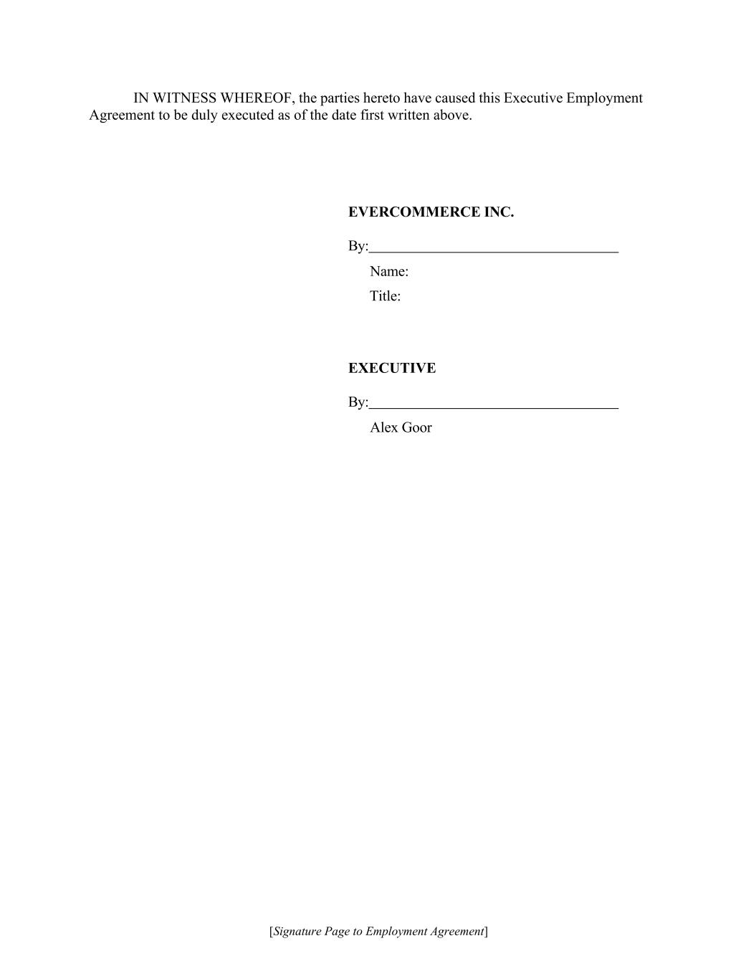
[Signature Page to Employment Agreement] IN WITNESS WHEREOF, the parties hereto have caused this Executive Employment Agreement to be duly executed as of the date first written above. EVERCOMMERCE INC. By: Name: Title: EXECUTIVE By: Alex Goor


EXHIBIT A [ ]


EXHIBIT B [ ]

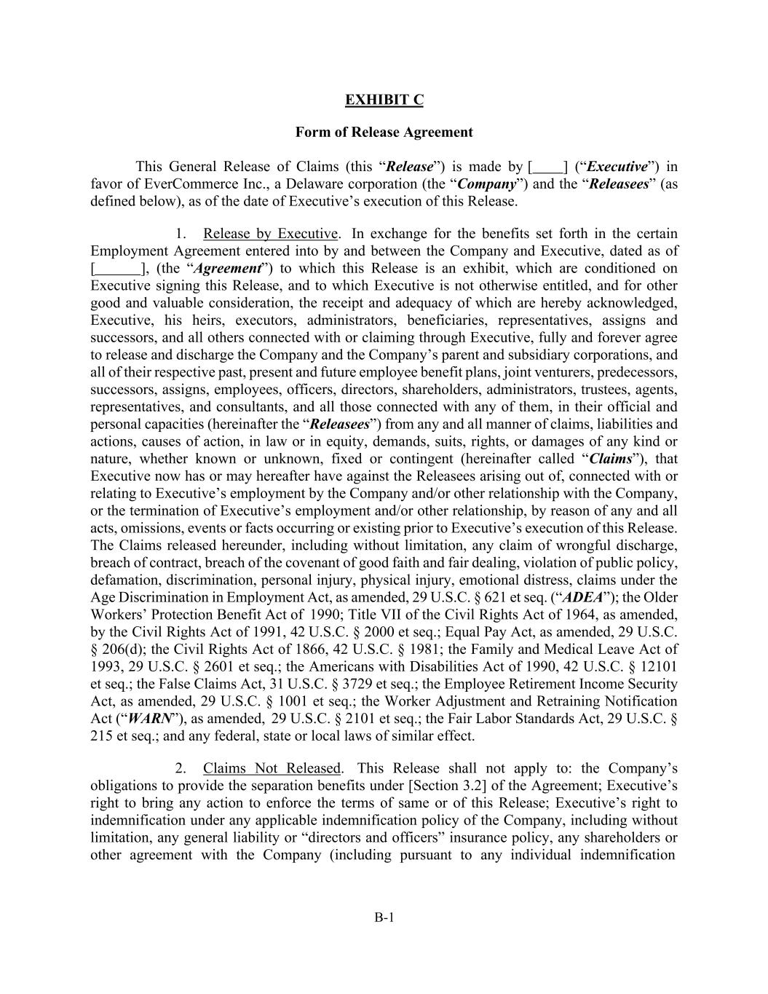
B-1 EXHIBIT C Form of Release Agreement This General Release of Claims (this “Release”) is made by [ ] (“Executive”) in favor of EverCommerce Inc., a Delaware corporation (the “Company”) and the “Releasees” (as defined below), as of the date of Executive’s execution of this Release. 1. Release by Executive. In exchange for the benefits set forth in the certain Employment Agreement entered into by and between the Company and Executive, dated as of [ ], (the “Agreement”) to which this Release is an exhibit, which are conditioned on Executive signing this Release, and to which Executive is not otherwise entitled, and for other good and valuable consideration, the receipt and adequacy of which are hereby acknowledged, Executive, his heirs, executors, administrators, beneficiaries, representatives, assigns and successors, and all others connected with or claiming through Executive, fully and forever agree to release and discharge the Company and the Company’s parent and subsidiary corporations, and all of their respective past, present and future employee benefit plans, joint venturers, predecessors, successors, assigns, employees, officers, directors, shareholders, administrators, trustees, agents, representatives, and consultants, and all those connected with any of them, in their official and personal capacities (hereinafter the “Releasees”) from any and all manner of claims, liabilities and actions, causes of action, in law or in equity, demands, suits, rights, or damages of any kind or nature, whether known or unknown, fixed or contingent (hereinafter called “Claims”), that Executive now has or may hereafter have against the Releasees arising out of, connected with or relating to Executive’s employment by the Company and/or other relationship with the Company, or the termination of Executive’s employment and/or other relationship, by reason of any and all acts, omissions, events or facts occurring or existing prior to Executive’s execution of this Release. The Claims released hereunder, including without limitation, any claim of wrongful discharge, breach of contract, breach of the covenant of good faith and fair dealing, violation of public policy, defamation, discrimination, personal injury, physical injury, emotional distress, claims under the Age Discrimination in Employment Act, as amended, 29 U.S.C. § 621 et seq. (“ADEA”); the Older Workers’ Protection Benefit Act of 1990; Title VII of the Civil Rights Act of 1964, as amended, by the Civil Rights Act of 1991, 42 U.S.C. § 2000 et seq.; Equal Pay Act, as amended, 29 U.S.C. § 206(d); the Civil Rights Act of 1866, 42 U.S.C. § 1981; the Family and Medical Leave Act of 1993, 29 U.S.C. § 2601 et seq.; the Americans with Disabilities Act of 1990, 42 U.S.C. § 12101 et seq.; the False Claims Act, 31 U.S.C. § 3729 et seq.; the Employee Retirement Income Security Act, as amended, 29 U.S.C. § 1001 et seq.; the Worker Adjustment and Retraining Notification Act (“WARN”), as amended, 29 U.S.C. § 2101 et seq.; the Fair Labor Standards Act, 29 U.S.C. § 215 et seq.; and any federal, state or local laws of similar effect. 2. Claims Not Released. This Release shall not apply to: the Company’s obligations to provide the separation benefits under [Section 3.2] of the Agreement; Executive’s right to bring any action to enforce the terms of same or of this Release; Executive’s right to indemnification under any applicable indemnification policy of the Company, including without limitation, any general liability or “directors and officers” insurance policy, any shareholders or other agreement with the Company (including pursuant to any individual indemnification

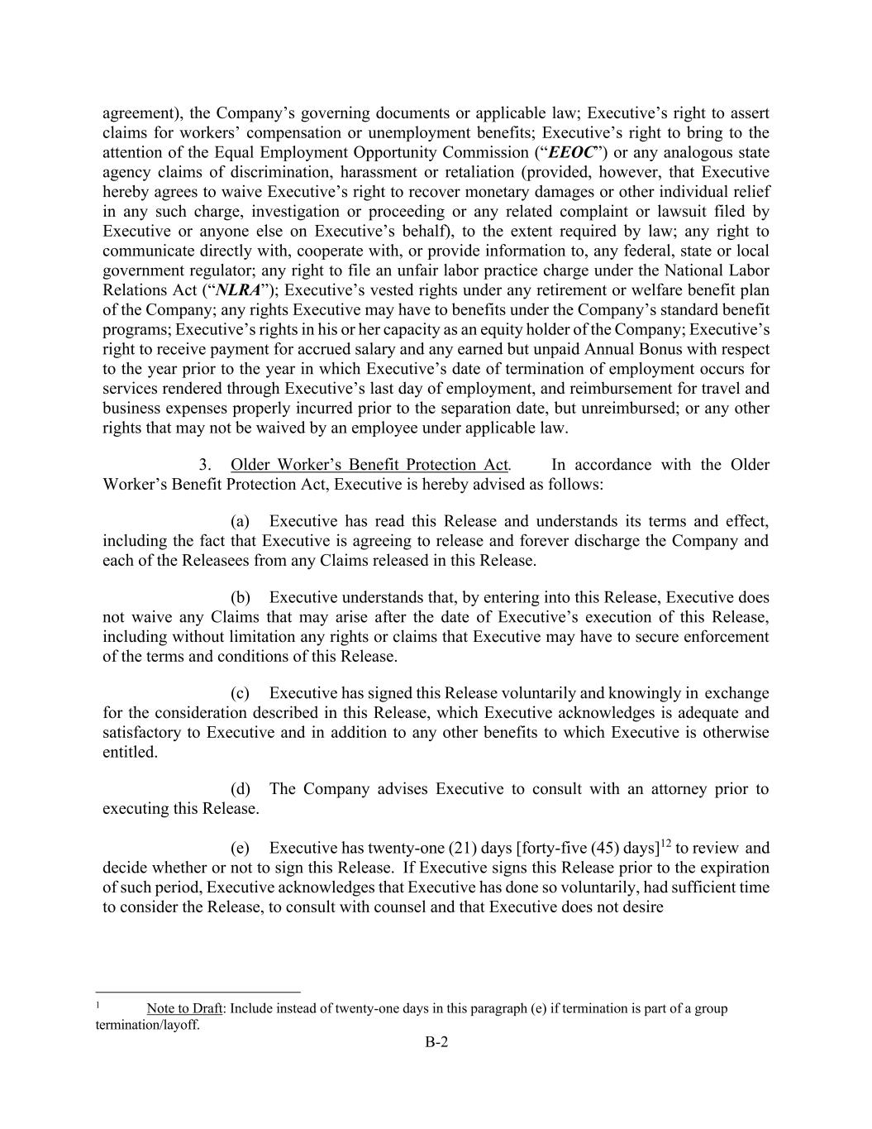
B-2 agreement), the Company’s governing documents or applicable law; Executive’s right to assert claims for workers’ compensation or unemployment benefits; Executive’s right to bring to the attention of the Equal Employment Opportunity Commission (“EEOC”) or any analogous state agency claims of discrimination, harassment or retaliation (provided, however, that Executive hereby agrees to waive Executive’s right to recover monetary damages or other individual relief in any such charge, investigation or proceeding or any related complaint or lawsuit filed by Executive or anyone else on Executive’s behalf), to the extent required by law; any right to communicate directly with, cooperate with, or provide information to, any federal, state or local government regulator; any right to file an unfair labor practice charge under the National Labor Relations Act (“NLRA”); Executive’s vested rights under any retirement or welfare benefit plan of the Company; any rights Executive may have to benefits under the Company’s standard benefit programs; Executive’s rights in his or her capacity as an equity holder of the Company; Executive’s right to receive payment for accrued salary and any earned but unpaid Annual Bonus with respect to the year prior to the year in which Executive’s date of termination of employment occurs for services rendered through Executive’s last day of employment, and reimbursement for travel and business expenses properly incurred prior to the separation date, but unreimbursed; or any other rights that may not be waived by an employee under applicable law. 3. Older Worker’s Benefit Protection Act. In accordance with the Older Worker’s Benefit Protection Act, Executive is hereby advised as follows: (a) Executive has read this Release and understands its terms and effect, including the fact that Executive is agreeing to release and forever discharge the Company and each of the Releasees from any Claims released in this Release. (b) Executive understands that, by entering into this Release, Executive does not waive any Claims that may arise after the date of Executive’s execution of this Release, including without limitation any rights or claims that Executive may have to secure enforcement of the terms and conditions of this Release. (c) Executive has signed this Release voluntarily and knowingly in exchange for the consideration described in this Release, which Executive acknowledges is adequate and satisfactory to Executive and in addition to any other benefits to which Executive is otherwise entitled. (d) The Company advises Executive to consult with an attorney prior to executing this Release. (e) Executive has twenty-one (21) days [forty-five (45) days]12 to review and decide whether or not to sign this Release. If Executive signs this Release prior to the expiration of such period, Executive acknowledges that Executive has done so voluntarily, had sufficient time to consider the Release, to consult with counsel and that Executive does not desire 1 Note to Draft: Include instead of twenty-one days in this paragraph (e) if termination is part of a group termination/layoff.

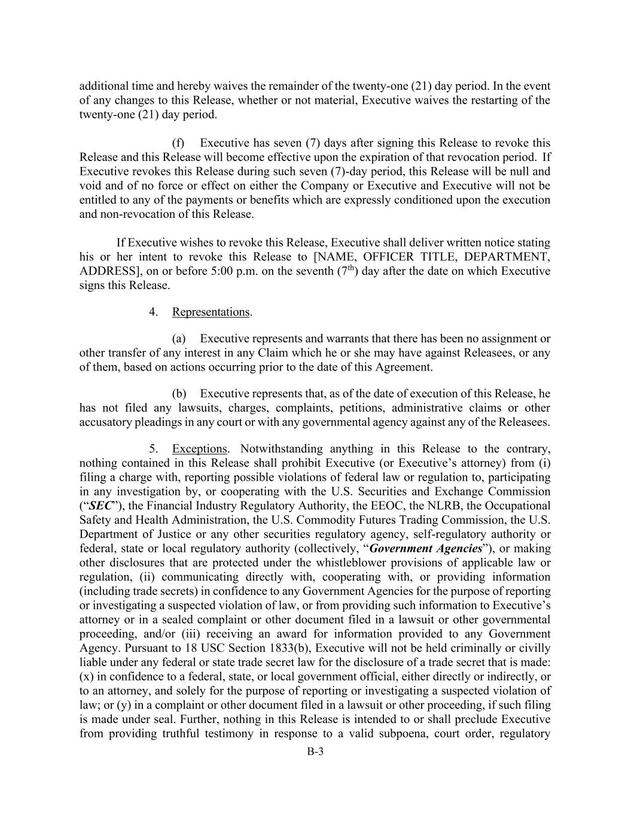
B-3 additional time and hereby waives the remainder of the twenty-one (21) day period. In the event of any changes to this Release, whether or not material, Executive waives the restarting of the twenty-one (21) day period. (f) Executive has seven (7) days after signing this Release to revoke this Release and this Release will become effective upon the expiration of that revocation period. If Executive revokes this Release during such seven (7)-day period, this Release will be null and void and of no force or effect on either the Company or Executive and Executive will not be entitled to any of the payments or benefits which are expressly conditioned upon the execution and non-revocation of this Release. If Executive wishes to revoke this Release, Executive shall deliver written notice stating his or her intent to revoke this Release to [NAME, OFFICER TITLE, DEPARTMENT, ADDRESS], on or before 5:00 p.m. on the seventh (7th) day after the date on which Executive signs this Release. 4. Representations. (a) Executive represents and warrants that there has been no assignment or other transfer of any interest in any Claim which he or she may have against Releasees, or any of them, based on actions occurring prior to the date of this Agreement. (b) Executive represents that, as of the date of execution of this Release, he has not filed any lawsuits, charges, complaints, petitions, administrative claims or other accusatory pleadings in any court or with any governmental agency against any of the Releasees. 5. Exceptions. Notwithstanding anything in this Release to the contrary, nothing contained in this Release shall prohibit Executive (or Executive’s attorney) from (i) filing a charge with, reporting possible violations of federal law or regulation to, participating in any investigation by, or cooperating with the U.S. Securities and Exchange Commission (“SEC”), the Financial Industry Regulatory Authority, the EEOC, the NLRB, the Occupational Safety and Health Administration, the U.S. Commodity Futures Trading Commission, the U.S. Department of Justice or any other securities regulatory agency, self-regulatory authority or federal, state or local regulatory authority (collectively, “Government Agencies”), or making other disclosures that are protected under the whistleblower provisions of applicable law or regulation, (ii) communicating directly with, cooperating with, or providing information (including trade secrets) in confidence to any Government Agencies for the purpose of reporting or investigating a suspected violation of law, or from providing such information to Executive’s attorney or in a sealed complaint or other document filed in a lawsuit or other governmental proceeding, and/or (iii) receiving an award for information provided to any Government Agency. Pursuant to 18 USC Section 1833(b), Executive will not be held criminally or civilly liable under any federal or state trade secret law for the disclosure of a trade secret that is made: (x) in confidence to a federal, state, or local government official, either directly or indirectly, or to an attorney, and solely for the purpose of reporting or investigating a suspected violation of law; or (y) in a complaint or other document filed in a lawsuit or other proceeding, if such filing is made under seal. Further, nothing in this Release is intended to or shall preclude Executive from providing truthful testimony in response to a valid subpoena, court order, regulatory

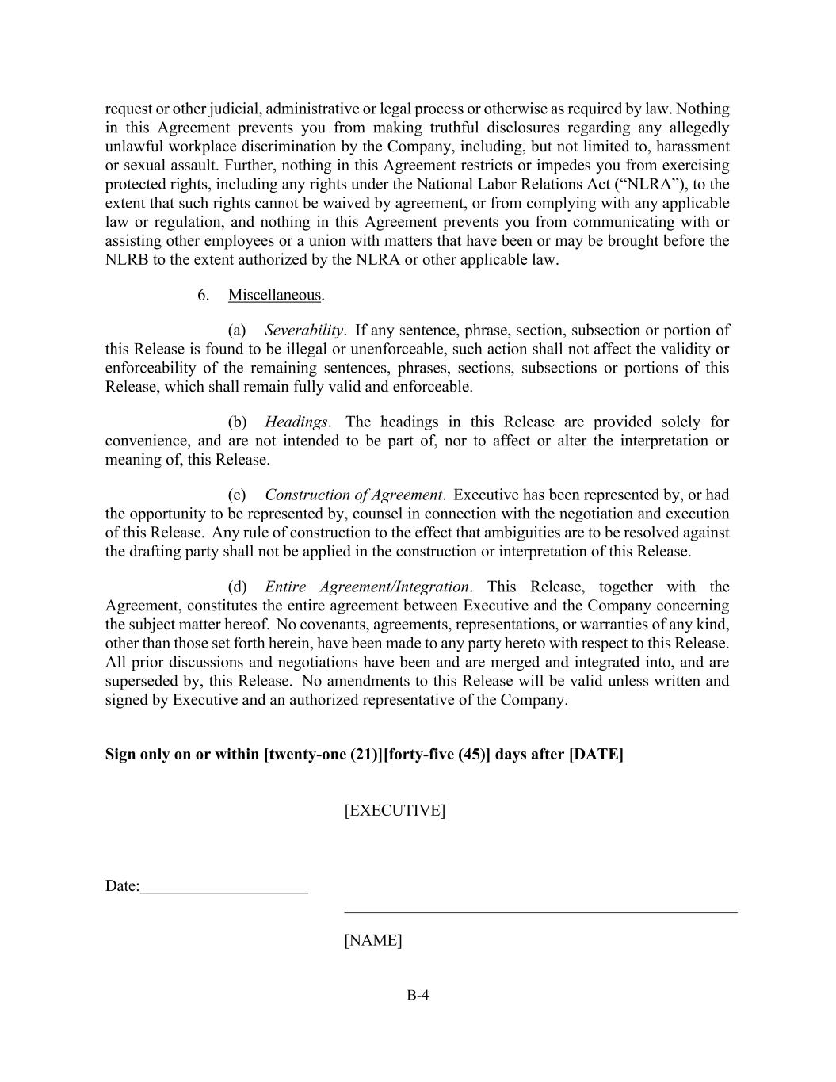
B-4 request or other judicial, administrative or legal process or otherwise as required by law. Nothing in this Agreement prevents you from making truthful disclosures regarding any allegedly unlawful workplace discrimination by the Company, including, but not limited to, harassment or sexual assault. Further, nothing in this Agreement restricts or impedes you from exercising protected rights, including any rights under the National Labor Relations Act (“NLRA”), to the extent that such rights cannot be waived by agreement, or from complying with any applicable law or regulation, and nothing in this Agreement prevents you from communicating with or assisting other employees or a union with matters that have been or may be brought before the NLRB to the extent authorized by the NLRA or other applicable law. 6. Miscellaneous. (a) Severability. If any sentence, phrase, section, subsection or portion of this Release is found to be illegal or unenforceable, such action shall not affect the validity or enforceability of the remaining sentences, phrases, sections, subsections or portions of this Release, which shall remain fully valid and enforceable. (b) Headings. The headings in this Release are provided solely for convenience, and are not intended to be part of, nor to affect or alter the interpretation or meaning of, this Release. (c) Construction of Agreement. Executive has been represented by, or had the opportunity to be represented by, counsel in connection with the negotiation and execution of this Release. Any rule of construction to the effect that ambiguities are to be resolved against the drafting party shall not be applied in the construction or interpretation of this Release. (d) Entire Agreement/Integration. This Release, together with the Agreement, constitutes the entire agreement between Executive and the Company concerning the subject matter hereof. No covenants, agreements, representations, or warranties of any kind, other than those set forth herein, have been made to any party hereto with respect to this Release. All prior discussions and negotiations have been and are merged and integrated into, and are superseded by, this Release. No amendments to this Release will be valid unless written and signed by Executive and an authorized representative of the Company. Sign only on or within [twenty-one (21)][forty-five (45)] days after [DATE] [EXECUTIVE] Date: [NAME]


EXHIBIT D Inventions:

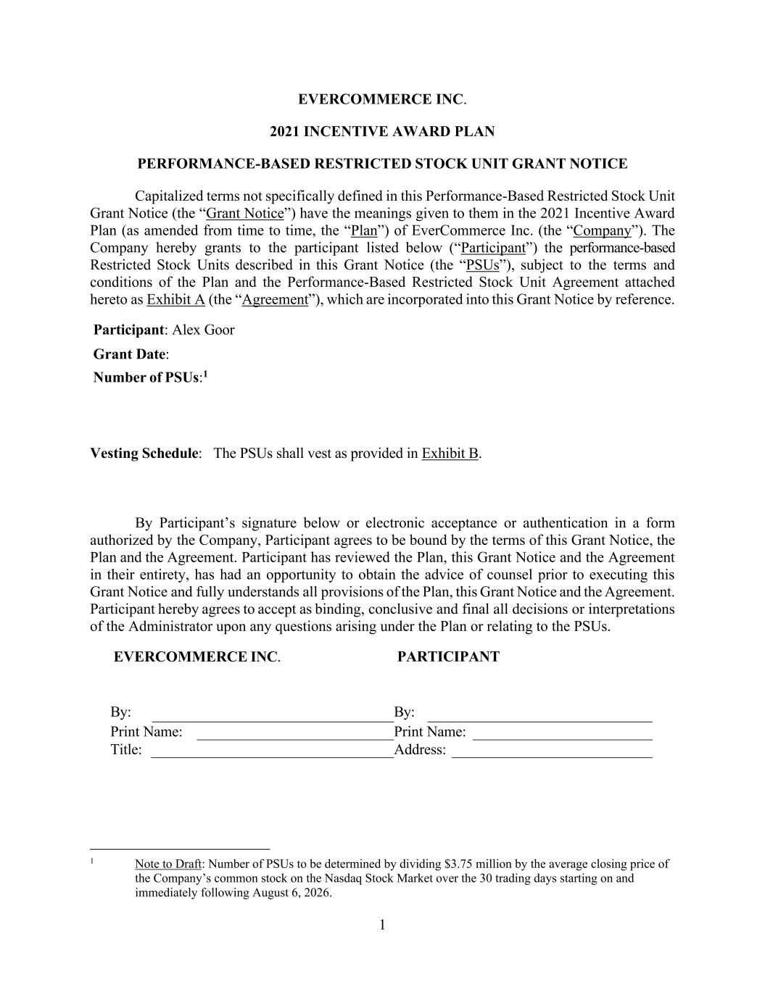
1 EVERCOMMERCE INC. 2021 INCENTIVE AWARD PLAN PERFORMANCE-BASED RESTRICTED STOCK UNIT GRANT NOTICE Capitalized terms not specifically defined in this Performance-Based Restricted Stock Unit Grant Notice (the “Grant Notice”) have the meanings given to them in the 2021 Incentive Award Plan (as amended from time to time, the “Plan”) of EverCommerce Inc. (the “Company”). The Company hereby grants to the participant listed below (“Participant”) the performance-based Restricted Stock Units described in this Grant Notice (the “PSUs”), subject to the terms and conditions of the Plan and the Performance-Based Restricted Stock Unit Agreement attached hereto as Exhibit A (the “Agreement”), which are incorporated into this Grant Notice by reference. Participant: Alex Goor Grant Date: Number of PSUs:1 Vesting Schedule: The PSUs shall vest as provided in Exhibit B. By Participant’s signature below or electronic acceptance or authentication in a form authorized by the Company, Participant agrees to be bound by the terms of this Grant Notice, the Plan and the Agreement. Participant has reviewed the Plan, this Grant Notice and the Agreement in their entirety, has had an opportunity to obtain the advice of counsel prior to executing this Grant Notice and fully understands all provisions of the Plan, this Grant Notice and the Agreement. Participant hereby agrees to accept as binding, conclusive and final all decisions or interpretations of the Administrator upon any questions arising under the Plan or relating to the PSUs. EVERCOMMERCE INC. PARTICIPANT By: By: Print Name: Print Name: Title: Address: 1 Note to Draft: Number of PSUs to be determined by dividing $3.75 million by the average closing price of the Company’s common stock on the Nasdaq Stock Market over the 30 trading days starting on and immediately following August 6, 2026.

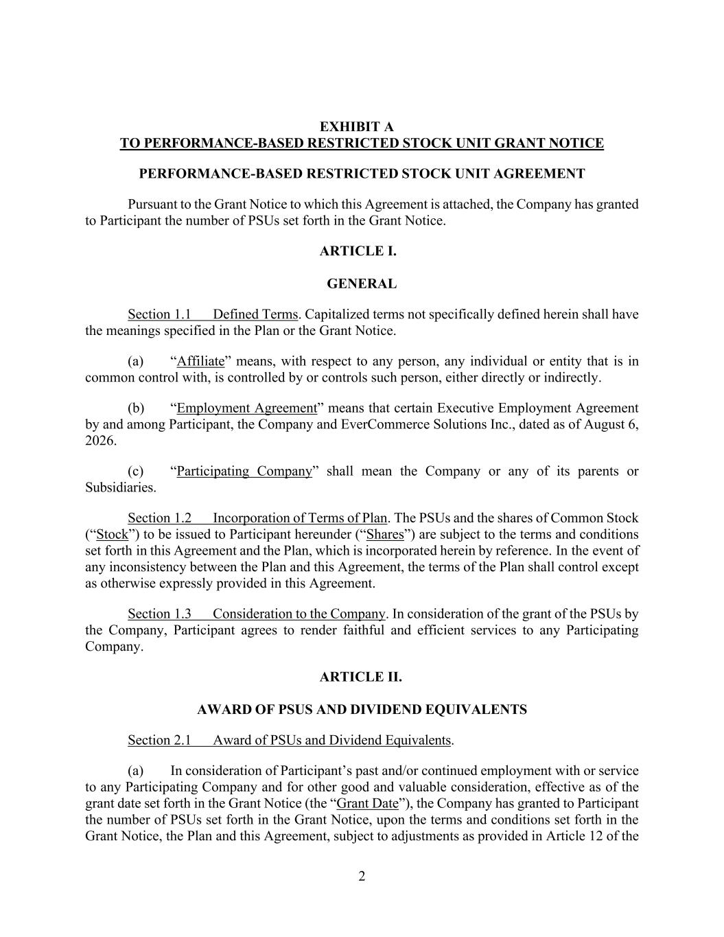
2 EXHIBIT A TO PERFORMANCE-BASED RESTRICTED STOCK UNIT GRANT NOTICE PERFORMANCE-BASED RESTRICTED STOCK UNIT AGREEMENT Pursuant to the Grant Notice to which this Agreement is attached, the Company has granted to Participant the number of PSUs set forth in the Grant Notice. ARTICLE I. GENERAL Section 1.1 Defined Terms. Capitalized terms not specifically defined herein shall have the meanings specified in the Plan or the Grant Notice. (a) “Affiliate” means, with respect to any person, any individual or entity that is in common control with, is controlled by or controls such person, either directly or indirectly. (b) “Employment Agreement” means that certain Executive Employment Agreement by and among Participant, the Company and EverCommerce Solutions Inc., dated as of August 6, 2026. (c) “Participating Company” shall mean the Company or any of its parents or Subsidiaries. Section 1.2 Incorporation of Terms of Plan. The PSUs and the shares of Common Stock (“Stock”) to be issued to Participant hereunder (“Shares”) are subject to the terms and conditions set forth in this Agreement and the Plan, which is incorporated herein by reference. In the event of any inconsistency between the Plan and this Agreement, the terms of the Plan shall control except as otherwise expressly provided in this Agreement. Section 1.3 Consideration to the Company. In consideration of the grant of the PSUs by the Company, Participant agrees to render faithful and efficient services to any Participating Company. ARTICLE II. AWARD OF PSUS AND DIVIDEND EQUIVALENTS Section 2.1 Award of PSUs and Dividend Equivalents. (a) In consideration of Participant’s past and/or continued employment with or service to any Participating Company and for other good and valuable consideration, effective as of the grant date set forth in the Grant Notice (the “Grant Date”), the Company has granted to Participant the number of PSUs set forth in the Grant Notice, upon the terms and conditions set forth in the Grant Notice, the Plan and this Agreement, subject to adjustments as provided in Article 12 of the

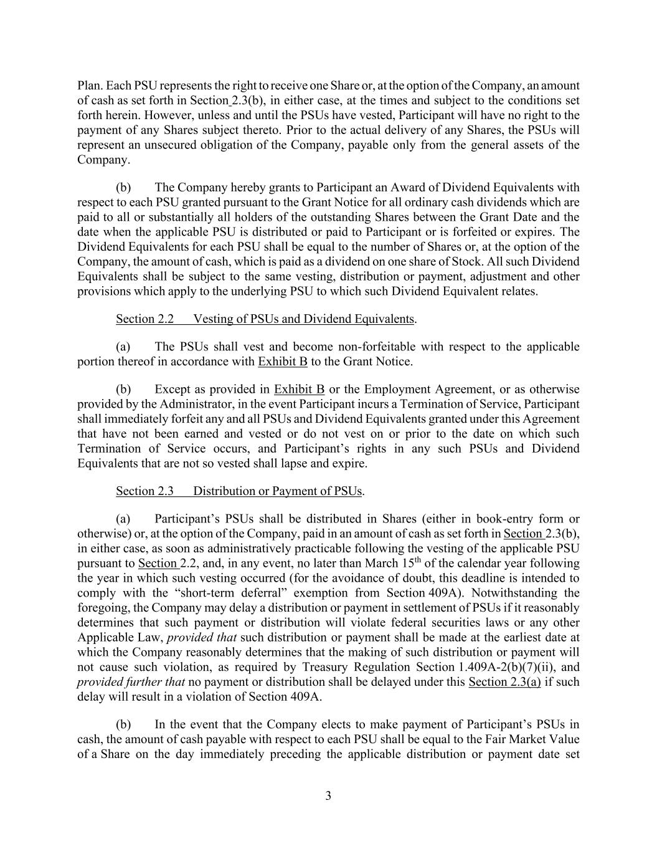
3 Plan. Each PSU represents the right to receive one Share or, at the option of the Company, an amount of cash as set forth in Section 2.3(b), in either case, at the times and subject to the conditions set forth herein. However, unless and until the PSUs have vested, Participant will have no right to the payment of any Shares subject thereto. Prior to the actual delivery of any Shares, the PSUs will represent an unsecured obligation of the Company, payable only from the general assets of the Company. (b) The Company hereby grants to Participant an Award of Dividend Equivalents with respect to each PSU granted pursuant to the Grant Notice for all ordinary cash dividends which are paid to all or substantially all holders of the outstanding Shares between the Grant Date and the date when the applicable PSU is distributed or paid to Participant or is forfeited or expires. The Dividend Equivalents for each PSU shall be equal to the number of Shares or, at the option of the Company, the amount of cash, which is paid as a dividend on one share of Stock. All such Dividend Equivalents shall be subject to the same vesting, distribution or payment, adjustment and other provisions which apply to the underlying PSU to which such Dividend Equivalent relates. Section 2.2 Vesting of PSUs and Dividend Equivalents. (a) The PSUs shall vest and become non-forfeitable with respect to the applicable portion thereof in accordance with Exhibit B to the Grant Notice. (b) Except as provided in Exhibit B or the Employment Agreement, or as otherwise provided by the Administrator, in the event Participant incurs a Termination of Service, Participant shall immediately forfeit any and all PSUs and Dividend Equivalents granted under this Agreement that have not been earned and vested or do not vest on or prior to the date on which such Termination of Service occurs, and Participant’s rights in any such PSUs and Dividend Equivalents that are not so vested shall lapse and expire. Section 2.3 Distribution or Payment of PSUs. (a) Participant’s PSUs shall be distributed in Shares (either in book-entry form or otherwise) or, at the option of the Company, paid in an amount of cash as set forth in Section 2.3(b), in either case, as soon as administratively practicable following the vesting of the applicable PSU pursuant to Section 2.2, and, in any event, no later than March 15th of the calendar year following the year in which such vesting occurred (for the avoidance of doubt, this deadline is intended to comply with the “short-term deferral” exemption from Section 409A). Notwithstanding the foregoing, the Company may delay a distribution or payment in settlement of PSUs if it reasonably determines that such payment or distribution will violate federal securities laws or any other Applicable Law, provided that such distribution or payment shall be made at the earliest date at which the Company reasonably determines that the making of such distribution or payment will not cause such violation, as required by Treasury Regulation Section 1.409A-2(b)(7)(ii), and provided further that no payment or distribution shall be delayed under this Section 2.3(a) if such delay will result in a violation of Section 409A. (b) In the event that the Company elects to make payment of Participant’s PSUs in cash, the amount of cash payable with respect to each PSU shall be equal to the Fair Market Value of a Share on the day immediately preceding the applicable distribution or payment date set

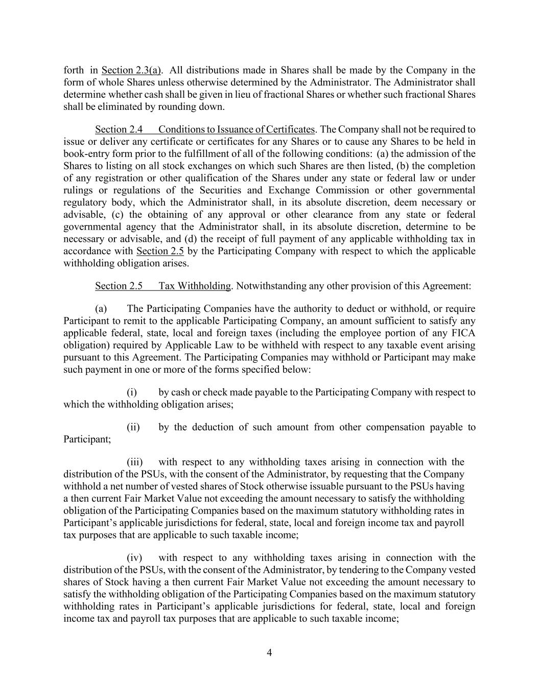
4 forth in Section 2.3(a). All distributions made in Shares shall be made by the Company in the form of whole Shares unless otherwise determined by the Administrator. The Administrator shall determine whether cash shall be given in lieu of fractional Shares or whether such fractional Shares shall be eliminated by rounding down. Section 2.4 Conditions to Issuance of Certificates. The Company shall not be required to issue or deliver any certificate or certificates for any Shares or to cause any Shares to be held in book-entry form prior to the fulfillment of all of the following conditions: (a) the admission of the Shares to listing on all stock exchanges on which such Shares are then listed, (b) the completion of any registration or other qualification of the Shares under any state or federal law or under rulings or regulations of the Securities and Exchange Commission or other governmental regulatory body, which the Administrator shall, in its absolute discretion, deem necessary or advisable, (c) the obtaining of any approval or other clearance from any state or federal governmental agency that the Administrator shall, in its absolute discretion, determine to be necessary or advisable, and (d) the receipt of full payment of any applicable withholding tax in accordance with Section 2.5 by the Participating Company with respect to which the applicable withholding obligation arises. Section 2.5 Tax Withholding. Notwithstanding any other provision of this Agreement: (a) The Participating Companies have the authority to deduct or withhold, or require Participant to remit to the applicable Participating Company, an amount sufficient to satisfy any applicable federal, state, local and foreign taxes (including the employee portion of any FICA obligation) required by Applicable Law to be withheld with respect to any taxable event arising pursuant to this Agreement. The Participating Companies may withhold or Participant may make such payment in one or more of the forms specified below: (i) by cash or check made payable to the Participating Company with respect to which the withholding obligation arises; (ii) by the deduction of such amount from other compensation payable to Participant; (iii) with respect to any withholding taxes arising in connection with the distribution of the PSUs, with the consent of the Administrator, by requesting that the Company withhold a net number of vested shares of Stock otherwise issuable pursuant to the PSUs having a then current Fair Market Value not exceeding the amount necessary to satisfy the withholding obligation of the Participating Companies based on the maximum statutory withholding rates in Participant’s applicable jurisdictions for federal, state, local and foreign income tax and payroll tax purposes that are applicable to such taxable income; (iv) with respect to any withholding taxes arising in connection with the distribution of the PSUs, with the consent of the Administrator, by tendering to the Company vested shares of Stock having a then current Fair Market Value not exceeding the amount necessary to satisfy the withholding obligation of the Participating Companies based on the maximum statutory withholding rates in Participant’s applicable jurisdictions for federal, state, local and foreign income tax and payroll tax purposes that are applicable to such taxable income;

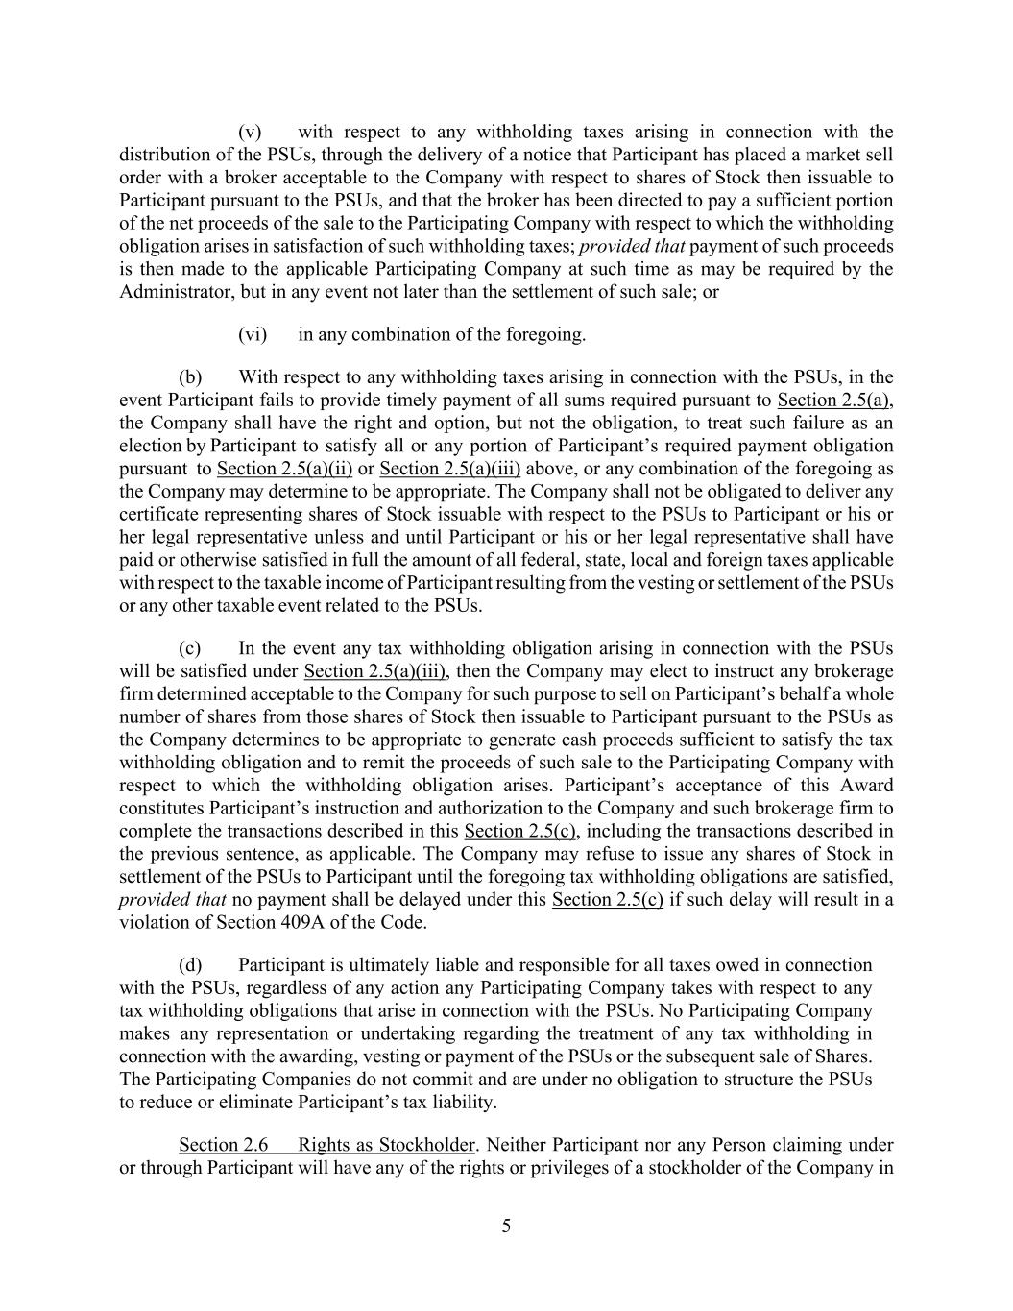
5 (v) with respect to any withholding taxes arising in connection with the distribution of the PSUs, through the delivery of a notice that Participant has placed a market sell order with a broker acceptable to the Company with respect to shares of Stock then issuable to Participant pursuant to the PSUs, and that the broker has been directed to pay a sufficient portion of the net proceeds of the sale to the Participating Company with respect to which the withholding obligation arises in satisfaction of such withholding taxes; provided that payment of such proceeds is then made to the applicable Participating Company at such time as may be required by the Administrator, but in any event not later than the settlement of such sale; or (vi) in any combination of the foregoing. (b) With respect to any withholding taxes arising in connection with the PSUs, in the event Participant fails to provide timely payment of all sums required pursuant to Section 2.5(a), the Company shall have the right and option, but not the obligation, to treat such failure as an election by Participant to satisfy all or any portion of Participant’s required payment obligation pursuant to Section 2.5(a)(ii) or Section 2.5(a)(iii) above, or any combination of the foregoing as the Company may determine to be appropriate. The Company shall not be obligated to deliver any certificate representing shares of Stock issuable with respect to the PSUs to Participant or his or her legal representative unless and until Participant or his or her legal representative shall have paid or otherwise satisfied in full the amount of all federal, state, local and foreign taxes applicable with respect to the taxable income of Participant resulting from the vesting or settlement of the PSUs or any other taxable event related to the PSUs. (c) In the event any tax withholding obligation arising in connection with the PSUs will be satisfied under Section 2.5(a)(iii), then the Company may elect to instruct any brokerage firm determined acceptable to the Company for such purpose to sell on Participant’s behalf a whole number of shares from those shares of Stock then issuable to Participant pursuant to the PSUs as the Company determines to be appropriate to generate cash proceeds sufficient to satisfy the tax withholding obligation and to remit the proceeds of such sale to the Participating Company with respect to which the withholding obligation arises. Participant’s acceptance of this Award constitutes Participant’s instruction and authorization to the Company and such brokerage firm to complete the transactions described in this Section 2.5(c), including the transactions described in the previous sentence, as applicable. The Company may refuse to issue any shares of Stock in settlement of the PSUs to Participant until the foregoing tax withholding obligations are satisfied, provided that no payment shall be delayed under this Section 2.5(c) if such delay will result in a violation of Section 409A of the Code. (d) Participant is ultimately liable and responsible for all taxes owed in connection with the PSUs, regardless of any action any Participating Company takes with respect to any tax withholding obligations that arise in connection with the PSUs. No Participating Company makes any representation or undertaking regarding the treatment of any tax withholding in connection with the awarding, vesting or payment of the PSUs or the subsequent sale of Shares. The Participating Companies do not commit and are under no obligation to structure the PSUs to reduce or eliminate Participant’s tax liability. Section 2.6 Rights as Stockholder. Neither Participant nor any Person claiming under or through Participant will have any of the rights or privileges of a stockholder of the Company in

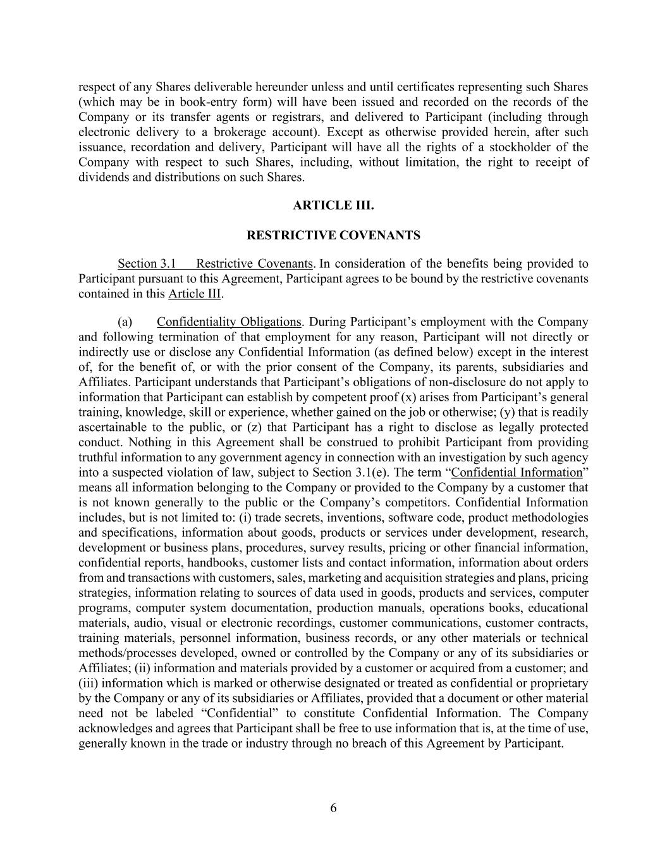
6 respect of any Shares deliverable hereunder unless and until certificates representing such Shares (which may be in book-entry form) will have been issued and recorded on the records of the Company or its transfer agents or registrars, and delivered to Participant (including through electronic delivery to a brokerage account). Except as otherwise provided herein, after such issuance, recordation and delivery, Participant will have all the rights of a stockholder of the Company with respect to such Shares, including, without limitation, the right to receipt of dividends and distributions on such Shares. ARTICLE III. RESTRICTIVE COVENANTS Section 3.1 Restrictive Covenants. In consideration of the benefits being provided to Participant pursuant to this Agreement, Participant agrees to be bound by the restrictive covenants contained in this Article III. (a) Confidentiality Obligations. During Participant’s employment with the Company and following termination of that employment for any reason, Participant will not directly or indirectly use or disclose any Confidential Information (as defined below) except in the interest of, for the benefit of, or with the prior consent of the Company, its parents, subsidiaries and Affiliates. Participant understands that Participant’s obligations of non-disclosure do not apply to information that Participant can establish by competent proof (x) arises from Participant’s general training, knowledge, skill or experience, whether gained on the job or otherwise; (y) that is readily ascertainable to the public, or (z) that Participant has a right to disclose as legally protected conduct. Nothing in this Agreement shall be construed to prohibit Participant from providing truthful information to any government agency in connection with an investigation by such agency into a suspected violation of law, subject to Section 3.1(e). The term “Confidential Information” means all information belonging to the Company or provided to the Company by a customer that is not known generally to the public or the Company’s competitors. Confidential Information includes, but is not limited to: (i) trade secrets, inventions, software code, product methodologies and specifications, information about goods, products or services under development, research, development or business plans, procedures, survey results, pricing or other financial information, confidential reports, handbooks, customer lists and contact information, information about orders from and transactions with customers, sales, marketing and acquisition strategies and plans, pricing strategies, information relating to sources of data used in goods, products and services, computer programs, computer system documentation, production manuals, operations books, educational materials, audio, visual or electronic recordings, customer communications, customer contracts, training materials, personnel information, business records, or any other materials or technical methods/processes developed, owned or controlled by the Company or any of its subsidiaries or Affiliates; (ii) information and materials provided by a customer or acquired from a customer; and (iii) information which is marked or otherwise designated or treated as confidential or proprietary by the Company or any of its subsidiaries or Affiliates, provided that a document or other material need not be labeled “Confidential” to constitute Confidential Information. The Company acknowledges and agrees that Participant shall be free to use information that is, at the time of use, generally known in the trade or industry through no breach of this Agreement by Participant.

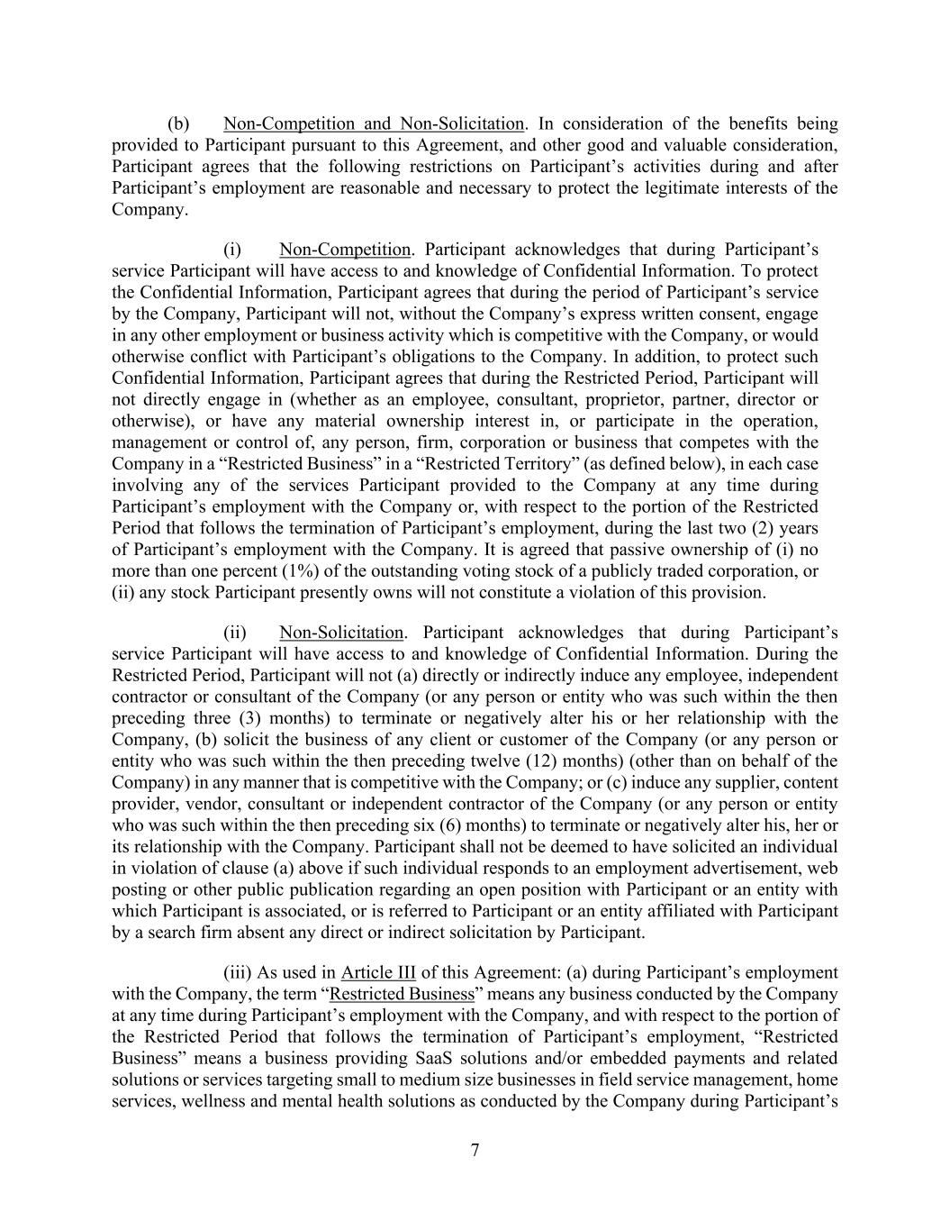
7 (b) Non-Competition and Non-Solicitation. In consideration of the benefits being provided to Participant pursuant to this Agreement, and other good and valuable consideration, Participant agrees that the following restrictions on Participant’s activities during and after Participant’s employment are reasonable and necessary to protect the legitimate interests of the Company. (i) Non-Competition. Participant acknowledges that during Participant’s service Participant will have access to and knowledge of Confidential Information. To protect the Confidential Information, Participant agrees that during the period of Participant’s service by the Company, Participant will not, without the Company’s express written consent, engage in any other employment or business activity which is competitive with the Company, or would otherwise conflict with Participant’s obligations to the Company. In addition, to protect such Confidential Information, Participant agrees that during the Restricted Period, Participant will not directly engage in (whether as an employee, consultant, proprietor, partner, director or otherwise), or have any material ownership interest in, or participate in the operation, management or control of, any person, firm, corporation or business that competes with the Company in a “Restricted Business” in a “Restricted Territory” (as defined below), in each case involving any of the services Participant provided to the Company at any time during Participant’s employment with the Company or, with respect to the portion of the Restricted Period that follows the termination of Participant’s employment, during the last two (2) years of Participant’s employment with the Company. It is agreed that passive ownership of (i) no more than one percent (1%) of the outstanding voting stock of a publicly traded corporation, or (ii) any stock Participant presently owns will not constitute a violation of this provision. (ii) Non-Solicitation. Participant acknowledges that during Participant’s service Participant will have access to and knowledge of Confidential Information. During the Restricted Period, Participant will not (a) directly or indirectly induce any employee, independent contractor or consultant of the Company (or any person or entity who was such within the then preceding three (3) months) to terminate or negatively alter his or her relationship with the Company, (b) solicit the business of any client or customer of the Company (or any person or entity who was such within the then preceding twelve (12) months) (other than on behalf of the Company) in any manner that is competitive with the Company; or (c) induce any supplier, content provider, vendor, consultant or independent contractor of the Company (or any person or entity who was such within the then preceding six (6) months) to terminate or negatively alter his, her or its relationship with the Company. Participant shall not be deemed to have solicited an individual in violation of clause (a) above if such individual responds to an employment advertisement, web posting or other public publication regarding an open position with Participant or an entity with which Participant is associated, or is referred to Participant or an entity affiliated with Participant by a search firm absent any direct or indirect solicitation by Participant. (iii) As used in Article III of this Agreement: (a) during Participant’s employment with the Company, the term “Restricted Business” means any business conducted by the Company at any time during Participant’s employment with the Company, and with respect to the portion of the Restricted Period that follows the termination of Participant’s employment, “Restricted Business” means a business providing SaaS solutions and/or embedded payments and related solutions or services targeting small to medium size businesses in field service management, home services, wellness and mental health solutions as conducted by the Company during Participant’s

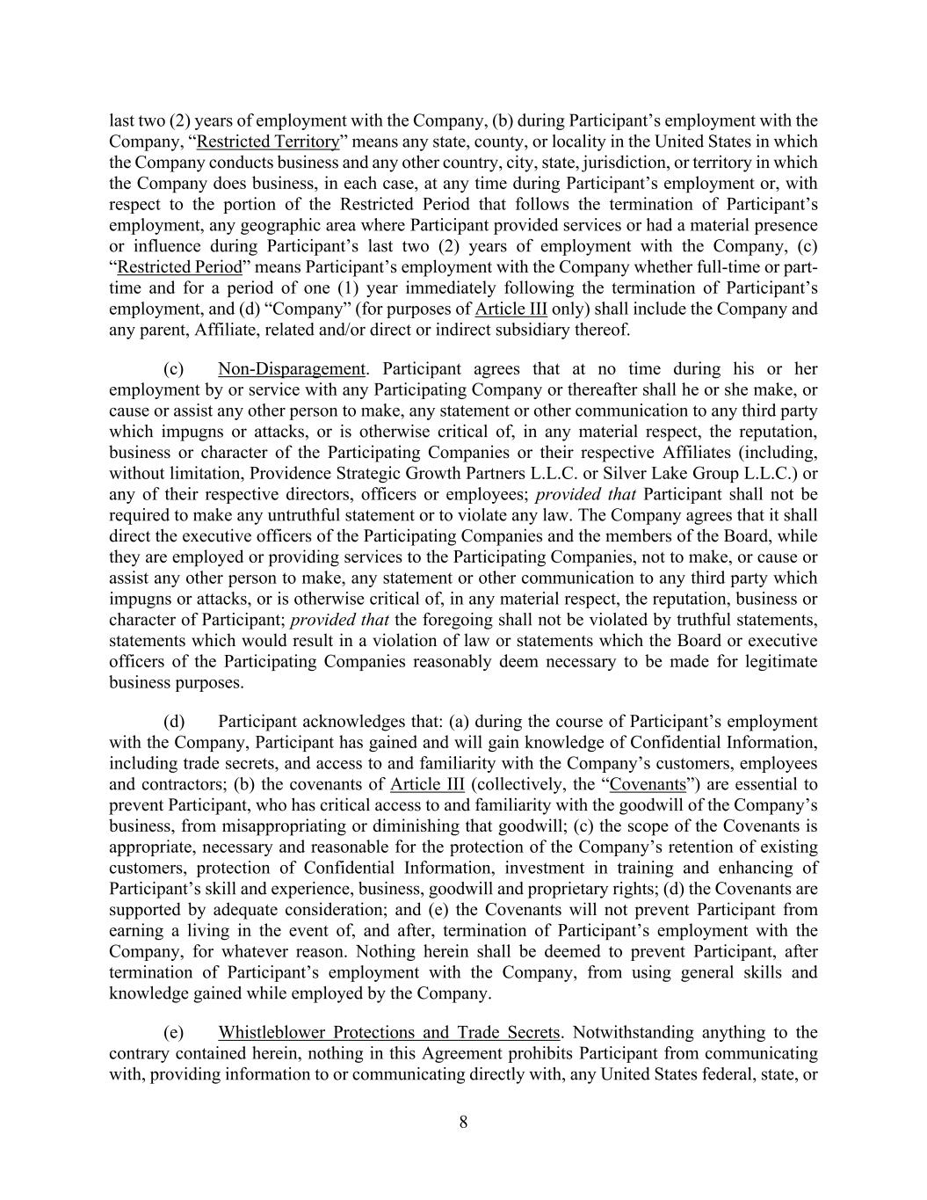
8 last two (2) years of employment with the Company, (b) during Participant’s employment with the Company, “Restricted Territory” means any state, county, or locality in the United States in which the Company conducts business and any other country, city, state, jurisdiction, or territory in which the Company does business, in each case, at any time during Participant’s employment or, with respect to the portion of the Restricted Period that follows the termination of Participant’s employment, any geographic area where Participant provided services or had a material presence or influence during Participant’s last two (2) years of employment with the Company, (c) “Restricted Period” means Participant’s employment with the Company whether full-time or part- time and for a period of one (1) year immediately following the termination of Participant’s employment, and (d) “Company” (for purposes of Article III only) shall include the Company and any parent, Affiliate, related and/or direct or indirect subsidiary thereof. (c) Non-Disparagement. Participant agrees that at no time during his or her employment by or service with any Participating Company or thereafter shall he or she make, or cause or assist any other person to make, any statement or other communication to any third party which impugns or attacks, or is otherwise critical of, in any material respect, the reputation, business or character of the Participating Companies or their respective Affiliates (including, without limitation, Providence Strategic Growth Partners L.L.C. or Silver Lake Group L.L.C.) or any of their respective directors, officers or employees; provided that Participant shall not be required to make any untruthful statement or to violate any law. The Company agrees that it shall direct the executive officers of the Participating Companies and the members of the Board, while they are employed or providing services to the Participating Companies, not to make, or cause or assist any other person to make, any statement or other communication to any third party which impugns or attacks, or is otherwise critical of, in any material respect, the reputation, business or character of Participant; provided that the foregoing shall not be violated by truthful statements, statements which would result in a violation of law or statements which the Board or executive officers of the Participating Companies reasonably deem necessary to be made for legitimate business purposes. (d) Participant acknowledges that: (a) during the course of Participant’s employment with the Company, Participant has gained and will gain knowledge of Confidential Information, including trade secrets, and access to and familiarity with the Company’s customers, employees and contractors; (b) the covenants of Article III (collectively, the “Covenants”) are essential to prevent Participant, who has critical access to and familiarity with the goodwill of the Company’s business, from misappropriating or diminishing that goodwill; (c) the scope of the Covenants is appropriate, necessary and reasonable for the protection of the Company’s retention of existing customers, protection of Confidential Information, investment in training and enhancing of Participant’s skill and experience, business, goodwill and proprietary rights; (d) the Covenants are supported by adequate consideration; and (e) the Covenants will not prevent Participant from earning a living in the event of, and after, termination of Participant’s employment with the Company, for whatever reason. Nothing herein shall be deemed to prevent Participant, after termination of Participant’s employment with the Company, from using general skills and knowledge gained while employed by the Company. (e) Whistleblower Protections and Trade Secrets. Notwithstanding anything to the contrary contained herein, nothing in this Agreement prohibits Participant from communicating with, providing information to or communicating directly with, any United States federal, state, or

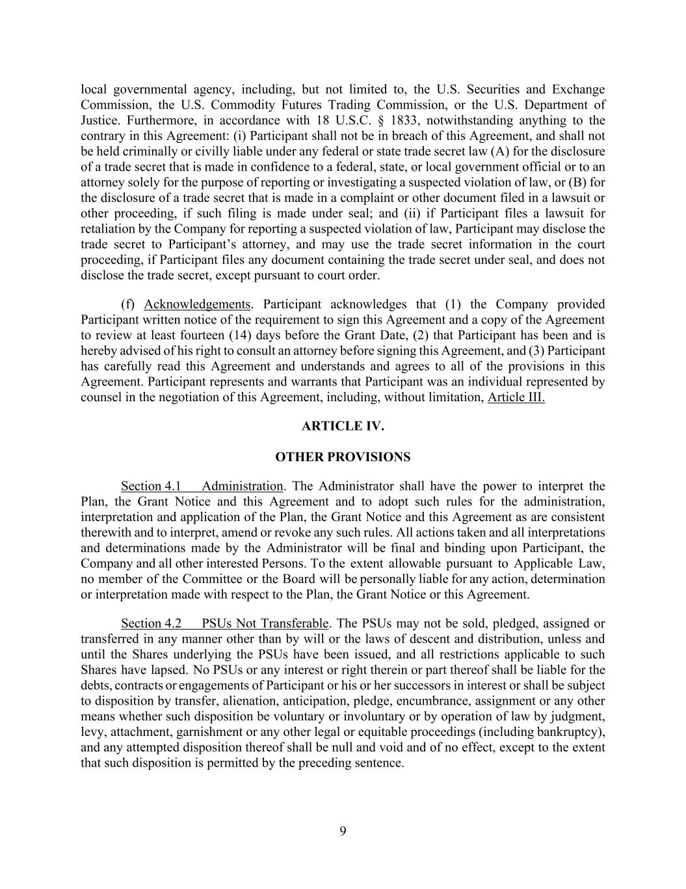
9 local governmental agency, including, but not limited to, the U.S. Securities and Exchange Commission, the U.S. Commodity Futures Trading Commission, or the U.S. Department of Justice. Furthermore, in accordance with 18 U.S.C. § 1833, notwithstanding anything to the contrary in this Agreement: (i) Participant shall not be in breach of this Agreement, and shall not be held criminally or civilly liable under any federal or state trade secret law (A) for the disclosure of a trade secret that is made in confidence to a federal, state, or local government official or to an attorney solely for the purpose of reporting or investigating a suspected violation of law, or (B) for the disclosure of a trade secret that is made in a complaint or other document filed in a lawsuit or other proceeding, if such filing is made under seal; and (ii) if Participant files a lawsuit for retaliation by the Company for reporting a suspected violation of law, Participant may disclose the trade secret to Participant’s attorney, and may use the trade secret information in the court proceeding, if Participant files any document containing the trade secret under seal, and does not disclose the trade secret, except pursuant to court order. (f) Acknowledgements. Participant acknowledges that (1) the Company provided Participant written notice of the requirement to sign this Agreement and a copy of the Agreement to review at least fourteen (14) days before the Grant Date, (2) that Participant has been and is hereby advised of his right to consult an attorney before signing this Agreement, and (3) Participant has carefully read this Agreement and understands and agrees to all of the provisions in this Agreement. Participant represents and warrants that Participant was an individual represented by counsel in the negotiation of this Agreement, including, without limitation, Article III. ARTICLE IV. OTHER PROVISIONS Section 4.1 Administration. The Administrator shall have the power to interpret the Plan, the Grant Notice and this Agreement and to adopt such rules for the administration, interpretation and application of the Plan, the Grant Notice and this Agreement as are consistent therewith and to interpret, amend or revoke any such rules. All actions taken and all interpretations and determinations made by the Administrator will be final and binding upon Participant, the Company and all other interested Persons. To the extent allowable pursuant to Applicable Law, no member of the Committee or the Board will be personally liable for any action, determination or interpretation made with respect to the Plan, the Grant Notice or this Agreement. Section 4.2 PSUs Not Transferable. The PSUs may not be sold, pledged, assigned or transferred in any manner other than by will or the laws of descent and distribution, unless and until the Shares underlying the PSUs have been issued, and all restrictions applicable to such Shares have lapsed. No PSUs or any interest or right therein or part thereof shall be liable for the debts, contracts or engagements of Participant or his or her successors in interest or shall be subject to disposition by transfer, alienation, anticipation, pledge, encumbrance, assignment or any other means whether such disposition be voluntary or involuntary or by operation of law by judgment, levy, attachment, garnishment or any other legal or equitable proceedings (including bankruptcy), and any attempted disposition thereof shall be null and void and of no effect, except to the extent that such disposition is permitted by the preceding sentence.

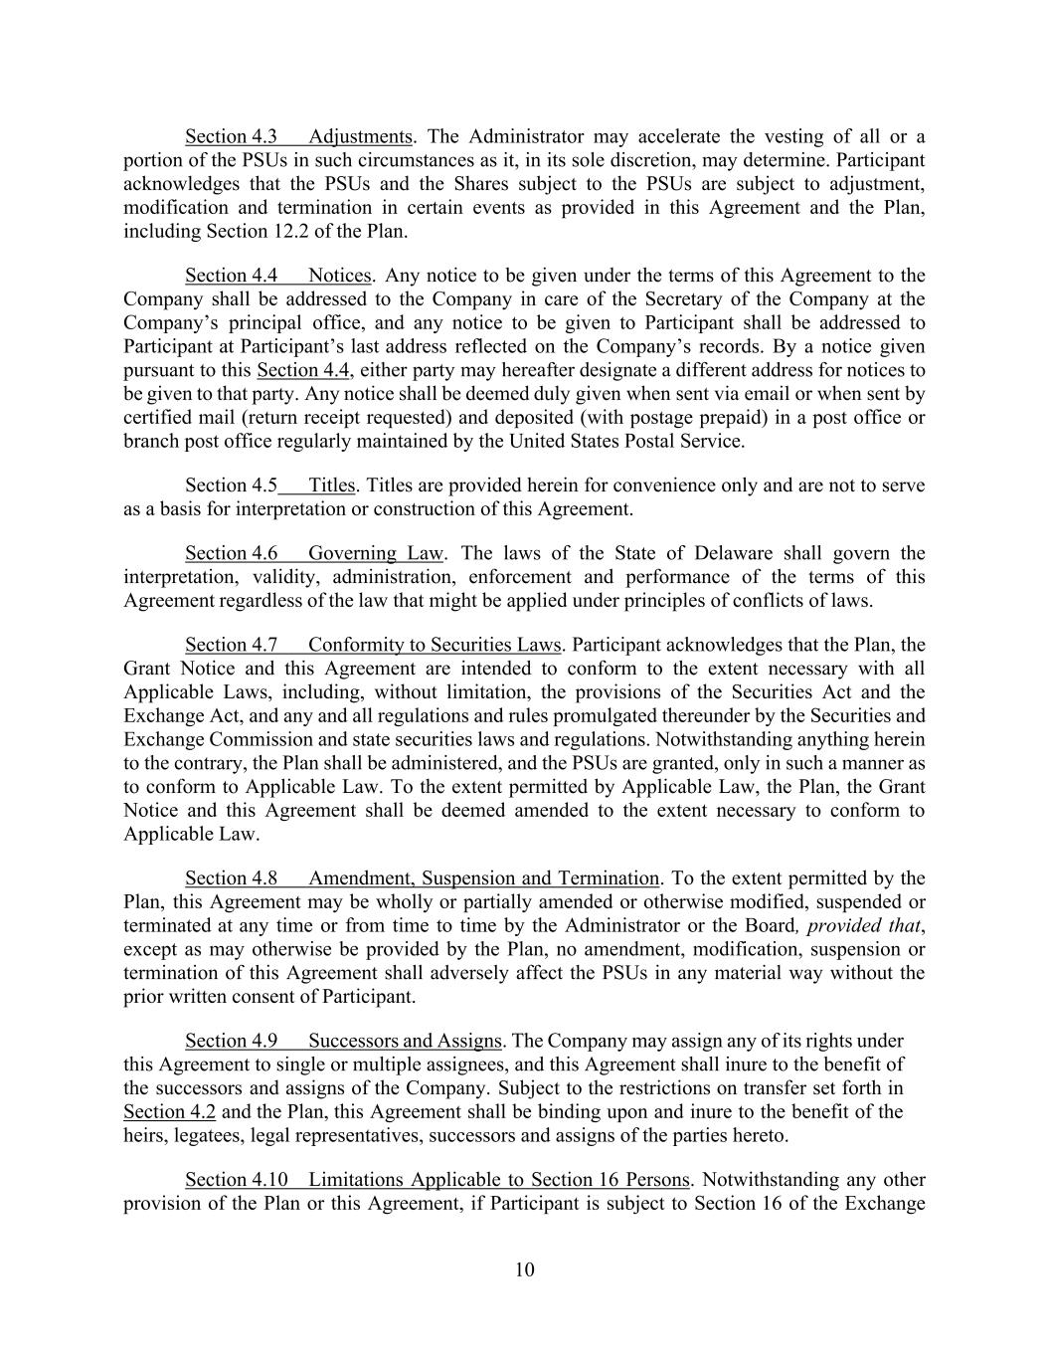
10 Section 4.3 Adjustments. The Administrator may accelerate the vesting of all or a portion of the PSUs in such circumstances as it, in its sole discretion, may determine. Participant acknowledges that the PSUs and the Shares subject to the PSUs are subject to adjustment, modification and termination in certain events as provided in this Agreement and the Plan, including Section 12.2 of the Plan. Section 4.4 Notices. Any notice to be given under the terms of this Agreement to the Company shall be addressed to the Company in care of the Secretary of the Company at the Company’s principal office, and any notice to be given to Participant shall be addressed to Participant at Participant’s last address reflected on the Company’s records. By a notice given pursuant to this Section 4.4, either party may hereafter designate a different address for notices to be given to that party. Any notice shall be deemed duly given when sent via email or when sent by certified mail (return receipt requested) and deposited (with postage prepaid) in a post office or branch post office regularly maintained by the United States Postal Service. Section 4.5 Titles. Titles are provided herein for convenience only and are not to serve as a basis for interpretation or construction of this Agreement. Section 4.6 Governing Law. The laws of the State of Delaware shall govern the interpretation, validity, administration, enforcement and performance of the terms of this Agreement regardless of the law that might be applied under principles of conflicts of laws. Section 4.7 Conformity to Securities Laws. Participant acknowledges that the Plan, the Grant Notice and this Agreement are intended to conform to the extent necessary with all Applicable Laws, including, without limitation, the provisions of the Securities Act and the Exchange Act, and any and all regulations and rules promulgated thereunder by the Securities and Exchange Commission and state securities laws and regulations. Notwithstanding anything herein to the contrary, the Plan shall be administered, and the PSUs are granted, only in such a manner as to conform to Applicable Law. To the extent permitted by Applicable Law, the Plan, the Grant Notice and this Agreement shall be deemed amended to the extent necessary to conform to Applicable Law. Section 4.8 Amendment, Suspension and Termination. To the extent permitted by the Plan, this Agreement may be wholly or partially amended or otherwise modified, suspended or terminated at any time or from time to time by the Administrator or the Board, provided that, except as may otherwise be provided by the Plan, no amendment, modification, suspension or termination of this Agreement shall adversely affect the PSUs in any material way without the prior written consent of Participant. Section 4.9 Successors and Assigns. The Company may assign any of its rights under this Agreement to single or multiple assignees, and this Agreement shall inure to the benefit of the successors and assigns of the Company. Subject to the restrictions on transfer set forth in Section 4.2 and the Plan, this Agreement shall be binding upon and inure to the benefit of the heirs, legatees, legal representatives, successors and assigns of the parties hereto. Section 4.10 Limitations Applicable to Section 16 Persons. Notwithstanding any other provision of the Plan or this Agreement, if Participant is subject to Section 16 of the Exchange

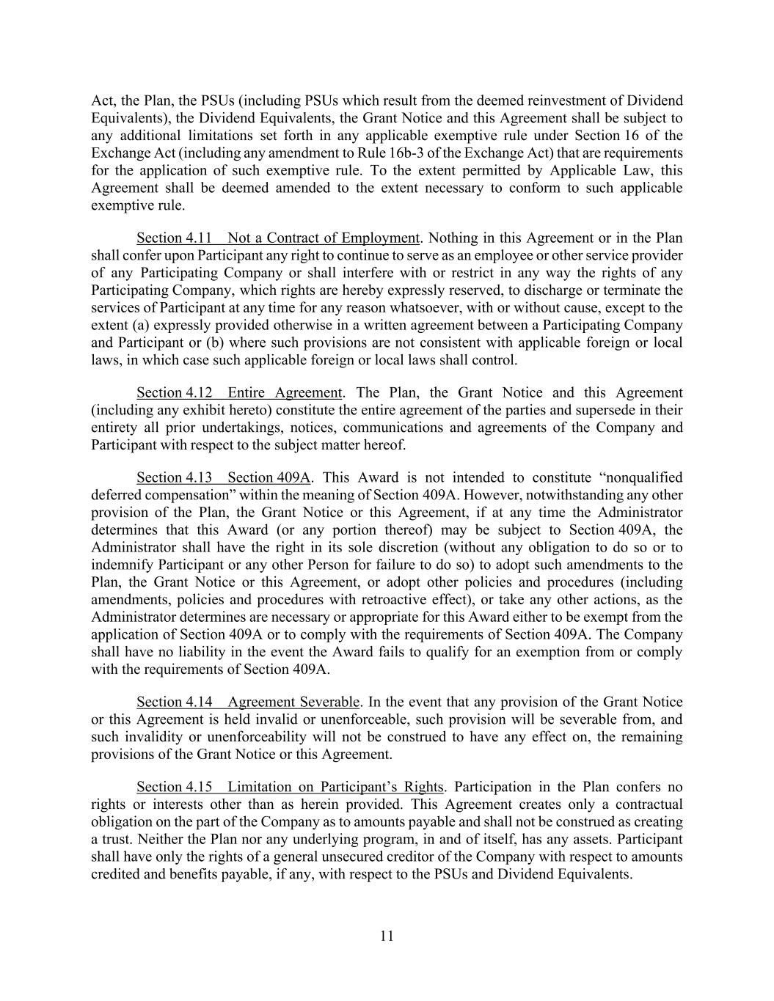
11 Act, the Plan, the PSUs (including PSUs which result from the deemed reinvestment of Dividend Equivalents), the Dividend Equivalents, the Grant Notice and this Agreement shall be subject to any additional limitations set forth in any applicable exemptive rule under Section 16 of the Exchange Act (including any amendment to Rule 16b-3 of the Exchange Act) that are requirements for the application of such exemptive rule. To the extent permitted by Applicable Law, this Agreement shall be deemed amended to the extent necessary to conform to such applicable exemptive rule. Section 4.11 Not a Contract of Employment. Nothing in this Agreement or in the Plan shall confer upon Participant any right to continue to serve as an employee or other service provider of any Participating Company or shall interfere with or restrict in any way the rights of any Participating Company, which rights are hereby expressly reserved, to discharge or terminate the services of Participant at any time for any reason whatsoever, with or without cause, except to the extent (a) expressly provided otherwise in a written agreement between a Participating Company and Participant or (b) where such provisions are not consistent with applicable foreign or local laws, in which case such applicable foreign or local laws shall control. Section 4.12 Entire Agreement. The Plan, the Grant Notice and this Agreement (including any exhibit hereto) constitute the entire agreement of the parties and supersede in their entirety all prior undertakings, notices, communications and agreements of the Company and Participant with respect to the subject matter hereof. Section 4.13 Section 409A. This Award is not intended to constitute “nonqualified deferred compensation” within the meaning of Section 409A. However, notwithstanding any other provision of the Plan, the Grant Notice or this Agreement, if at any time the Administrator determines that this Award (or any portion thereof) may be subject to Section 409A, the Administrator shall have the right in its sole discretion (without any obligation to do so or to indemnify Participant or any other Person for failure to do so) to adopt such amendments to the Plan, the Grant Notice or this Agreement, or adopt other policies and procedures (including amendments, policies and procedures with retroactive effect), or take any other actions, as the Administrator determines are necessary or appropriate for this Award either to be exempt from the application of Section 409A or to comply with the requirements of Section 409A. The Company shall have no liability in the event the Award fails to qualify for an exemption from or comply with the requirements of Section 409A. Section 4.14 Agreement Severable. In the event that any provision of the Grant Notice or this Agreement is held invalid or unenforceable, such provision will be severable from, and such invalidity or unenforceability will not be construed to have any effect on, the remaining provisions of the Grant Notice or this Agreement. Section 4.15 Limitation on Participant’s Rights. Participation in the Plan confers no rights or interests other than as herein provided. This Agreement creates only a contractual obligation on the part of the Company as to amounts payable and shall not be construed as creating a trust. Neither the Plan nor any underlying program, in and of itself, has any assets. Participant shall have only the rights of a general unsecured creditor of the Company with respect to amounts credited and benefits payable, if any, with respect to the PSUs and Dividend Equivalents.

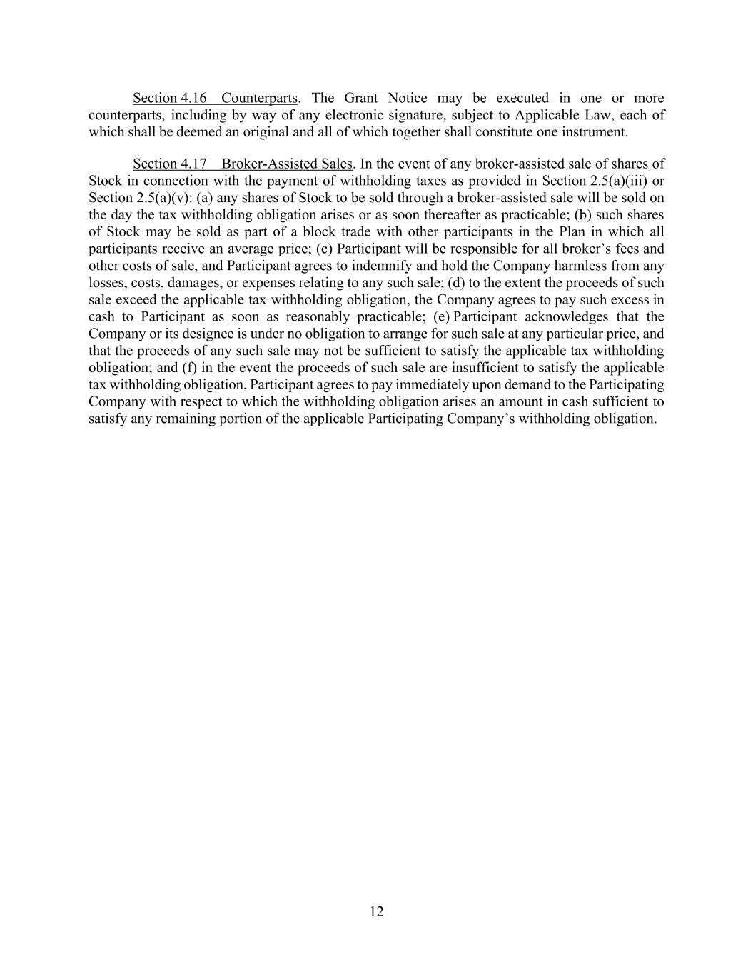
12 Section 4.16 Counterparts. The Grant Notice may be executed in one or more counterparts, including by way of any electronic signature, subject to Applicable Law, each of which shall be deemed an original and all of which together shall constitute one instrument. Section 4.17 Broker-Assisted Sales. In the event of any broker-assisted sale of shares of Stock in connection with the payment of withholding taxes as provided in Section 2.5(a)(iii) or Section 2.5(a)(v): (a) any shares of Stock to be sold through a broker-assisted sale will be sold on the day the tax withholding obligation arises or as soon thereafter as practicable; (b) such shares of Stock may be sold as part of a block trade with other participants in the Plan in which all participants receive an average price; (c) Participant will be responsible for all broker’s fees and other costs of sale, and Participant agrees to indemnify and hold the Company harmless from any losses, costs, damages, or expenses relating to any such sale; (d) to the extent the proceeds of such sale exceed the applicable tax withholding obligation, the Company agrees to pay such excess in cash to Participant as soon as reasonably practicable; (e) Participant acknowledges that the Company or its designee is under no obligation to arrange for such sale at any particular price, and that the proceeds of any such sale may not be sufficient to satisfy the applicable tax withholding obligation; and (f) in the event the proceeds of such sale are insufficient to satisfy the applicable tax withholding obligation, Participant agrees to pay immediately upon demand to the Participating Company with respect to which the withholding obligation arises an amount in cash sufficient to satisfy any remaining portion of the applicable Participating Company’s withholding obligation.

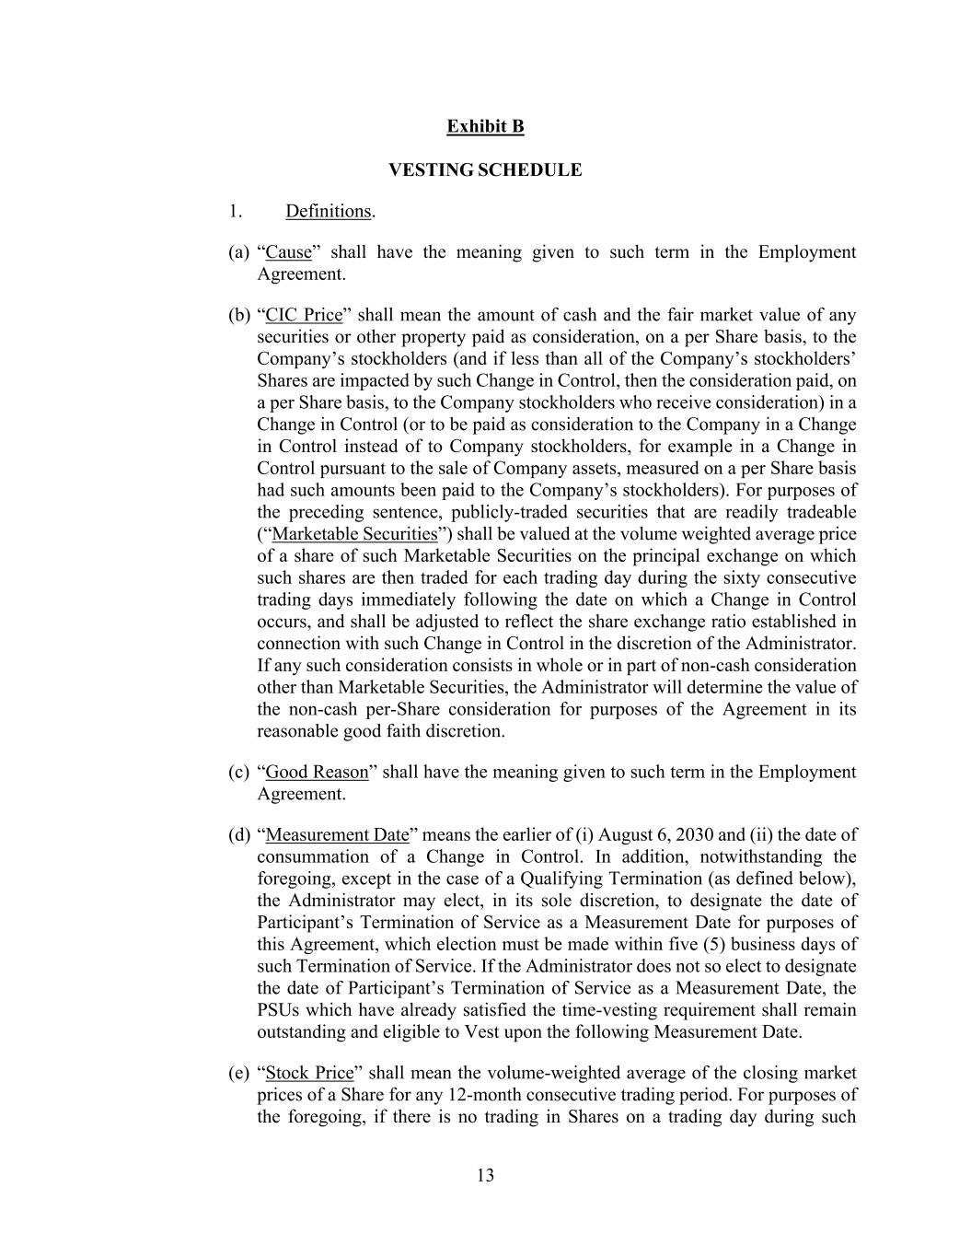
13 Exhibit B VESTING SCHEDULE 1. Definitions. (a) “Cause” shall have the meaning given to such term in the Employment Agreement. (b) “CIC Price” shall mean the amount of cash and the fair market value of any securities or other property paid as consideration, on a per Share basis, to the Company’s stockholders (and if less than all of the Company’s stockholders’ Shares are impacted by such Change in Control, then the consideration paid, on a per Share basis, to the Company stockholders who receive consideration) in a Change in Control (or to be paid as consideration to the Company in a Change in Control instead of to Company stockholders, for example in a Change in Control pursuant to the sale of Company assets, measured on a per Share basis had such amounts been paid to the Company’s stockholders). For purposes of the preceding sentence, publicly-traded securities that are readily tradeable (“Marketable Securities”) shall be valued at the volume weighted average price of a share of such Marketable Securities on the principal exchange on which such shares are then traded for each trading day during the sixty consecutive trading days immediately following the date on which a Change in Control occurs, and shall be adjusted to reflect the share exchange ratio established in connection with such Change in Control in the discretion of the Administrator. If any such consideration consists in whole or in part of non-cash consideration other than Marketable Securities, the Administrator will determine the value of the non-cash per-Share consideration for purposes of the Agreement in its reasonable good faith discretion. (c) “Good Reason” shall have the meaning given to such term in the Employment Agreement. (d) “Measurement Date” means the earlier of (i) August 6, 2030 and (ii) the date of consummation of a Change in Control. In addition, notwithstanding the foregoing, except in the case of a Qualifying Termination (as defined below), the Administrator may elect, in its sole discretion, to designate the date of Participant’s Termination of Service as a Measurement Date for purposes of this Agreement, which election must be made within five (5) business days of such Termination of Service. If the Administrator does not so elect to designate the date of Participant’s Termination of Service as a Measurement Date, the PSUs which have already satisfied the time-vesting requirement shall remain outstanding and eligible to Vest upon the following Measurement Date. (e) “Stock Price” shall mean the volume-weighted average of the closing market prices of a Share for any 12-month consecutive trading period. For purposes of the foregoing, if there is no trading in Shares on a trading day during such

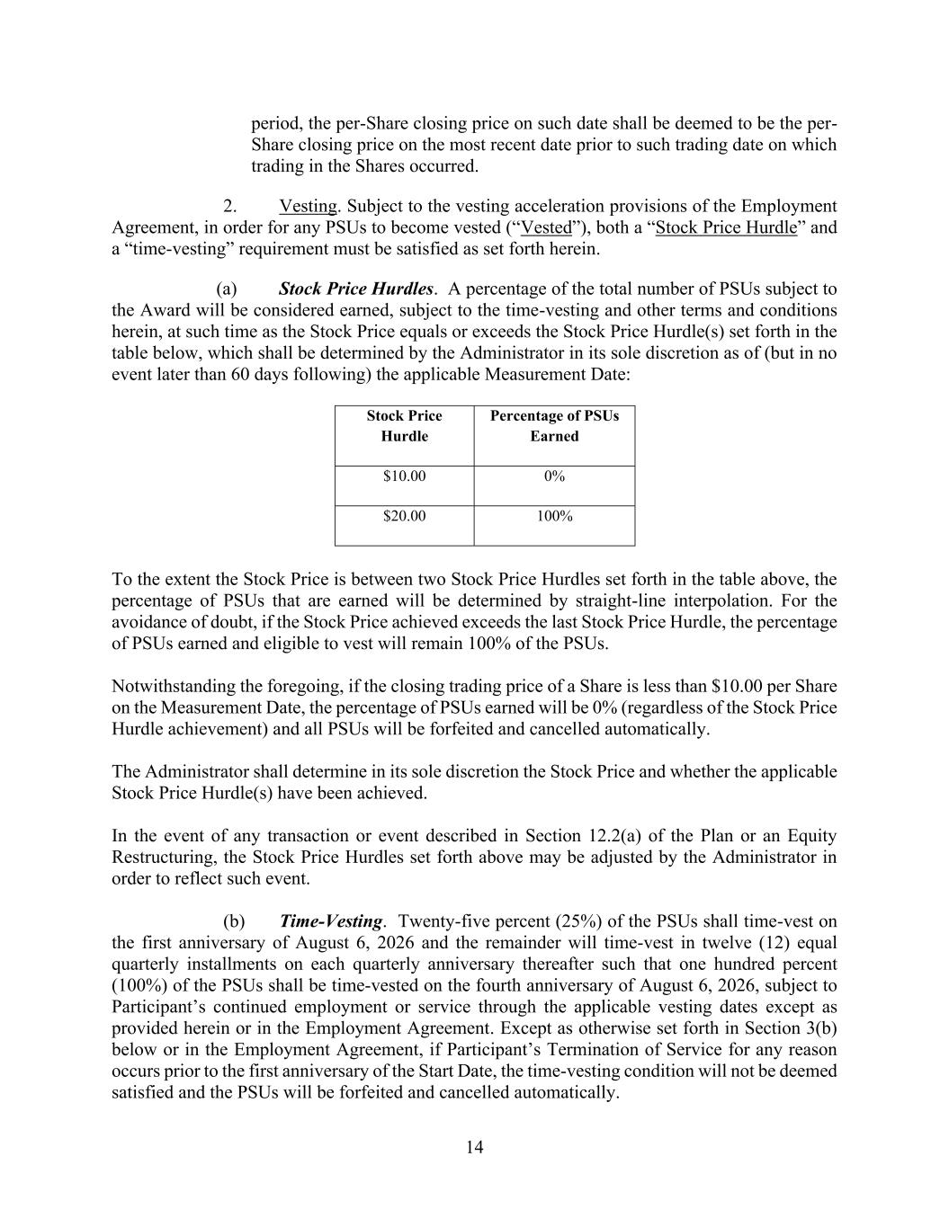
14 period, the per-Share closing price on such date shall be deemed to be the per- Share closing price on the most recent date prior to such trading date on which trading in the Shares occurred. 2. Vesting. Subject to the vesting acceleration provisions of the Employment Agreement, in order for any PSUs to become vested (“Vested”), both a “Stock Price Hurdle” and a “time-vesting” requirement must be satisfied as set forth herein. (a) Stock Price Hurdles. A percentage of the total number of PSUs subject to the Award will be considered earned, subject to the time-vesting and other terms and conditions herein, at such time as the Stock Price equals or exceeds the Stock Price Hurdle(s) set forth in the table below, which shall be determined by the Administrator in its sole discretion as of (but in no event later than 60 days following) the applicable Measurement Date: Stock Price Hurdle Percentage of PSUs Earned $10.00 0% $20.00 100% To the extent the Stock Price is between two Stock Price Hurdles set forth in the table above, the percentage of PSUs that are earned will be determined by straight-line interpolation. For the avoidance of doubt, if the Stock Price achieved exceeds the last Stock Price Hurdle, the percentage of PSUs earned and eligible to vest will remain 100% of the PSUs. Notwithstanding the foregoing, if the closing trading price of a Share is less than $10.00 per Share on the Measurement Date, the percentage of PSUs earned will be 0% (regardless of the Stock Price Hurdle achievement) and all PSUs will be forfeited and cancelled automatically. The Administrator shall determine in its sole discretion the Stock Price and whether the applicable Stock Price Hurdle(s) have been achieved. In the event of any transaction or event described in Section 12.2(a) of the Plan or an Equity Restructuring, the Stock Price Hurdles set forth above may be adjusted by the Administrator in order to reflect such event. (b) Time-Vesting. Twenty-five percent (25%) of the PSUs shall time-vest on the first anniversary of August 6, 2026 and the remainder will time-vest in twelve (12) equal quarterly installments on each quarterly anniversary thereafter such that one hundred percent (100%) of the PSUs shall be time-vested on the fourth anniversary of August 6, 2026, subject to Participant’s continued employment or service through the applicable vesting dates except as provided herein or in the Employment Agreement. Except as otherwise set forth in Section 3(b) below or in the Employment Agreement, if Participant’s Termination of Service for any reason occurs prior to the first anniversary of the Start Date, the time-vesting condition will not be deemed satisfied and the PSUs will be forfeited and cancelled automatically.

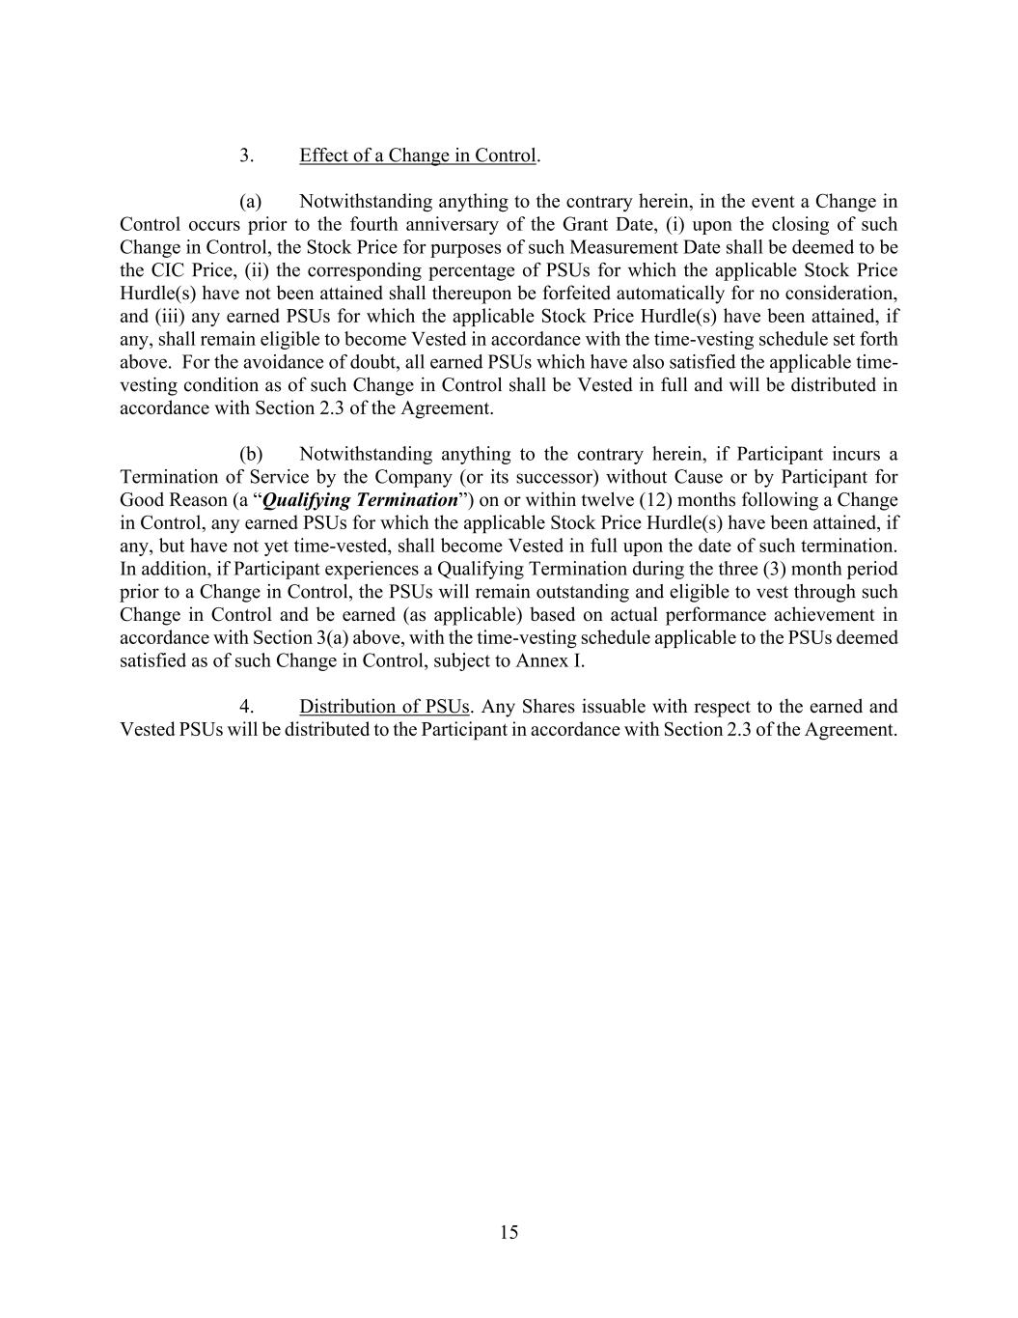
15 3. Effect of a Change in Control. (a) Notwithstanding anything to the contrary herein, in the event a Change in Control occurs prior to the fourth anniversary of the Grant Date, (i) upon the closing of such Change in Control, the Stock Price for purposes of such Measurement Date shall be deemed to be the CIC Price, (ii) the corresponding percentage of PSUs for which the applicable Stock Price Hurdle(s) have not been attained shall thereupon be forfeited automatically for no consideration, and (iii) any earned PSUs for which the applicable Stock Price Hurdle(s) have been attained, if any, shall remain eligible to become Vested in accordance with the time-vesting schedule set forth above. For the avoidance of doubt, all earned PSUs which have also satisfied the applicable time- vesting condition as of such Change in Control shall be Vested in full and will be distributed in accordance with Section 2.3 of the Agreement. (b) Notwithstanding anything to the contrary herein, if Participant incurs a Termination of Service by the Company (or its successor) without Cause or by Participant for Good Reason (a “Qualifying Termination”) on or within twelve (12) months following a Change in Control, any earned PSUs for which the applicable Stock Price Hurdle(s) have been attained, if any, but have not yet time-vested, shall become Vested in full upon the date of such termination. In addition, if Participant experiences a Qualifying Termination during the three (3) month period prior to a Change in Control, the PSUs will remain outstanding and eligible to vest through such Change in Control and be earned (as applicable) based on actual performance achievement in accordance with Section 3(a) above, with the time-vesting schedule applicable to the PSUs deemed satisfied as of such Change in Control, subject to Annex I. 4. Distribution of PSUs. Any Shares issuable with respect to the earned and Vested PSUs will be distributed to the Participant in accordance with Section 2.3 of the Agreement.


16 Annex I [ ]

Exhibit 99.1

EverCommerce Announces Second Quarter 2026 Financial Results
Denver, CO (August 5, 2026) EverCommerce Inc. ("EverCommerce" or the "Company") (NASDAQ: EVCM), a leading service commerce platform, today announced financial results for the quarter ended June 30, 2026.
Second Quarter 2026 Financial Highlights
•Revenue from continuing operations of $152.0 million, an increase of 2.7% compared to $148.0 million for the quarter ended June 30, 2025. Pro Forma Revenue increased 2.0% to $152.0 million, compared to $149.0 million for the quarter ended June 30, 2025.
•Subscription and transaction fees revenue from continuing operations of $147.4 million, an increase of 3.2% compared to $142.8 million for the quarter ended June 30, 2025. Pro Forma subscription and transaction fees revenue increased 2.4% to $147.4 million, compared to $143.9 million for the quarter ended June 30, 2025.
•Net income from continuing operations was $9.7 million, or $0.05 per basic and diluted share, for the quarter ended June 30, 2026, compared to $5.8 million, or $0.03 per basic and diluted share, for the quarter ended June 30, 2025.
•Adjusted EBITDA from continuing operations was $44.5 million for the quarter ended June 30, 2026, compared to $45.0 million for the quarter ended June 30, 2025.
"Evercommerce’s second quarter results were in-line with the midpoint of guidance range for revenue and exceeded the top end of guidance range for Adjusted EBITDA.” said Eric Remer, Evercommerce’s Founder and CEO. “I'm proud of what our team accomplished during the quarter and, more importantly, of the Company we've built together, While our outlook for the balance of 2026 has moderated and we now expect results toward the lower end of our guidance ranges, I remain confident in the strength of our platform, our customer relationships and our long-term strategy. As the Company begins its next chapter with Alex as CEO, he will focus on accelerating long-term growth and continuing to create value for our customers, employees and shareholders."
A reconciliation of GAAP to Non-GAAP measures has been provided in the financial statement tables included at the end of this press release. An explanation of these measures is also included below under the heading “Non-GAAP Financial Measures and Key Performance Metrics.”
Share Repurchases
The Company repurchased and retired 1.4 million shares of common stock for approximately $14.8 million during the three months ended June 30, 2026. As of June 30, 2026, $19.2 million remained available under the Repurchase Program.
Repurchases under the program may be made from time to time in the open market at prevailing market prices or in privately negotiated transactions. Open market repurchases will be structured to occur within the pricing and volume requirements of Rule 10b-18. The Company may also, from time to time, enter into Rule 10b5-1 plans to facilitate repurchases of its shares under this authorization. This program does not obligate the Company to acquire any particular amount of common stock and the program may be extended, modified, suspended or discontinued at any time at the Company’s discretion. The Company expects to fund repurchases with cash on hand.

1
Business Outlook
Based on information as of today, August 5, 2026, the Company is issuing the following financial guidance for the third quarter 2026 and full year 2026.
Third Quarter 2026:
•Revenue is expected to be in the range of $151.5 million to $154.5 million.
•Adjusted EBITDA is expected to be in the range of $44 million to $46 million.
Full Year 2026:
•Revenue is expected to be in the range of $612 million to $632 million.
•Adjusted EBITDA is expected to be in the range of $183 million to $191 million.
Based on our current outlook, we now expect full-year results to trend toward the lower end of our guidance ranges.
A reconciliation of Adjusted EBITDA to net income, the most directly comparable GAAP measure, is not available without unreasonable efforts on a forward-looking basis due to the high variability, complexity and low visibility with respect to certain charges excluded from this non-GAAP measure; in particular, the measures and effects of stock-based compensation expense specific to equity compensation awards that are directly impacted by unpredictable fluctuations in our stock price. It is important to note that these charges could be material to EverCommerce's results computed in accordance with GAAP.
Conference Call Information
EverCommerce’s management team will hold a conference call to discuss our second quarter 2026 results and outlook today, August 5, 2026, at 5:00 p.m. ET. Please visit the "Investor Relations" page of the Company's website (https://investors.evercommerce.com) for both telephonic and webcast access to this call as well as a copy of the presentation materials used on the call. An archive replay will be available following the conclusion of the call.
Investor Contact
Ryan Siurek
Chief Financial Officer
720-407-2888
IR@evercommerce.com
Media Contact
Jeanne Trogan
VP of Communications
737-465-2897
Press@evercommerce.com
About EverCommerce
EverCommerce (Nasdaq: EVCM) is an AI platform for the service economy, enabling more than 745,000 SMB customers worldwide with software that helps them schedule and manage work, communicate with customers and patients, bill and get paid, and build lasting customer relationships. With its EverPro, EverHealth, and EverWell brands specializing in the Home, Health, and Wellness service industries, EverCommerce delivers AI-driven workflows that matter most so service professionals can spend more time delivering great outcomes and less time on administrative work. Learn more at EverCommerce.com.

2
Forward-Looking Statements
This press release contains forward-looking statements within the meaning of the Private Securities Litigation Reform Act of 1995. All statements contained in this press release that do not relate to matters of historical fact should be considered forward-looking statements, including without limitation, statements regarding our future operations and financial results, including our guidance, AI based tools and anticipated expansion efforts, future stock repurchases, our potential for growth and our strategy. These statements are neither promises nor guarantees, but involve known and unknown risks, uncertainties and other important factors that may cause our actual results, performance or achievements to be materially different from any future results, performance or achievements expressed or implied by the forward-looking statements, including, but not limited to, our limited operating history and evolving business; our historical growth rates may not be sustainable or indicative of future growth; we have experienced net losses in the past and we may not achieve profitability in the future; we may continue to experience significant quarterly and annual fluctuations in our operating results due to a number of factors, which makes our future operating results difficult to predict; in order to support the growth of our business and our acquisition strategy, we may need to incur additional indebtedness or seek capital through new equity or debt financings; we may not be able to continue to expand our share of our existing vertical markets or expand into new vertical markets; we face intense competition in each of the industries in which we operate; the industries in which we operate are rapidly evolving and the market for technology-enabled services that empower SMBs is relatively immature and unproven; we are subject to economic and political risk, the business cycles of our clients and changes in the overall level of consumer and commercial spending, which could negatively impact our business, financial condition and results of operations; we are dependent on payment card networks, such as Visa and MasterCard, and payment processors, such as Worldpay and PayPal, and if we fail to comply with the applicable requirements of our payment networks or our payment processors, they can seek to fine us, suspend us or terminate our agreements and/or terminate our registrations through our bank sponsors; the inability to keep pace with rapid developments and changes in the electronic payments market or to introduce, develop and market new and enhanced versions of our software solutions; real or perceived errors, failures or bugs in our solutions; our and our third-party providers' exposure to cybersecurity risks and incidents; our use of AI technologies and evolving regulatory framework governing the use of such technologies; our estimated total addressable market is subject to inherent challenges and uncertainties; failure to effectively develop and expand our sales and marketing capabilities; impairment in the value of our goodwill or intangible assets; our information technology systems and our third-party providers’ information technology systems, including Worldpay, PayPal and other payment processing partners, may fail or our third-party providers may discontinue providing their services or technology generally or to us specifically; the impact of a future pandemic, epidemic or outbreak of an infectious disease on our business, financial condition and results of operations, as well as the business or operations of third parties with whom we conduct business; our success in achieving our objectives through acquisitions, divestitures or other strategic transactions; our revenues and profits generated through acquisitions may be less than anticipated, and we may fail to uncover all liabilities of acquisition targets; risks related to scrutiny on environmental sustainability and social initiatives; our ability to adequately protect or enforce our intellectual property and other proprietary rights; risk of patent, trademark and other intellectual property infringement claims; the impact of our use of AI technologies on our ability to obtain intellectual property protection in our solutions; risks related to governmental regulation and other legal obligations, particularly related to privacy, data protection and information security, and our actual or perceived failure to comply with such obligations; risks related to our sponsor stockholders agreement and qualifying as a “controlled company” under the rules of The Nasdaq Stock Market; as well as the other factors described in our Annual Report on Form 10-K for the year ended December 31, 2025 and updated by our other filings with the SEC. These factors could cause actual results to differ materially from those indicated by the forward-looking statements made in this press release. Any such forward-looking statements represent management’s estimates as of the date of this press release. While we may elect to update such forward-looking statements at some point in the future, we disclaim any obligation to do so, even if subsequent events cause our views to change.

3

Non-GAAP Financial Measures and Key Performance Metrics
EverCommerce has provided in this press release financial information that has not been prepared in accordance with generally accepted accounting principles in the United States (“GAAP”). EverCommerce uses these non-GAAP financial measures internally in analyzing its financial results and believes that use of these non-GAAP financial measures is useful to investors as an additional tool to evaluate ongoing operating results and trends and in comparing EverCommerce’s financial results with other companies in its industry, many of which present similar non-GAAP financial measures. Unless otherwise indicated, all non-GAAP financial measures are presented on the basis of continuing operations only.
Non-GAAP financial measures are not meant to be considered in isolation or as a substitute for comparable GAAP financial measures and should be read only in conjunction with EverCommerce’s consolidated financial statements prepared in accordance with GAAP. A reconciliation of EverCommerce’s historical non-GAAP financial measures to the most directly comparable GAAP measures has been provided in the financial statement tables included in this press release, and investors are encouraged to review the reconciliation.
Pro Forma Revenue, Pro Forma Subscription and Transaction Fees Revenue, Pro Forma Revenue Growth Rate, Pro Forma Subscription and Transaction Fees Revenue Growth Rate. Pro Forma Revenue, Pro Forma Subscription and Transaction Fees Revenue, Pro Forma Revenue Growth Rate, and Pro Forma Subscription and Transaction Fees Revenue Growth Rate are key performance measures that our management uses to assess our consolidated operating performance from continuing operations over time. Management also uses these metrics for planning and forecasting purposes.
Our year-over-year Pro Forma Revenue, Pro Forma Subscription and Transaction Fees Revenue, Pro Forma Revenue Growth Rate, and Pro Forma Subscription and Transaction Fees Revenue Growth Rate are calculated as though all acquisitions and divestitures completed as of the end of the latest period were completed as of the first day of the prior year period presented. In calculating Pro Forma Revenue, Pro Forma Subscription and Transaction Fees Revenue, Pro Forma Revenue Growth Rate, and Pro Forma Subscription and Transaction Fees Revenue Growth Rate, we add the revenue from acquisitions for the reporting periods prior to the date of acquisition (including estimated purchase accounting adjustments) and exclude revenue from divestitures for the reporting periods prior to the date of divestiture, and then, calculate our revenue growth rate between the two reported periods. As a result, these metrics include pro forma revenue from businesses acquired and excludes revenue from businesses divested of during the period, including revenue generated during periods when we did not yet own the acquired businesses and excludes revenue prior to the divestiture of the business. In including such pre-acquisition revenue and excluding pre-divestiture revenue, these metrics allow us to measure the underlying revenue growth of our business as it stands as of the end of the respective period, which we believe provides insight into our then-current operations. Pro Forma Revenue, Pro Forma Subscription and Transaction Fees Revenue, Pro Forma Revenue Growth Rate, and Pro Forma Subscription and Transaction Fees Revenue Growth Rate do not represent organic revenue generated by our business as it stood at the beginning of the respective period. Pro Forma Revenue, Pro Forma Subscription and Transaction Fees Revenue, Pro Forma Revenue Growth Rate, and Pro Forma Subscription and Transaction Fees Revenue Growth Rate are not necessarily indicative of either future results of operations or actual results that might have been achieved had the acquisitions and divestitures been consummated on the first day of the prior year period presented. We believe that these metrics are useful to investors in analyzing our financial and operational performance period over period and evaluating the growth of our business, normalizing for the impact of acquisitions and divestitures. These metrics are particularly useful to management due to the number of acquired entities.
Adjusted Gross Profit. Adjusted Gross Profit is a key performance measure that our management uses to assess our operational performance, as it represents the results of revenues and direct costs, which are key components of our operations. We believe that this non-GAAP financial measure is useful to investors and other interested parties in analyzing our financial performance because it reflects the gross profitability of our operations, and excludes the indirect costs associated with our sales and marketing, product development, general and administrative activities, and depreciation and amortization, and the impact of our financing methods and income taxes.

4
Gross profit is calculated as total revenues less cost of revenues (exclusive of depreciation and amortization), amortization of developed technology, amortization of capitalized software and depreciation expense (allocated to cost of revenues). We calculate Adjusted Gross Profit as gross profit adjusted to exclude depreciation and amortization allocated to cost of revenues. Adjusted Gross Profit should be viewed as a measure of operating performance that is a supplement to, and not a substitute for, operating income or loss, net earnings or loss and other GAAP measures of income (loss) or profitability.
Adjusted EBITDA and Adjusted EBITDA margin. Adjusted EBITDA and Adjusted EBITDA margin are key performance measures that our management uses to assess our financial performance and are also used for internal planning and forecasting purposes. We believe that these non-GAAP financial measures are useful to investors and other interested parties in analyzing our financial performance because they provide a comparable overview of our operations across historical periods. In addition, we believe that providing Adjusted EBITDA, together with a reconciliation of net income (loss) to Adjusted EBITDA, helps investors make comparisons between our company and other companies that may have different capital structures, different tax rates, and/or different forms of employee compensation.
Adjusted EBITDA and Adjusted EBITDA margin are used by our management team as additional measures of our performance for purposes of business decision-making, including managing expenditures, and evaluating potential acquisitions. Period-to-period comparisons of Adjusted EBITDA and Adjusted EBITDA margin help our management identify additional trends in our financial results that may not be shown solely by period-to-period comparisons of net income (loss) or income (loss) from continuing operations. In addition, we may use Adjusted EBITDA in the incentive compensation programs applicable to some of our employees. Our Management recognizes that Adjusted EBITDA has inherent limitations because of the excluded items, and may not be directly comparable to similarly titled metrics used by other companies.
We calculate Adjusted EBITDA as net income (loss) adjusted to exclude interest and other expense, net, income tax expense (benefit), depreciation and amortization, other amortization, stock-based compensation, and transaction-related and other non-recurring or unusual costs. Other amortization includes amortization for capitalized contract acquisition costs. Transaction-related costs are specific deal-related costs such as legal fees, financial and tax due diligence, consulting and escrow fees. Other non-recurring or unusual costs are expenses such as impairment charges, (gains) losses from divestitures, system implementation costs including amortization of cloud-based software implementation costs, executive separation costs, severance expense related to planned restructuring activities, and costs associated with integration and transformational improvements. Transaction-related and other non-recurring or unusual costs are excluded as they are not representative of our underlying operating performance. Adjusted EBITDA should be viewed as a measure of operating performance that is a supplement to, and not a substitute for, operating income or loss, net earnings or loss and other GAAP measures of income (loss).

5
EverCommerce Inc.
Condensed Consolidated Balance Sheets
(in thousands, except per share and share amounts)
(unaudited)
 |  |  | June 30, |  |  |  |  |  | December 31,
 |  |  | 2026 |  |  |  |  |  | 2025
Assets
Current assets:
Cash and cash equivalents |  |  | $ | 133,496 |  |  |  |  | $ | 129,730
Accounts receivable, net of allowance for expected credit losses of $3.7 million and $3.6 million at June 30, 2026 and December 31, 2025, respectively |  |  | 37,681 |  |  |  |  |  | 37,046
Contract assets |  |  | 12,334 |  |  |  |  |  | 11,612
Prepaid expenses and other current assets |  |  | 34,948 |  |  |  |  |  | 34,391
Total current assets |  |  | 218,459 |  |  |  |  |  | 212,779
Property and equipment, net |  |  | 6,033 |  |  |  |  |  | 5,744
Capitalized software, net |  |  | 66,925 |  |  |  |  |  | 58,968
Other non-current assets |  |  | 38,544 |  |  |  |  |  | 36,261
Intangible assets, net |  |  | 141,950 |  |  |  |  |  | 164,240
Goodwill |  |  | 892,531 |  |  |  |  |  | 893,802
Total assets |  |  | 1,364,442 |  |  |  |  |  | 1,371,794
Liabilities and Stockholders’ Equity
Current liabilities:
Accounts payable |  |  | $ | 10,737 |  |  |  |  | $ | 5,125
Accrued expenses and other |  |  | 50,532 |  |  |  |  |  | 55,836
Deferred revenue |  |  | 22,101 |  |  |  |  |  | 21,670
Customer deposits |  |  | 13,051 |  |  |  |  |  | 12,519
Current maturities of long-term debt |  |  | 5,500 |  |  |  |  |  | 5,500
Total current liabilities |  |  | 101,921 |  |  |  |  |  | 100,650
Long-term debt, net of current maturities and deferred financing costs |  |  | 515,442 |  |  |  |  |  | 517,891
Other non-current liabilities |  |  | 31,801 |  |  |  |  |  | 36,380
Total liabilities |  |  | 649,164 |  |  |  |  |  | 654,921
Stockholders’ equity:
Preferred stock, $0.00001 par value, 50,000,000 shares authorized and no shares issued or outstanding as of June 30, 2026 and December 31, 2025 |  |  | — |  |  |  |  |  | —
Common stock, $0.00001 par value, 2,000,000,000 shares authorized and 176,601,707 and 178,111,971 shares issued and outstanding at June 30, 2026 and December 31, 2025, respectively |  |  | 2 |  |  |  |  |  | 2
Accumulated other comprehensive loss |  |  | (14,288) |  |  |  |  |  | (12,686)
Additional paid-in capital |  |  | 1,356,142 |  |  |  |  |  | 1,373,022
Accumulated deficit |  |  | (626,578) |  |  |  |  |  | (643,465)
Total stockholders’ equity |  |  | 715,278 |  |  |  |  |  | 716,873
Total liabilities and stockholders’ equity |  |  | $ | 1,364,442 |  |  |  |  | $ | 1,371,794

6
EverCommerce Inc.

Condensed Consolidated Statements of Operations and Comprehensive Income
(in thousands, except per share and share amounts)
(unaudited)
 |  |  | Three months ended  June 30, |  |  |  |  |  |  |  |  |  |  |  | Six months ended  June 30,
 |  |  | 2026 |  |  |  |  |  | 2025 |  |  |  |  |  | 2026 |  |  |  |  |  | 2025
Revenues:
Subscription and transaction fees |  |  | $ | 147,350 |  |  |  |  | $ | 142,841 |  |  |  |  | $ | 289,449 |  |  |  |  | $ | 280,620
Other |  |  | 4,667 |  |  |  |  |  | 5,174 |  |  |  |  |  | 10,033 |  |  |  |  |  | 9,668
Total revenues |  |  | 152,017 |  |  |  |  |  | 148,015 |  |  |  |  |  | 299,482 |  |  |  |  |  | 290,288
Operating expenses:
Cost of revenues (exclusive of depreciation and amortization presented separately below) |  |  | 32,517 |  |  |  |  |  | 33,395 |  |  |  |  |  | 65,201 |  |  |  |  |  | 64,583
Sales and marketing |  |  | 33,724 |  |  |  |  |  | 30,611 |  |  |  |  |  | 66,811 |  |  |  |  |  | 59,394
Product development |  |  | 21,396 |  |  |  |  |  | 19,497 |  |  |  |  |  | 42,595 |  |  |  |  |  | 39,460
General and administrative |  |  | 31,642 |  |  |  |  |  | 32,121 |  |  |  |  |  | 64,314 |  |  |  |  |  | 63,402
Depreciation and amortization |  |  | 15,264 |  |  |  |  |  | 16,589 |  |  |  |  |  | 30,379 |  |  |  |  |  | 33,357
Loss on sale and impairments |  |  | — |  |  |  |  |  | — |  |  |  |  |  | 131 |  |  |  |  |  | 85
Total operating expenses |  |  | 134,543 |  |  |  |  |  | 132,213 |  |  |  |  |  | 269,431 |  |  |  |  |  | 260,281
Operating income |  |  | 17,474 |  |  |  |  |  | 15,802 |  |  |  |  |  | 30,051 |  |  |  |  |  | 30,007
Interest and other expense, net |  |  | (6,286) |  |  |  |  |  | (8,798) |  |  |  |  |  | (11,060) |  |  |  |  |  | (21,557)
Net income from continuing operations before income tax expense |  |  | 11,188 |  |  |  |  |  | 7,004 |  |  |  |  |  | 18,991 |  |  |  |  |  | 8,450
Income tax expense |  |  | (1,472) |  |  |  |  |  | (1,243) |  |  |  |  |  | (2,104) |  |  |  |  |  | (1,755)
Net income from continuing operations |  |  | 9,716 |  |  |  |  |  | 5,761 |  |  |  |  |  | 16,887 |  |  |  |  |  | 6,695
Income (loss) from discontinued operations, net of income tax |  |  | — |  |  |  |  |  | 2,392 |  |  |  |  |  | — |  |  |  |  |  | (6,255)
Net income |  |  | 9,716 |  |  |  |  |  | 8,153 |  |  |  |  |  | 16,887 |  |  |  |  |  | 440
Other comprehensive income:
Foreign currency translation (loss) gain, net |  |  | (741) |  |  |  |  |  | 4,009 |  |  |  |  |  | (1,602) |  |  |  |  |  | 4,486
Comprehensive income |  |  | $ | 8,975 |  |  |  |  | $ | 12,162 |  |  |  |  | $ | 15,285 |  |  |  |  | $ | 4,926
Basic net income (loss) per share attributable to common stockholders:
Continuing operations |  |  | $ | 0.05 |  |  |  |  | $ | 0.03 |  |  |  |  | $ | 0.10 |  |  |  |  | $ | 0.04
Discontinued operations |  |  | — |  |  |  |  |  | 0.01 |  |  |  |  |  | — |  |  |  |  |  | (0.04)
Total |  |  | $ | 0.05 |  |  |  |  | $ | 0.04 |  |  |  |  | $ | 0.10 |  |  |  |  | $ | —
Diluted net income (loss) per share attributable to common stockholders:
Continuing operations |  |  | $ | 0.05 |  |  |  |  | $ | 0.03 |  |  |  |  | $ | 0.09 |  |  |  |  | $ | 0.04
Discontinued operations |  |  | — |  |  |  |  |  | 0.01 |  |  |  |  |  | — |  |  |  |  |  | (0.04)
Total |  |  | $ | 0.05 |  |  |  |  | $ | 0.04 |  |  |  |  | $ | 0.09 |  |  |  |  | $ | —
Weighted-average shares of common stock outstanding used in computing net income (loss) per share:
Basic |  |  | 176,929,675 |  |  |  |  |  | 182,600,189 |  |  |  |  |  | 177,302,643 |  |  |  |  |  | 183,031,556
Diluted |  |  | 178,792,743 |  |  |  |  |  | 184,240,814 |  |  |  |  |  | 179,734,330 |  |  |  |  |  | 184,838,467

7
EverCommerce Inc.
Condensed Consolidated Statements of Cash Flows
(in thousands)
(unaudited)
Six months ended
June 30,
 |  |  | 2026 |  |  |  |  |  | 2025
Cash flows provided by operating activities:
Net income |  |  | $ | 16,887 |  |  |  |  | $ | 440
Adjustments to reconcile net income to net cash provided by operating activities:
Depreciation and amortization |  |  | 30,379 |  |  |  |  |  | 34,549
Stock-based compensation expense |  |  | 11,650 |  |  |  |  |  | 15,210
Deferred taxes |  |  | 1,238 |  |  |  |  |  | 136
Amortization of deferred financing costs and non-cash interest |  |  | 587 |  |  |  |  |  | 806
Loss on sale and impairments |  |  | 131 |  |  |  |  |  | 9,106
Bad debt expense |  |  | 2,269 |  |  |  |  |  | 2,365
(Gain) loss on interest rate swap valuation adjustments |  |  | (5,034) |  |  |  |  |  | 6,007
Change in contingent consideration liability |  |  | 2,232 |  |  |  |  |  | —
Other non-cash items |  |  | 1,753 |  |  |  |  |  | (58)
Changes in operating assets and liabilities:
Accounts receivable, net |  |  | (2,986) |  |  |  |  |  | (8,065)
Prepaid expenses and other current assets |  |  | (1,595) |  |  |  |  |  | (4,634)
Other non-current assets |  |  | (987) |  |  |  |  |  | (552)
Accounts payable |  |  | 5,641 |  |  |  |  |  | (2,702)
Accrued expenses and other |  |  | (6,585) |  |  |  |  |  | 6,896
Deferred revenue |  |  | 547 |  |  |  |  |  | 2,007
Other non-current liabilities |  |  | (2,982) |  |  |  |  |  | (3,852)
Net cash provided by operating activities |  |  | 53,145 |  |  |  |  |  | 57,659
Cash flows used in investing activities:
Purchases of property and equipment |  |  | (1,485) |  |  |  |  |  | (992)
Capitalization of software costs |  |  | (15,579) |  |  |  |  |  | (12,668)
Proceeds from disposition of fitness solutions, net of transaction costs, cash and restricted cash |  |  | — |  |  |  |  |  | (85)
Net cash used in investing activities |  |  | (17,064) |  |  |  |  |  | (13,745)
Cash flows used in financing activities:
Payments on long-term debt |  |  | (2,750) |  |  |  |  |  | (2,750)
Exercise of stock options, net |  |  | 2,314 |  |  |  |  |  | 6,212
Proceeds from common stock issuance for Employee Stock Purchase Plan |  |  | 1,528 |  |  |  |  |  | 1,562
Employee taxes paid for RSU withholdings |  |  | (3,642) |  |  |  |  |  | (2,997)
Repurchase and retirement of common stock |  |  | (28,567) |  |  |  |  |  | (31,603)
Net cash used in financing activities |  |  | (31,117) |  |  |  |  |  | (29,576)
Effect of foreign currency exchange rate changes on cash |  |  | (1,198) |  |  |  |  |  | 940
Net increase in cash, cash equivalents and restricted cash, including cash and restricted cash classified as held for sale |  |  | 3,766 |  |  |  |  |  | 15,278
Cash, cash equivalents and restricted cash, including cash and restricted cash classified as held for sale:
Beginning of period |  |  | 129,730 |  |  |  |  |  | 135,782
End of period |  |  | $ | 133,496 |  |  |  |  | $ | 151,060
Supplemental disclosures of cash flow information:
Cash paid for interest |  |  | $ | 15,645 |  |  |  |  | $ | 18,244
Cash paid for income taxes |  |  | $ | 1,595 |  |  |  |  | $ | 2,561

8
EverCommerce Inc.
Non-GAAP Financial Measures and Key Performance Metrics
(unaudited)

 |  |  | Three months ended  June 30, |  |  |  |  |  |  |  |  |  |  |  | Six months ended  June 30,
 |  |  | 2026 |  |  |  |  |  | 2025 |  |  |  |  |  | 2026 |  |  |  |  |  | 2025
Pro Forma Revenue:
Revenue |  |  | $ | 152,017 |  |  |  |  | $ | 148,015 |  |  |  |  | $ | 299,482 |  |  |  |  | $ | 290,288
Plus acquisition revenue (1) |  |  | — |  |  |  |  |  | 1,018 |  |  |  |  |  | — |  |  |  |  |  | 1,939
Pro Forma Revenue |  |  | $ | 152,017 |  |  |  |  | $ | 149,033 |  |  |  |  | $ | 299,482 |  |  |  |  | $ | 292,227
(1) Acquisition revenue includes the estimated revenue associated with ZyraTalk prior to the September 15, 2025 acquisition date (see the Pro Forma Revenue and Pro Forma Revenue Growth Rate definition under Non-GAAP financial measures and Key Performance Metrics).

 |  |  | Three months ended  June 30, |  |  |  |  |  |  |  |  |  |  |  | Six months ended  June 30,
 |  |  | 2026 |  |  |  |  |  | 2025 |  |  |  |  |  | 2026 |  |  |  |  |  | 2025
Pro Forma Subscription and Transaction Fees Revenue:
Subscription and transaction fees revenue |  |  | $ | 147,350 |  |  |  |  | $ | 142,841 |  |  |  |  | $ | 289,449 |  |  |  |  | $ | 280,620
Plus acquisition revenue (1) |  |  | — |  |  |  |  |  | 1,018 |  |  |  |  |  | — |  |  |  |  |  | 1,939
Pro Forma Subscription and Transaction Fees Revenue |  |  | $ | 147,350 |  |  |  |  | $ | 143,859 |  |  |  |  | $ | 289,449 |  |  |  |  | $ | 282,559
(1) Acquisition revenue includes the estimated revenue associated with ZyraTalk prior to the September 15, 2025 acquisition date (see the Pro Forma Subscription and Transaction Fees Revenue and Pro Forma Subscription and Transaction Fees Revenue Growth Rate definition under Non-GAAP financial measures and Key Performance Metrics).

 |  |  | Three months ended  June 30, |  |  |  |  |  |  |  |  |  |  |  | Six months ended  June 30,
 |  |  | 2026 |  |  |  |  |  | 2025 |  |  |  |  |  | 2026 |  |  |  |  |  | 2025
 |  |  | (in thousands)
Reconciliation from Gross Profit to Adjusted Gross Profit:
Gross profit from continuing operations |  |  | $ | 114,468 |  |  |  |  | $ | 110,067 |  |  |  |  | $ | 224,352 |  |  |  |  | $ | 216,500
Depreciation and amortization |  |  | 5,032 |  |  |  |  |  | 4,553 |  |  |  |  |  | 9,929 |  |  |  |  |  | 9,205
Adjusted gross profit from continuing operations |  |  | $ | 119,500 |  |  |  |  | $ | 114,620 |  |  |  |  | $ | 234,281 |  |  |  |  | $ | 225,705

9
 |  |  | Three months ended  June 30, |  |  |  |  |  |  |  |  |  |  |  | Six months ended  June 30,
 |  |  | 2026 |  |  |  |  |  | 2025 |  |  |  |  |  | 2026 |  |  |  |  |  | 2025
 |  |  | (in thousands)
Reconciliation from Net Income to Adjusted EBITDA:
Net income from continuing operations |  |  | $ | 9,716 |  |  |  |  | $ | 5,761 |  |  |  |  | $ | 16,887 |  |  |  |  | $ | 6,695
Adjusted to exclude the following:
Interest and other expense, net |  |  | 6,286 |  |  |  |  |  | 8,798 |  |  |  |  |  | 11,060 |  |  |  |  |  | 21,557
Income tax expense |  |  | 1,472 |  |  |  |  |  | 1,243 |  |  |  |  |  | 2,104 |  |  |  |  |  | 1,755
Depreciation and amortization |  |  | 15,264 |  |  |  |  |  | 16,589 |  |  |  |  |  | 30,379 |  |  |  |  |  | 33,357
Other amortization |  |  | 1,754 |  |  |  |  |  | 1,541 |  |  |  |  |  | 3,456 |  |  |  |  |  | 3,023
Stock-based compensation expense |  |  | 5,769 |  |  |  |  |  | 8,072 |  |  |  |  |  | 11,650 |  |  |  |  |  | 14,827
Transaction-related and other non-recurring or unusual costs |  |  | 4,281 |  |  |  |  |  | 2,953 |  |  |  |  |  | 9,675 |  |  |  |  |  | 8,688
Adjusted EBITDA from continuing operations |  |  | $ | 44,542 |  |  |  |  | $ | 44,957 |  |  |  |  | $ | 85,211 |  |  |  |  | $ | 89,902

10

